Acoustic alarms reduce bycatch of harbour porpoises in Danish North Sea gillnet fisheries

Finn Larsenª* and Ole R. Eigaardª

ªNational Institute of Aquatic Resources
Technical University of Denmark
Charlottenlund Castle
DK-2920 Charlottenlund
Denmark

*Corresponding author email: fl@aqua.dtu.dk
Corresponding author phone: +45 35 88 34 96

Abstract
A double-blind experiment in the Danish gillnet fishery for cod (Gadus morhua) demonstrated that pingers can substantially reduce bycatch of harbour porpoises (Phocoena phocoena). Fourteen vessels fished a total of 168 days in the North Sea in 1997. In the wreck fishery the total effort was 1052 nets with active pingers, 1056 nets with dummy pingers and 74 nets without pingers. Eight porpoises were caught, all in nets with dummy pingers. In the flat bottom/stony ground fishery the total effort was 5596 nets with active pingers, 5210 nets with dummy pingers and 2973 nets without pingers. Sixteen porpoises were caught, including 1 animal in a net with active pingers, 6 in nets with dummy pingers and 9 in nets without pingers. The difference in bycatch between nets with active pingers and nets with inactive or no pingers was highly significant (p < 0.007) for both the wreck fishery and the flat bottom/stony ground fishery. We conclude that the direct effects of the pinger signals on the porpoises caused the reduction in bycatch, which means that the results can be generalised to other situations where harbour porpoises are taken in gillnets. Generalized linear modelling demonstrated that cod cpue was not affected negatively by pingers. It was furthermore estimated that the stony ground fishery had significantly lower (p<0.001) cpue values (a factor 0.47) compared to the wreck fishery. The results of this experiment led to the introduction of pingers in Danish gillnet fisheries in 2001 and were also part of the basis for EU Council Regulation 812/2004 introducing EU-wide use of pingers.

Keywords: Phocoena phocoena, acoustic alarm, bycatch reduction, cod cpue, gillnet

1. Introduction
An investigation of the bycatch of harbour porpoises in the Danish North Sea bottom set gillnet fishery in 1992 and 1993 concluded that the total annual bycatch was in the order of 7000 animals (Vinther, 1999). Later, a more refined analysis gave an average annual bycatch of 5591 over the years 1987–2001 (Vinther and Larsen, 2004). This level of bycatch was considered to be unacceptable and research into ways of mitigating this bycatch was initiated in 1996 by DIFRES¹ (now the National Institute of Aquatic Resources).

Research conducted in the USA, UK and the Netherlands had suggested that acoustic alarms (pingers) could be efficient in reducing the bycatch of porpoises (Goodson et al., 1997; Kastelein et al., 1997; Kraus et al., 1997). As a part of the EU funded BY-CARE project, DIFRES conducted a controlled experiment in 1997 with the main objective to test whether the use of pingers could reduce the bycatch of harbour porpoises in the Danish gillnet fishery for cod. Information was also collected on the total fish catches including discards, to evaluate whether the pingers had an effect on cod catchability. The experiment was conducted in cooperation with the fisheries organisations and interested fishermen to draw on their experience, and to identify as early as possible any potential problems in using pingers during routine fishing operations.

2. Methods
The principal criteria for selecting a fishery for the pinger experiment was that it should have as high a harbour porpoise bycatch rate as possible, to facilitate estimation of a specific reduction. Of the North Sea fisheries in which the bycatch rate was known, the bottom set gillnet fishery for cod in the area 55°30'–57°30'N and 2–6°E in the third quarter of the year had the highest bycatch rate (Vinther, 1995). This fishery is a highly selective single species fishery in which the target species usually constitutes more than 90 % of the total catch weight, and bycatch species are of minor economic importance. Haddock (Melanogrammus aeglefinus), ling (Molva molva) and saithe (Pollachius virens) are the most frequent bycaught species but they rarely constitute more than 1–2 % of the total catch weight. The bottom set gillnet fishery for cod has two components: One is the fishery on flat bottom or stony grounds and the other is the so-called wreck fishery. There were indications that the wreck fishery had a higher bycatch rate than the other cod gillnet fisheries, which was later confirmed by Vinther (1999). However, there were insufficient numbers of vessels pursuing the wreck fishery to base the trial on these vessels alone. Nets used in these fisheries were 1,000 meshes long, typically 21.5–26.5 meshes high and stretched mesh size was 130–170 mm. The head rope was 8 or 10 mm and 70–80 m long given hanging ratios of around 0.5. Nets were tied together into strings of varying length. In the wreck fishery strings were 4–10 nets long and typically 2–4 strings were placed on each wreck. In the fishery on flat bottom/stony grounds, strings were typically 20–60 nets long, depending on whether they were set in parallel rows or as a single meandering string. Fishing depths were typically 20–80 m and soak times in September were 8–15 hours, depending somewhat on water temperature.

The experiment was designed as a double-blind experiment with a control group of nets with inactive pingers (“dummies”). The double-blind aspect meant that neither the crew nor the observer knew which of the pingers on board were active and which were dummies. To avoid consistent differences between the participating vessels in fishing practices and preferred areas having an effect on the results of the experiment, all vessels alternated on a daily basis between fishing with active pingers and dummy pingers on the nets. Thus each vessel was given an active set of pingers as well as a dummy set. Each pinger was given an individual ID-number and each set was colour coded to facilitate identification. Between trips all active pingers were checked to ensure proper functioning and the vessels received different sets of both active pingers and dummies before heading out on the next trip.

The main objective of the experiment was to determine whether the use of pingers could result in a significant reduction in harbour porpoise bycatch, here understood as a statistically significant reduction of at least 50 % determined with a probability of 0.95. Analyses of bycatch rates from previous years suggested that a total effort of around 1000 km of nets fished, equally distributed on the treatment group (nets with active pingers) and the control group (nets with dummies) was necessary. To limit the effect of a seasonal trend in the bycatch rate, the experiment was limited in duration to approximately 5 weeks. Based on information on the typical effort of a vessel engaged in the selected fishery, it was estimated that 12 vessels were required to obtain a total effort of 1000 km in 5 weeks of fishing. The main criteria for selecting the 12 vessels needed were similarity with respect to fishing practice, preferred fishing area and fishing gear. All participating vessels had an independent observer on board for the duration of the experiment. The principal tasks of the observer were the attachment and replacement of pingers following specific guidelines and collection of information on gear type, fishing effort, pinger use and bycatch of cetaceans. In addition the observer collected data on species and size composition of all other catches including discards. The collection of data was centred on a haul, defined here as a number of nets with the same mesh size, set at roughly the same position and depth and with similar seabed conditions. In the wreck fishery, a haul was defined as all the nets with the same mesh size set on a wreck.

The pinger used was a prototype, LU–1 developed by Loughborough University, England, with the technical specifications listed in Table 1. LU–1 was equipped with a capacitor switch, which activated the signal emission when the pinger was submerged in water. Before the experiment and after each fishing trip, all active pingers were tested to ensure proper functioning. Pingers were attached to the nets with a carabiner hook on a short line and a 50 mm-wide Velcro strap glued to the mid part of the pinger and strapped around the head rope. The pingers were attached to the tail-ends, i.e. the bridles used to tie the nets together into strings. The general rule for inter-pinger distance was that no part of a net should be more than one net length (~70 m) from a pinger. In general this would mean placing pingers between every other net. However, when strings were set in parallel rows close to each other, only every other row or sometimes only every third row would have pingers attached. On wrecks it would normally be sufficient to have one pinger on each side of the wreck.

In the wreck fishery, where only a few short strings are set on each wreck, it was possible to attach the pingers during shooting of the nets. However, in the flat bottom/stony ground fishery strings are normally shot at a higher speed (up to 6 knots), and it is not possible to attach the pingers during shooting. Here the pingers were attached and replaced during hauling when the nets passed the table where the catch was removed, before going through the net cleaner and into the net pounder. Since all pingers were brought ashore for checking between trips, this attachment procedure meant that in the flat bottom/stony ground fishery pingers could not be placed on the nets in the first set on a new trip. These sets without pingers constituted a third group in the experiment.

The bycatch of harbour porpoises was considered as a Bernoulli process, where each sampling unit (here the individual nets) was given the value 1 if there was a bycatch in the net, or 0 if there was no bycatch in the net. For each of the three groups in the experiment this resulted in two figures, that together described the probability of porpoise bycatch in that group. Using Fisher’s Exact Test it was tested whether the three groups had significantly different probabilities of bycatch. The data were analysed separately for the wreck fishery and the flat bottom/stony ground fishery, because bycatch rates were expected to differ between these two fisheries (Vinther 1999).

Pinger effects on catches of the main target species, cod, were analysed using generalized linear modelling (GLM, McCullagh and Nelder 1989). Catch per unit effort (cpue) values were calculated as total cod catch weight per net (kg•net⁻¹). The variation in cpue values (CPUE) by haul was modelled in response to five factors: pingertype (PT), fishery (F), ICES-rectangle (IR), mesh-size (MS) and Vessel (V). A traditional GLM approach was considered appropriate; zero cpues are few (0.15% of the observations) and the assumption of log-normally distributed cpue values cannot be rejected based on plots of standardized model residuals against the quantiles of standard normal distribution (QQ-plots, Fig. 1). All variables and possible first-order interactions were tested using the log likelihood value of the full parameterized model as a baseline. Model reductions (the mesh size factor and all first-order interactions) were made at a 0.1 % significance level (log likelihood ratio test) resulting in the following end model:

(1) Log (CPUE_{ijk}) = β₀ + PT_{i} + F_{j} + IR_{k} + V_{l} + ε_{ijkl}

Model 1 was parameterized on the basis of catch records of cod from 494 haul of the experimental fishery (99 hauls had incomplete information on target species catch and could not be included). The cod cpue values ranged from 0.08 to 538 kg•net⁻¹. β₀ is the common fixed intercept and i denotes the three pinger categories (pinger, dummy-pinger and no-pinger), j denotes the two fishery categories (wreck and flat bottom/stony ground), k denotes the 22 different ICES rectangles, l denotes the 14 different vessels in the experimental fishery, and ε is a random noise parameter, assumed to be normally distributed. The calculations were made using the GLM procedure of the SAS software (SAS Institute Inc. 2004).

3. Results
The experiment was conducted from 31 August to 10 October 1997. A total of 14 fishing vessels participated and they had a total of 168 days at sea including 593 hauls during the experiment. One of the hauls was excluded from the analyses because it could not be established whether this haul had active or dummy pingers attached. The geographical distribution of the 592 remaining hauls is shown in Fig. 2. The wreck fishing included a total of 1052 nets with active pingers, 1056 nets with dummy pingers and 74 nets without pingers (Table 2). The flat bottom/stony ground fishing included a total of 5596 nets with active pingers, 5210 nets with dummy pingers and 2973 nets without pingers. Nets with mesh size 170 mm were by far the most abundant in both the wreck fishery and the flat bottom/stony ground fishery with 82 % and 74 % of nets, respectively, having this mesh size.

A total of 24 porpoises were caught during the experiment. In the wreck fishery no animals were caught in nets with active pingers, 8 were caught in nets with dummy pingers and none caught in nets without pingers (Table 2). In the flat bottom/stony ground fishery 1 animal was caught in a net with active pingers, 6 were caught in nets with dummy pingers and 9 caught in nets without pingers No net caught more than one porpoise.

In the wreck fishery the bycatch frequency of porpoises was zero in nets with active pingers, 0.008 in nets with dummy pingers and zero in nets without pingers. The difference in bycatch frequency between nets with active pingers and nets with dummy pingers is highly significant (p = 0.007). In the flat bottom/stony ground fishery the bycatch frequency was 0.0002 in nets with active pingers, 0.0012 in nets with dummy pingers and 0.0030 in nets without pingers. The difference in bycatch frequency between nets with active pingers and nets with dummy pingers was not significant. The difference in bycatch frequency between nets with dummy pingers and nets without pingers was also not significant. If nets with dummy pingers and nets without pingers are pooled into one control group, the difference in bycatch frequency between nets with active pingers and the pooled control group is highly significant (p = 0.004). The bycatch rate is almost an order of magnitude larger in the wreck fishery compared to the flat bottom/stony ground fishery and this difference is highly significant (p = 0.0008).

The mean cod cpue estimate from the GLM was 17.99 kg•net⁻¹ for hauls without pingers fished on wrecks (Table 3). The stony ground fishery had significantly lower cpue values (a factor 0.47, P < 0.001) compared to the wreck fishery. None of the pinger type effects were significantly different, although the model results indicate a positive effect of both active and dummy pingers compared to no pingers (Table 3). One vessel had significantly higher catch rates compared to the thirteen others (ranging from a factor 1.9 to 6.4), which did not have siginificantly different cpues. None of the 22 ICES-rectangle estimates were significantly different. R-square of the model was 0.53.

4. Discussion
Comparing the bycatch frequencies in nets with active pingers and nets with dummy or no pingers, the high-frequency pinger signals reduced the bycatch of harbour porpoises by more than 90% and this difference was highly significant. This applies to both the wreck fishery and to the flat bottom/stony ground fishery. In the flat bottom/stony ground fishery there was no significant difference in bycatch frequency between nets with dummy pingers and nets without pingers, suggesting as expected, that the physical presence of the pingers on the head rope had no effect on the bycatch. The wreck fishery had too few nets without pingers to be informative regarding this question, but we conclude that the reduction in bycatch was caused by the pinger signals and that these signals were highly effective in reducing bycatch of harbour porpoises during the trial.
These results are in agreement with pingers trials conducted with harbour porpoises in other areas and fisheries (Gearin et al., 2000; Gönener and Bilgin, 2009; Kraus et al., 1997; Trippel et al., 1999). We also found that porpoise catch rates were significantly higher in the wreck fishery compared to the flat bottom/stony ground fishery, in agreement with Vinther (1999).

Whether the effect of the pingers on the bycatch of harbour porpoises was indirect, e.g. through the deterrence of prey animals, or directly on the porpoises cannot be determined from the experiment reported here. However, studies on free living harbour porpoises conducted in Loch Duich, Scotland, in 1996 showed that alarm signals similar to those of LU-1 resulted in an immediate escape reaction of the exposed animals (Goodson et al., 1997). This is in agreement with studies conducted on free living harbour porpoises in Washington State, USA (Laake et al., 1998)and on harbour porpoises in captivity (Kastelein et al., 1997; Kastelein et al., 2008; Lockyer et al., 2001). In all four studies an immediate direct effect was found on the animals. Dawson et al. (2013) in their review of the use of active acoustic devices to mitigate bycatch of small cetaceans in gillnets also favoured the hypothesis that acoustic pingers are aversive and act to displace animals. It is thus very probable that the reduced bycatch reported in the present study was a result of the direct effect of the high-frequency sounds on the porpoises’ behaviour. This is an important conclusion in relation to extrapolating the results to other fisheries, as it suggests that the effect was independent of the actual fishery used for the trial, but was a result of the porpoises reacting directly to the pinger signals. This is supported by the fact that pingers have been very efficient at reducing harbour porpoises bycatch across a number of different gillnet fisheries in different areas (e.g. Gearin et al., 2000; Gönener and Bilgin, 2009; Kraus et al., 1997; Trippel et al., 1999). We therefore conclude that the use of high-frequency pinger signals can reduce bycatch of harbour porpoises, not only in the Danish North Sea bottom set gillnet fishery for cod, but also in other similar gillnet fisheries, at least in the short term. The IWC Scientific Committee arrived at a similar conclusion when in 1999 it agreed that the results of the experiments presented to it, including the results of our study, could be generalised to other situations where harbour porpoises are taken in bottom-set gillnet fisheries (IWC, 2000). The results of our study also formed the basis for the 2001 introduction of mandatory use of pingers in certain Danish gillnet fisheries with high bycatch rates, including the wreck fishery, and were part of the basis for EU Council Regulation 812/2004 introducing EU-wide use of pingers in certain fisheries (European Commission, 2004).

Whether pingers will remain effective in the longer term will depend on whether the porpoises will habituate to the pinger signals. In general, it would be expected that the degree of habituation will depend on a number of factors like the signal frequencies, source level, wave form, predictability, how often porpoises encounter pinger signals, as well as on the behaviour of the porpoises, but very little is known about how these factors influence the effective range of the pingers. The experiment presented here cannot provide answers in this respect, as it is not known e.g. how often individual porpoises were exposed to the pinger signals during the experiment. Furthermore, LU-1 was designed to reduce the problem of habituation by using 8 different signals with signal interval varying randomly between 5 and 30 seconds. Habituation to pinger signals have been shown to take place with harbour porpoises in captivity (Teilmann et al., 2006) as well as with free-living animals (Cox et al., 2001). This has, however, not led to increased bycatches in the Gulf of Maine fisheries where pingers have been used for the longest span of years, and where you would expect to see the first signs of habituation (Palka et al., 2008). The explanation for this apparent contradiction between the results of dedicated experiments with porpoises and observations from the commercial gillnet fisheries could be that the pingers, even after the porpoises have habituated to them, are able to keep the porpoises at sufficient distance from the nets to avoid entanglement. An alternative explanation could be that even in the Gulf of Maine, most porpoises have not been exposed to pinger signals at a level where habituation will set in. Habituation experiments in the wild conducted over much longer time periods than was done by Cox et al. (2001) and with different types of pingers could throw light on this important question. It is important to keep in mind though, that this apparent contradiction is based on the assumption that the porpoises’ immediate reaction to a pinger will persist in the longer term, i.e. that pingers work exclusively by scaring the porpoises away from the pingers. If this assumption does not hold, e.g. if the porpoises’s reactions to repeated pinger exposure changes over time without increasing the probability of entanglement, then the contradiction may not exist in reality.

Together with habituation, an often cited concern with widespread pinger usage is habitat exclusion (e.g. Carlström et al., 2009; Culik et al., 2001), i.e. that porpoises will be excluded from important habitat because of deployment of pingers. There can be no doubt that porpoises will be excluded from some habitats, as the pingers at least in the short term seem to work by displacing the animals from the vicinity of the pingers. Whether such habitat exclusion will have negative effects for the porpoise populations will depend on a number of factors including the geographical distribution of pinger deployments, the effective range of the pingers, and whether these excluded habitats are particularly important for the populations or if there are alternative habitats that the porpoises can utilize without loss of fitness. It only adds to the complexity that there seems to be differences in how porpoises react to pinger signals, in particular how close they will approach an active pinger (Carlström et al., 2009; Cox et al., 2001; Culik et al., 2001), so there is no clear-cut boundary inside which no porpoise will venture, but more of a fuzzy transition zone. This makes it difficult to assess how much habitat the porpoises are actually excluded from let alone what effects this may have on the population level, although Dawson et al. (2013) with reference to the large ranges of individual porpoises concluded that it seemed unlikely that habitat exclusion would be a serious problem at the population level. More research into habitat exclusion, including the relative importance of different habitats for harbour porpoises is needed to throw light on this question.

According to our results there was no significant effect of the pinger signals on target species catches. This is in agreement with the studies of Kraus et al. (1997), Gearin et al. (2000) and Gönener and Bilgin (2009), who found no pinger effects on catches of cod, pollock/saithe, Chinook salmon (Oncorhynchus tshawytscha), sturgeon (Acipenser sp.), turbot (Schophtalmus maeoticus) or thornback rays (Raja clavata). Hence the risk of impairing target species catch rates when implementing bycatch reducing devices – as observed for sorting grids in some trawl fisheries and for metal-filled filaments in gillnet fisheries (Eigaard et al., 2004; Larsen et al., 2007) – should not be a concern with the acoustic alarms of this experiment. The model results actually indicate a positive cpue effect from both active and dummy pingers with a factor of approximately 1.3 compared to nets with no pingers, but this is not statistically significant (P=0.08). The acoustic signals of the active pinger could in theory attract cod, and such a speculation is to some extent supported from our results, where somewhat lower cpue values (a factor 1.16) are estimated for nets with dummy compared to active pingers

In the wreck fishery cod cpue values were approximately double those of the flat bottom/stony ground fishery when estimated as catch per net. Compared to this, Vinther and Larsen (2004) found no difference in cpue for cod when estimated as catch per day at sea. This illustrates the difference in strategy between the two types of gillnet fishery. The wreck fishery has a higher catch per net, but is more time consuming because of the need to locate the wrecks and set the nets very precisely on the wreck and because of this can handle fewer nets per day at sea. The flat bottom/stony ground fishery has a lower catch per net, but can handle more nets during a day at sea because the handling time per net is lower.

5. Conclusion
We conclude that the results of the pinger experiment conducted in the Danish North Sea cod gillnet fishery in 1997 showed that the pingers deployed were highly efficient in reducing bycatch of harbour porpoises both in the wreck fishery and the flat bottom/stony ground gillnet fishery, and that this happened without any negative effects on the target species catch. We also conclude that the reduced bycatch of porpoises was a result of the direct effect of the high-frequency sounds on the porpoises’ behaviour, meaning that the results can be generalised to other situations where harbour porpoises are taken in bottom-set gillnet fisheries.

Acknowledgements
We are grateful to the owners and crews of the 14 vessels participating in the experiment and to the observers who worked hard under sometimes difficult conditions to collect the data for this study. We are also greatful for the very valuable comments provided by two anonymous reviewers to an earlier version of the manuscript. The study was supported by the Danish Ministry for Food, Agriculture and Fisheries and by contract FAIR-CT95-0523 awarded by the European Commission DG XIV.

References
Carlström, J., Berggren, P. and Tregenza, N.J.C., 2009. Spatial and temporal impact of pingers on porpoises. Can. J. Fish. Aquat. Sci. 66, 72–82.

Cox, T.M., Read, A.J., Solow, A. and Tregenza, N., 2001. Will harbour porpoises (Phocoena phocoena) habituate to pingers? J. Cetacean Res. Manage. 3(1), 81–86.

Culik, B., Koschinski, S., Tregenza, N. and Ellis, G.M., 2001. Reactions of harbour porpoises Phocoena phocoena and herring Clupea harengus to acoustic alarms. Mar. Ecol. Prog. Ser. 211, 255–260.

Dawson, S.M., Northridge, S., Waples, D. and Read, A.J., 2013. To ping or not to ping: the use of active acoustic devices in mitigating interactions between small cetaceans and gillnet fisheries. Endang. Species Res. 19, 201–221.

Eigaard, O.R. and Holst, R., 2004. The effective selectivity of a composite gear for industrial fishing: a sorting grid in combination with a square mesh window. Fish. Res. 68, 99–112.

European Commission, 2004. Council Regulation (EC) No 812/2004 of 26.4.2004 laying down measures concerning incidental catches of cetaceans in fisheries and amending Regulation (EC) No 88/98. Official Journal of the European Union 47(150), 12–31. Available from URL: http://eur-lex.europa.eu/LexUriServ/LexUriServ.do?uri=OJ:L:2004:150:0012:0031:EN:PDF

Gearin, P.J., Gosho, M.E., Laake, J.L., Cooke, L., DeLong, R.L. and Hughes, K.M., 2000. Experimental testing of acoustic alarms (pingers) to reduce bycatch of harbour porpoise, Phocoena phocoena, in Washington State. J. Cetacean Res. Manage. 2(1), 1–9.

Goodson, A.D., Amundin, M., Mayo, R.H., Newborough, D., Lepper, P.A., Lockyer, C., Larsen, F. and Blomqvist C., 1997. Aversive sounds and sound pressure levels for the harbour porpoise (Phocoena phocoena): an initial field study. Document presented to ICES Theme Session (Q) Bycatch of marine mammals. Baltimore, September 1997.

Gönener, S and Bilgin, S., 2009. The effect of pingers on harbour porpoise, Phocoena phocoena bycatch and fishing effort in the turbot gill net fishery in the Turkish Black Sea coast. Turkish J. Fish. Aquat. Sci. 9, 151–157.

International Whaling Commission, 2000. Report of the Scientific Committee. J. Cetacean Res. Manage. 2(Suppl.), 1–66.

Kastelein, R.A., de Haan, D., Goodson, A.D., Staal, C. and Vaughan, N., 1997. The effects of various sounds on a harbour porpoise (Phocoena phocoena), in: Read, A.J., Wiepkema, P.R. and Nachtigall, P.E. (Eds.), The biology of the harbour porpoise, De Spil, Woerden, The Netherlands, pp. 157–167.

Kastelein, R.A., Verboom, W.C., Jennings, N., de Haan, D. and van der Heul, S., 2008. The influence of 70 and 120 kHz tonal signals on the behavior of harbor porpoises (Phocoena phocoena) in a floating pen. Mar. Environ. Res. 66, 319–326.

Kraus, S.D., Read, S.J., Solow, A., Baldwin, K., Spradlin, T., Anderson, E. and Williamson, J., 1997. Acoustic alarms reduce porpoise mortality. Nature 388, 525.

Laake, J., Rugh, D. and Baraff, L., 1998. Observations of harbor porpoise in the vicinity of acoustic alarms on a set gill net. NOAA Technical Memorandum, NMFS-AFSC-84, 40 pp.

Larsen, F., Eigaard, O.R. and Tougaard, J., 2007. Reduction of harbour porpoise bycatch by iron-oxide gillnets. Fish. Res. 85, 270–278.

Lockyer, C., Amundin, M., Desportes, G., Goodson, A.D. and Larsen, F., 2001. The tail of EPIC. Elimination of harbour porpoise incidental catches. Final report to the European Commission under contract DG XIV97/006. 249 pp.

McCullagh, P. and Nelder, J.A., 1989. Generalized Linear Models, 2nd edn. Chapman and Hall, London, UK.

Palka, D.L., Rossman, M.C., VanAtten, A.S. and Orphanides, C.D., 2008. Effect of pingers on harbour porpoise (Phocoena phocoena) bycatch in the US Northeast gillnet fishery. J. Cetacean Res. Manage. 10(3), 217–226.

SAS Institute Inc., 2004. SAS/IML 9.1 User’s Guide. Cary, NC: SAS Institute Inc. http://support.sas.com/documentation/onlinedoc/91pdf/sasdoc_91/iml_ug_7306.pdf [last accessed 21 May 2013]

Teilmann, J., Tougaard, J., Miller, L.A., Kirketerp, T., Hansen, K. and Brando, S., 2006. Reactions of captive harbour porpoises (Phocoena phocoena), to pinger-like sounds. Mar. Mam. Sci. 22(2), 240–260.

Trippel, E.A., Strong, M.B., Terhune, J.M. and Conway, J.D., 1999. Mitigation of harbour porpoise (Phocoena phocoena) by-catch in the gillnet fishery in the lower Bay of Fundy. Can. J. Fish. Aquat. Sci. 56, 113–123.

Vinther, M., 1995. Investigations on the North Sea gillnet fisheries. Danish Institute for Fisheries Research Report no. 489–1995 (ISSN 0109–4432).

Vinther, M., 1999. Bycatches of harbour porpoises (Phocoena phocoena L.) in Danish set-net fisheries. J. Cetacean Res. Manage. 1(2), 123–135.

Vinther, M. and Larsen, F., 2004. Updated estimates of harbour porpoise bycatch in the Danish bottom set gillnet fishery. J. Cetacean Res. Manage. 6(1), 19–24.

Figure 1. QQ plots of standardized residuals from model 1.

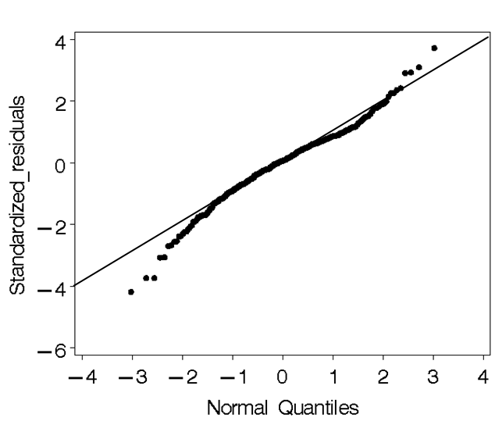

Figure 2. The North Sea with the geographical distribution of the hauls with dummy pingers, no pingers and active pingers deployed.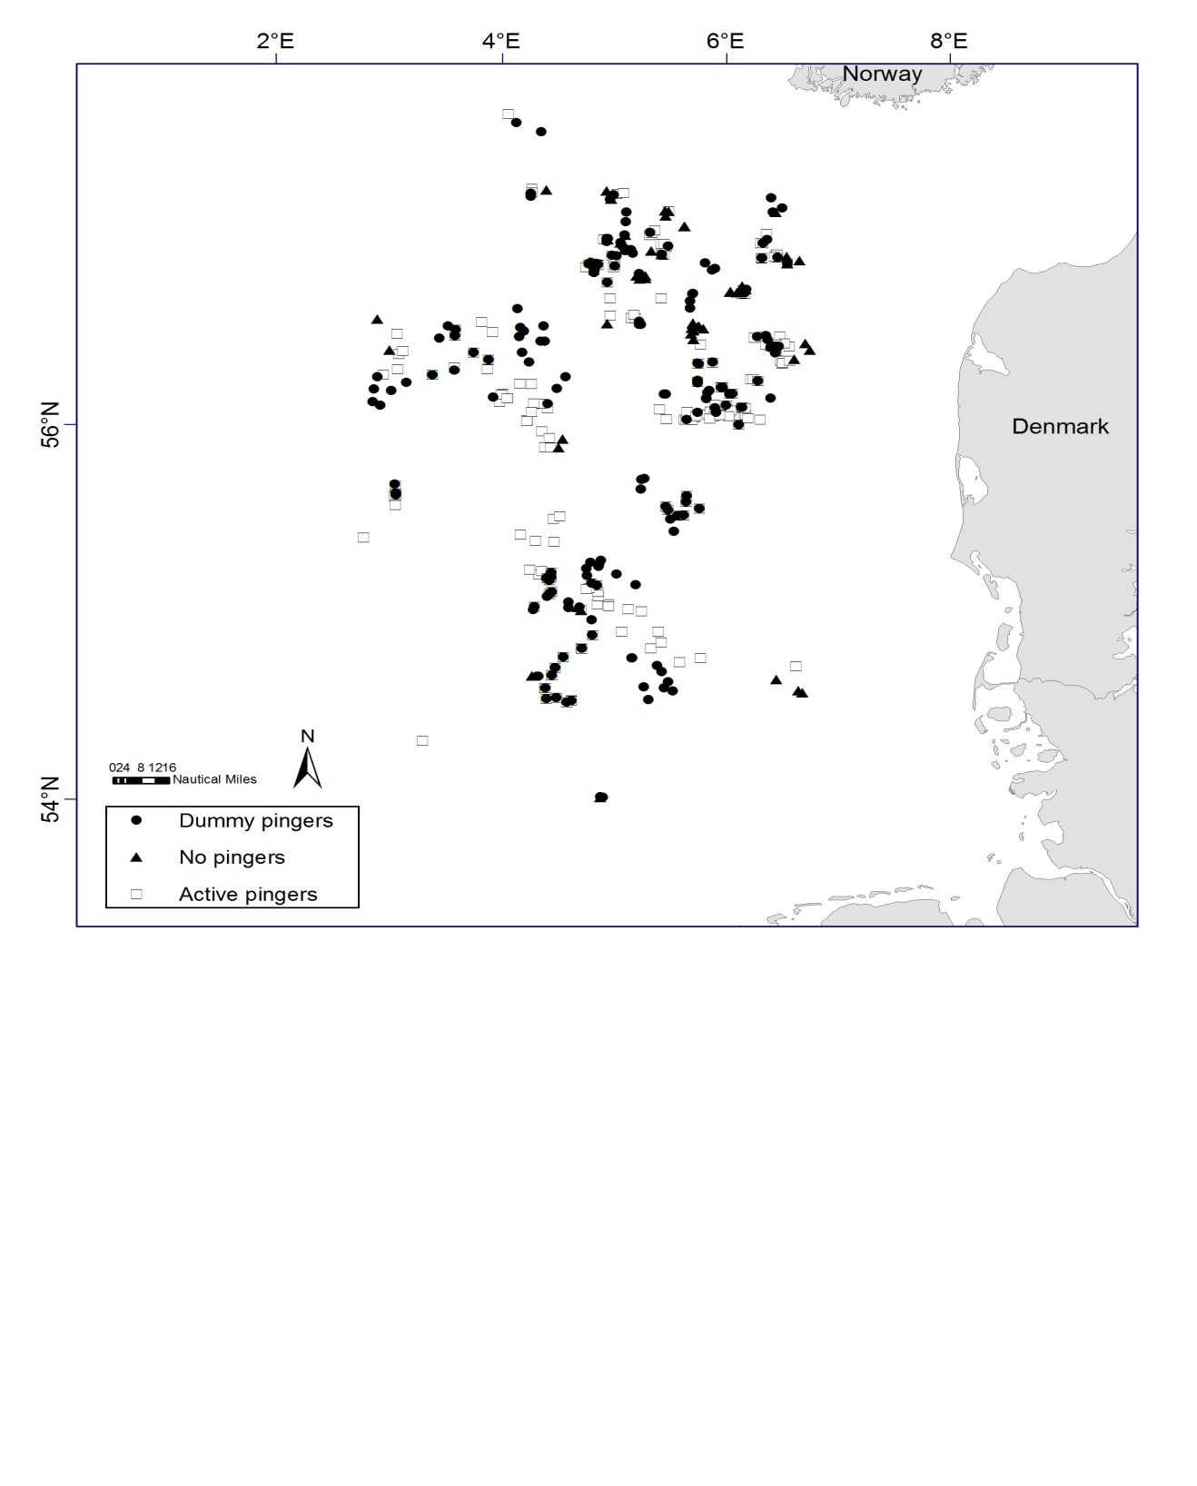

Table 1. Technical specifications of the LU–1 pinger used in the experiment.

________________________________________________
Property Specifications
________________________________________________
Frequency 8 different signals between 40 and 120 kHz
Source level 145 dB (re. 1 microPa @ 1 m)
Signal length 300 ms
Signal interval random between 5 and 30 s
Length 145 mm
Diameter 44 mm
Volume 0.22 l
Weight (in air) c. 400 g
__________________________________________________
Table 2. Number of nets with and without bycatch of porpoises in each of the treatment categories for each of the two types of fishing.
_________________________________________________________________________________________________________
Wreck fishing Flat bottom fishing Total numbers
With Without With Without With Without
porpoises porpoises porpoises porpoises porpoises porpoises
_________________________________________________________________________________________________________
With active pingers 0 1052 1 5595 1 6647
With dummy pingers 8 1048 6 5204 14 6252
Without pingers 0 74 9 2964 9 3038
Total numbers 8 2174 16 13763 24 15937

Table 3. Estimates of model 1 parameters and statistical test values based on data from 494 hauls. Estimates of vessel and area effects (ICES rectangles) are not included in the table.

Variable |  | Estimate | 95 % C.I. | Pr > | t |
Mean cpue |  | 17.99 | 16.39 - 19.76 | <0.001
Pinger type | Active | 1.31 | 1.28 - 1.35 | 0.084
 | Dummy | 1.16 | 1.13 - 1.19 | 0.366
 | No pinger | 1.00
Fishery | Stony ground | 0.47 | 0.46 - 0.48 | <0.001
 | Wreck | 1.00

¹ Danish Institute for Fisheries Research

