Variability and connectivity of plaice populations from the Eastern North Sea to the Baltic Sea, Part II. Biological evidence of population mixing.

Clara Ulrich (1), Jakob Hemmer-Hansen (2), Jesper Boje (1), Asbjørn Christensen (1), Karin Hüssy (1), Hailu Sun (3) & Lotte Worsøe Clausen (1)

1. DTU Aqua, Jægersborgs Allé 1, 2920 Charlottenlund, Denmark
2. DTU Aqua, Vejlsøvej 39, 8600 Silkeborg, Denmark
3. BGI-Shenzhen, Shenzhen, Guangdong Province 518083, China

# Highlights

* New insights are gathered for the stock identity of plaice in the ICES area IIIa
* Genetics, growth analyses, drift modelling, tagging and survey data are combined
* Local populations exist in Skagerrak but North Sea plaice extends in there too
* Stock assessment can be performed on the combined North Sea-Skagerrak area
* The productivity of the local populations should be monitored

# Abstract

A multi-disciplinary study was conducted to clarify stock identity and connectivity patterns in the populations of European plaice (*Pleuronectes platessa*) in the Skagerrak-Kattegat transition area between the Eastern North Sea and the Baltic Sea. Five independent biological studies were carried out in parallel. Genetic markers suggested the existence of different genetic populations in the transition area. Growth backcalculation with otoliths resulted in significant although limited differences in growth rates between North Sea and Skagerrak, indicating weak differentiation or important mixing. Hydrogeographical drift modelling suggested that some North Sea juveniles could settle along the coast line of the Skagerrak and the Kattegat. Tagging data suggested that both juveniles and adult fish from the North Sea perform feeding migrations into Skagerrak in summer/autumn. Finally, survey data suggested that Skagerrak also belongs to the area distribution of North Sea plaice. The outcomes of the individual studies were then combined into an overall synthesis. The existence of some resident components was evidenced, but it was also demonstrated that North Sea plaice migrate for feeding into Skagerrak and might constitute a large share of the catches in this area. The mixing of different populations within a management area has implications for stock assessment and management. Choice must be made to either lump or split the populations, and the feasibility and constraints of both options are discussed. The outcomes of this work have directly influenced the management decisions in 2015.

# KeyWords

Plaice; Pleuronectes platessa; Skagerrak; Kattegat; North Sea; Stock identity; Connectivity; lumping; splitting; genetics; growth; hydrodynamic model; tagging

# Introduction

Issues of stock identification have wide implications for conservation, when management areas are not matched with the distribution of biological populations. This well-known topic has long been a major focus in fisheries science (cf. reviews in e.g. Begg et al., 1999; Cadrin & Secor, 2009; Reiss et al,. 2009; Stephenson, 1999; Ying et al., 2011), and uncertainties on the actual population boundaries likely occur for most fish stocks. The awareness on this issue is further reinforced by the current concerns on distributional shifts linked to climate change (Link et al., 2011), and by the ever-evolving methods on stock identification (Cadrin et al., 2013) which provide a much more detailed knowledge on differences in populations at a fine geographical scale.

The European plaice (*Pleuronectes platessa*) is no exception in this domain. Plaice stock structure comprises different spawning components, which separate during spawning and mix during feeding. Juveniles of different spawning components mix also partly on nursery grounds (Hufnagl et al., 2013; Hunter et al., 2004; Kell et al., 2004). The North Sea plaice is the largest stock defined, but its connectivity with the smaller surrounding areas has long been questioned. In particular, the stock structure in the transition area between the saline North Sea and the brackish Baltic Sea has long remained unclear and no sound scientific basis for fisheries management could be developed. This transition area is characterised by very heterogeneous hydrogeographical conditions with regards to depth, salinity and currents, with steep gradients over short distances (Figure 1), and it is therefore increasingly recognised that these conditions contribute to a high, but complex structuration of many marine populations (Bekkevold et al., 2011; Limborg et al., 2009) and of the many fisheries that exploit them. Incidentally, the complexity of this transition area is also reflected in the multiple names and geographical identifications commonly used, which deserve clarification (Figure 1). The entire area is referred to as Area IIIa by the International Council for the Exploration of the Sea (ICES). It is constituted of two administrative sub-areas, The Skagerrak in the Northwest (=ICES IIIa North) and the Kattegat in the Southeast (=ICES IIIa South). These two sub-areas are, however, also sometimes referred to following the Baltic Sea Sub-Division (SD) nomenclature, where the Skagerrak corresponds to SD 20 and Kattegat corresponds to SD 21.

A first synthesis of knowledge was undertaken by Ulrich et al. (2013). That initial study challenged the prevalent assumption that plaice in the Skagerrak and in the Kattegat belong to the same entity. Plaice populations in the two areas had traditionally been assessed together, but with poor and unreliable outcomes, and no analytical advice had been given for the combined area since 2002. Using the existing information at the time, Ulrich et al. (2013) performed a comprehensive review of all available biological knowledge on plaice in this area, including published and unpublished literature as well as analyses of commercial and survey data and historical tagging data. The results suggested that plaice in the Skagerrak is closely associated with plaice in the North Sea, although local populations were suspected to be present in the area. Plaice in the Kattegat, the Belt Sea and the Sound was also to be considered a separate stock unit, as was plaice in the Baltic Sea. Following that earlier study, the basis of the scientific management advice formulated by the International Council for the Exploration of the Sea (ICES) was changed accordingly (ICES, 2012). It became possible to reliably assess the plaice in the Kattegat, the Belt Sea and the Sound (a stock referred to as “plaice in SD 21-23”, ICES 2015c) using a standard age-based model. However, uncertainty remained for the largest fishery component of this transition area, the Skagerrak. Age-based models applied on catch data from this area still failed to deliver proper assessment outcomes, suggesting a violation of the basic assessment assumption of an isolated population. Management advice could only be given on the basis of a biomass survey index from the most westerly part of the area (“West Skagerrak”, Figure 1), where most of the fisheries occur and where most of the mixing with the North Sea is assumed to take place (ICES, 2015e).

In spite of these progresses, the study by Ulrich et al. (2013) underlined nevertheless that the information available was fairly scarce and often old, and that many uncertainties remained. The alternative hypotheses on stock structure could not be fully ascertained. This absence of clear conclusions stopped further steps to be taken towards improved assessment and management. Furthermore, new issues in the approach agreed by ICES (2012) soon appeared. A closer investigation of the West Skagerrak biomass index revealed high variability between survey hauls and a strong stratification of plaice densities according to depth and longitude (ICES, 2015d). While stratification is a common feature in many marine populations and a well-known issue for the estimation of statistically sound abundance indices, this issue is particularly difficult to handle in this case because of the limited size of the area (hence a limited number of survey hauls) and of the steep depth gradient along the continental slope (Figure 1).

It became evident that collecting new data was necessary to progress on the biological understanding of the population structure of plaice in this small but economically important area. The present study is thus the direct follow up of the previous work by Ulrich et al. (2013). In line with the most up-to-date multi-disciplinary approaches to stock identification methods (Cadrin et al., 2013; ICES, 2015a), new genetic, otoliths growth and hydrodynamic modelling data were collected and analysed between 2013 and 2014, together with a more in-depth analysis of the existing fisheries, survey and tagging data. The present paper summarises briefly the methods and main results of the individual analyses for these different sources of information, and focuses on combining these findings into a coherent holistic picture of the situation, providing pragmatic conclusions regarding stock assessment and fisheries management. Further details on each dataset are given in Hemmer-Hansen et al. (2015) and in the Supplementary Material to this document.

# Material and methods

Five analyses are presented sequentially: (i) the genetic population structure; (ii) the characterisation of differences in growth using otoliths; (iii) the modelling of the hydrodynamic transport of eggs and larvae; (iv) the characterisation of adult migrations using historical tagging data; (v) the analysis of survey and fisheries data. The various analyses were performed independently from each other, using different types of data collected during different sampling programs. The genetic samples were collected specifically for this analysis; the growth analyses used otoliths collected over the last decade as part of the standard harbour sampling program; and tagging data were collected at the beginning of the twentieth century. There are therefore no common baselines of individual fish for which growth, genetics and migration patterns would be known.

## Genetic population structure

As for many marine fish species levels of genetic structuring have historically been found to be low in European plaice (Hoarau et al., 2002; Was et al., 2009). In particular, earlier work had identified a lack of clear genetic structuring between samples collected in the Baltic Sea and in the North Sea (Was et al., 2009). However, it was still not known whether these earlier results truly reflected the existence of one panmictic population distributed widely across both areas or whether they were constrained by the limited statistical power of the genetic tools available at that time. Alternative molecular methods have developed since then, and new analyses of population differentiation of plaice samples collected from the Baltic Sea to the North Sea were therefore conducted using a modern genomics two-step approach (Hemmer-Hansen *et al.*, in prep). A first step was to develop new genetic markers in plaice through high throughput next generation sequencing of restriction enzyme digested genomic DNA (RADseq, Baird et al. (2008); following the procedure outlined in Hohenlohe et al., 2013). This method allows for the characterization of thousands of genetic markers (Single Nucleotide Polymorphisms, SNPs) even in species where limited genomic resources are available, and is a promising method for a range of applications in marine fishes (Hemmer-Hansen et al., 2014). The EcoR1 enzyme was used to digest genomic DNA from eight individuals distributed across the natural distribution of the species (Two individuals collected in 2012 in the Baltic Sea, North Sea, Iceland and northern Norway, respectively). Individual sequencing reads were assembled to contigs with the programmes STACKS (Catchen et al. 2013) and VELVET (Zerbino and Burney 2008), and SNPs were identified with the programmes BOWTIE2 (Langmead and Salzberg 2012) and “ContigRefGenotype”, “collate” and “SNPStats0” (available from <http://webpages.uidaho.edu/hohenlohe/software.html>). In a second step, a subset of the discovered SNPs was selected for genotyping in 113 individuals distributed across 6 geographical locations (Figure 1 and Table 1 in supplementary material) by DNA capture following the procedures outlined in Liu *et al.* (2016), pooling 20 individuals per sequencing lane. All sequencing was conducted on the Illumina Hiseq-2000 platform at BGI-Shenzhen, China. To call genotypes, reads were aligned to the reference contigs with BOWTIE2 (Langmead and Salzberg 2012) and SNPs called with SAMTOOLS mpileup (Li et al. 2009) and BCFTOOLS (http://samtools.github.io/bcftools/).

Genetic differentiation between samples was estimated as pairwise FST measuring the percentage of the total genetic variance explained by variation between samples (varying between 0 = no difference between samples, and 1 = complete genetic isolation, Weir & Cockerham, 1984), and further visualized by a multidimensional scaling plot based on pairwise FST estimates. The analyses were performed using the R package genetics (Warnes et al, 2013), Geneland (Guillot et al. 2005) and stats (R Core Team 2014). Exact tests for pairwise population differentiation were conducted in GenePop (Rousset, 2008). Finally, the distribution of genetic variance within and between samples was evaluated with an Analysis of MOlecular VAriance (AMOVA) with the programme Arlequin (Excoffier and Lischer 2010), grouping samples according to genetic relationships identified through pairwise FST.

## Characterising differences in growth using otoliths

Growth of fish depends on endogenous (i.e. size, physiology, reproductive state, genotype etc.) and exogenous factors (i.e. physical and chemical environment and food availability). Growth is known to differ within and between areas, and area-specific differences in mean growth rate are therefore a robust measure for identifying specific areas where only limited mixing takes place between neighbouring populations or stocks. Noticeably, the opposite is not true though: observing similar growth leads to inconclusive results with respect to the degree of separation, since two distinct populations may experience similar growth conditions. Traditional size-at-age data fall short of providing unbiased growth estimates owing to size selectivity of the gear used and fishing pressure, amongst other factors. Instead, we used the growth chronologies of individual fishes, from hatch to capture, estimated visually from the rings on the fish’s otoliths. The width of an annual growth zone in the otolith reflects the fish’s somatic growth. The otoliths are thus natural bio-loggers and provide a tool to estimate the fish’s age and somatic growth throughout its life.

Older otoliths selected from the Danish harbour sampling library from three sampling years (2002, 2005 and 2008, predominantly first and second quarters) representative of different periods in plaice stock size (ICES, 2015b), were selected (n = 841, 896 and 991 for the three years respectively), covering 15 year classes, see details in Table 2 in Supplementary Material and in Hemmer-Hansen et al. (2015). The age range was restricted to individuals between 3 and 7 years old in order to (i) analyse mature individuals only, (ii) cover the age classes caught in the fishery and (iii) avoid results heavily influenced by a few old individuals. Samples were spread evenly between statistical rectangles from all management areas between the Eastern North Sea (ICES area IV) and the Eastern Baltic Sea (SD 25), allowing the analyses to be performed at different scales of spatial aggregation. In the Baltic Sea, no information on sex of the samples is available, whereas this information is documented in the North Sea and area IIIa. Since growth of plaice is known to be dimorphic, with females showing faster growth (Ulrich et al., 2013), analyses of combined sexes may be biased if sex ratios differ between areas. A first analysis at the regional scale was therefore conducted using the entire dataset including both males and females. A second analysis at a finer spatial scale in and around the Skagerrak was then performed using females only. Otolith images were digitised under standardised light and image capture settings. Otolith growth within each year of an individual’s life was measured, where the transition from dark to white zones corresponds to the end of a winter. Since otolith size and fish size are strongly correlated (Campana, 1990), these measurements can be used to estimate the size of the fish at the end of each winter (previous age) over the entire lifespan of the fish. Fish size at previous age was thus back-calculated based on these measurements using the scale-proportional approach (Campana, 1990), resulting in a growth curve (length at previous age) for each individual fish from hatch to capture. These growth curves were linearised by log-transforming length at previous age and analysed using Linear Mixed Effects Models from the nlme R package (Pinheiro et al., 2015) with previous age as dependent variable, sampling area as fixed effect and individual fish as random grouping effect:

${log⁡(Length}_{previous age})={Age}_{previous}× Area+(1|individual)+ε$.

Subsequently, pairwise comparison of areas were performed using Tukey Contrasts with the multcomp R package (Hothorn et al., 2008), to characterise whether different growth patterns were observed across adjacent areas. A significant area effect on the intercept but not on the slope of the Length – Age regressions indicates that individuals have a different origin but similar growth rates throughout the rest of their lives. Conversely, a significant area effect on the slope but not on the intercept of the regressions indicates that the individuals in different areas have had a similar size during their first year of life, but have experienced different growth rates throughout the rest of their lives. A significant effect on both slope and intercept is strongly indicative of spatio-temporal separation between areas.

## Modelling of the hydrodynamic transport of eggs and larvae

The connectivity of populations across areas can be analysed by hydrodynamic simulations computing the matrix of the probability of survival of eggs and larvae from a set of spawning areas to a set of nurseries where they will settle and grow in their juvenile phase. The probability of survival is the product of the success of the physical transport (advection to a settlement habitats) and of the biological survival across the various early life stages. Hydrodynamic drift experiments of pelagic early life-stages of plaice were simulated, extending the study by Hufnagl et al. (2013), which focused on the North Sea only, to the area IIIa. Similar settings were applied (see details in Hemmer-Hansen et al., 2015), with minor refinements reflecting the available biological knowledge in the area IIIa. The drift experiments were setup in the modular IBMlib framework (IBMlib, 2016) and the underlying 3D physical circulation model was the operational HBM model operated by The Danish Meteorological Institute (DMI) with a 10 km resolution and up to 77 vertical z-layers (Berg & Poulsen, 2012; Larsen et al. 2007). The HBM model features open model boundaries between Scotland and Norway and in the English Channel and includes tides and pre-calculated surges from a barotropic model of North Atlantic (Dick et al., 2001). Eggs were considered as passive drifters (with no fixed depth), added with vertical buoyant motion, as derived from Stokes law motion corresponding to an egg density of 1.02 g/cm3 (Coombs, 1990; Petereit, 2014) in relation to the local water density obtained from salinity, temperature and pressure. Pelagic larvae were passive, whereas the vertical swimming behaviour of demersal larval stages was modelled following Hufnagl et al., (2013). An annual biological mortality rate was applied for the various stages (33.4/yr for the pelagic egg, 16.5/yr for the pelagic larvae, 5.86/yr for the demersal larvae), following Wennhage (1999). Dynamic particle equations were integrated forward using standard algorithms, including stochastic dispersal effects reflecting subscale turbulence. Each run was based on 966 000 larvae distributed homogeneously over all spawning areas, corresponding to 10 representative egg/larvae per km2. This resolution allows for average transport patterns to emerge, although rare recruitment events (with probability < 1 o/oo) may not be fully resolved. The model was run for all years between 1994 and 2013 in order to assess the inter-annual variability of the drift patterns, including periods of low biomass and small recruitment of North Sea plaice (ICES, 2015b).

Potential spawning areas in the Kattegat and in the Skagerrak were taken from Cardinale et al. (2011). The Skagerrak spawning area defined in Cardinale et al. (2011) was extended to include the entire area of shallow waters (grid cells where depth is 10-40 m in at least 50 % of the habitat) located in the West Skagerrak (an area referred to as Jammer Bay, Figure 1). Building on the conclusions from Hufnagl et al. (2013), larvae advected into the transition area from North Sea spawning areas at Dogger Bank (South-western and central North Sea) and the German Bight (South-eastern North Sea, Figure 1, see also Figure 2 in Supplementary Material) were also considered. Juvenile settlement habitats were generated as fractional cells of the underlying hydrodynamic grid, where substratum (from GEUS, 1999) is considered soft and depth is shallower than 10m (from IOWtopo2, 2008). Four coastal settlement areas were thus defined: Jammer Bay (West Skagerrak), West Kattegat (Danish East Jutland Coast) Swedish West coast (extending alongside both the Skagerrak and the Kattegat) and Southern Kattegat (Danish Zealand coast) (Figure 1, see also Figure 2 in Supplementary Material).

## Adult migrations

The dataset compiled by Nielsen et al. (unpublished) on historical tagging studies (1903-1964) and described in Ulrich et al. (2013) was further analysed. This dataset gathers results from several tagging programs performed over time in different Danish waters, summing to approximately 13 000 recaptures recorded, from around 40 000 tags released. The dataset is heterogeneously spread over years, seasons and areas, and in particular the Skagerrak area has historically been studied much less than the other Danish waters and the observations are scarcer (Figure 3 in Supplementary Material). Nevertheless the large number of observations provides valuable information on global migration patterns. Ulrich et al. (2013) investigated the average relationships across the different areas to support the split between the Kattegat and the Skagerrak. Here, the relationships between the North Sea and the Skagerrak were investigated in more details, looking for exchange patterns at a lower spatio-temporal scale, in particular with regards to spawning migrations. Maturity is not amongst the recorded parameters at release so it was assumed that fish above 28 cm were mature (Rijnsdorp, 1989). Spawning time was broadly defined as January to April, accounting for both latitude and potential temperature regime that may affect spawning time range (Rijnsdorp et al., 2014), and feeding time was defined as July to November.

## Analyses of survey and fisheries data in the North Sea and Skagerrak

The aforementioned issues in the abundance index established by ICES (2012) called for an in-depth investigation of the suitability of the survey data for plaice in this area. Survey data from the International Bottom Trawl Survey (IBTS) since 1991 extracted from <https://datras.ices.dk/> were thus explored further for both the first and the third quarters. Exploratory abundance indices were compiled by ICES, using the standard calculation procedures commonly used for the abundance indices used in stock assessment, but restricted to various alternative combinations of areas in the Skagerrak and in the North Sea (e.g. Skagerrak alone; West Skagerrak alone; Jammer Bay alone; North Sea alone; North Sea and Skagerrak; North Sea and West Skagerrak). Their internal consistency (tracking of cohorts across ages and years) was investigated using plots from the FLR R package (Kell et al., 2007). Danish fisheries data over the same period were also collected and mapped.

# Results

The main findings of each analysis are summarised below, and a more complete overview of the results are available in Hemmer-Hansen et al. (2015) and in (ICES, 2015d) including corresponding working documents.

## Genetic population structure

Assembly and alignment of the RADseq data from eight individuals identified a large quantity of new SNPs in European plaice, of which 7,148 were used in analyses of population structure in six geographical samples composed of 17-20 individuals per sample (Figure 1 and Table 1 in supplementary material). Pairwise tests for sample differentiation showed that all samples were significantly different, although levels of divergence between some samples were relatively low (Table 1). Pairwise estimates of around 1.5-2% between North Sea and Baltic Sea samples correspond nevertheless to what have been observed in other marine fishes in the region (Limborg et al., 2009). The multidimensional scaling plot showed that samples grouped genetically according to geography, corresponding to a genetic gradient from the Baltic Sea through the transition zone (Kattegat/Skagerrak) and to the North Sea (Figure 2). Most of the variation between samples was explained by this gradient. This suggests the existence of different genetic populations in the North Sea, the transition zone and the Baltic Sea. The results from the AMOVA analysis, with samples grouped according to the patterns observed in Figure 2 (i.e. three groups represented by the samples [North Sea], [Kattegat, West Skagerrak, Skagerrak] and [Western Baltic, Eastern Baltic], respectively, supported this pattern. Here, the largest proportion of genetic variance was found within populations (99.27%, p<0.00001), but significant parts of the variation were also found among populations within groups (0.17%, p<0.00001) and among the three groups (0.56%, p<0.00001). Additional preliminary analyses of the variation at the level of individual fish (Hemmer-Hansen et al., in prep; results not shown here) indicated though that some fish collected in the Skagerrak had a North Sea genetic signature.

## Characterising differences in growth using otoliths

Growth patterns were analysed separately for 1) the entire region from the eastern North Sea to the eastern Baltic Sea and 2) the North Sea-Skagerrak focus area (females only) (Figure 3). In both cases, the model selected by ANCOVA displayed a significant area effect both on the intercept and on the slope (proxy for adult growth rate between 3 and 7 years). These differences in growth indicate a considerable isolation between the populations. Post-hoc pairwise comparison between neighbouring areas showed no significant differences between the two most eastern Baltic areas (SDs 24 and 25), and between the Kattegat-Belt Sea areas (Table 2). Conversely, a significant difference in growth patterns was observed between the Belt Sea and the Western Baltic Sea; and also between the Skagerrak and the Kattegat. These results suggest the occurrence of four separate components: Baltic Sea (Eastern+Western), Belt Sea/Kattegat, Skagerrak and North Sea.

Zooming on the North Sea/Skagerrak area (females only), post-hoc pairwise comparison found no significant differences between the eastern and western areas within Skagerrak respectively (Table 2). Notably, the growth patterns from females only were quite different from the patterns above observed for all animals, which can be explained by a relatively large difference in the sex-ratio across the different areas, so the results cannot be directly compared between the two studies.

Interestingly, the difference in growth between the North Sea and the West Skagerrak was significant, but only marginally (p = 0.041). This difference was observed to be exclusively attributable to differences in the slope of the LMEM (adult growth rate), but not in the intercept (Table 3). These results indicate that the plaice stocks within the North Sea and the Skagerrak are either two distinct populations with slightly different growth patterns, or two distinct populations with different growth patterns and considerable stock mixing to attenuate the stock-specific growth signals. The observed growth characteristics thus support the observed genetic population structure.

## Modelling of the hydrodynamic transport of eggs and larvae

The results of the 3D drift modelling showed important inter-annual variability in the magnitude of the inflow between the different years (Table 4), but some constant patterns also emerged. The results supported the findings of an easterly drift of eggs and larvae from Hufnagl et al. (2013). Eggs and larvae from Southwest and central North Sea (Dogger Bank) do likely not drift into Skagerrak and beyond (the small connectivity between inner North Sea populations and the Kattegat is mainly provided by a single unusual hydrographic year, 1995). Other patterns are more variable. The inflow from Southeast North Sea (German Bight) is very variable from year to year (Figure 4, right), but it is likely that some North Sea juveniles can settle along the Skagerrak and Kattegat coast line. The drifting patterns of eggs and larvae spawned in Skagerrak are similar to those of German Bight (Figure 4, left). In some years, the highest settlement probabilities were found outside of Skagerrak (survival > retention), while in some other years the larvae would mainly stay inside the Skagerrak (retention ~ survival). Finally, those spawned in the Kattegat will primarily stay within the Kattegat and settle along the Danish and Swedish coasts.

## Adult migrations

The analysis of seasonal patterns revealed cross-boundaries migrations (Figure 5). There is a strong connectivity between the North Sea and the Skagerrak, with mutual movements. More than 20% of the spawning fish tagged in the North Sea migrated into the Skagerrak during summer-autumn, and conversely 15% of the fish tagged in the spawning season in Skagerrak moved into the North Sea. In contrast to this, the adult fish in the Belt Sea and the Baltic Sea were almost entirely resident. Applying the similar selection of data to juvenile fish recaptures (less than 28 cm) showed that almost all fish were resident within the management area and did not perform longer migrations at any time of the year, except for the North Sea where a migration into Skagerrak was observed (14%) in the same order of magnitude as for adult fish (data not shown). Thus, both juveniles and adult fish from the North Sea performed feeding migrations into the Skagerrak in summer/autumn.

Summer tagging in Skagerrak was limited to few observations, but these showed a substantial return (54%) to the North Sea in the spawning season (Figure 5), sometimes quite far from the boundary. Additionally, the subset of adult fish released during spawning season and recaptured one year or more later also during spawning revealed full homing, with all fish being recaptured in the same area as where they were released, but at a distance up to 100 kilometres away on average.

As a summary, plaice populations in the Kattegat, the Belt Sea and the Baltic Sea seem highly resident and return home to spawn, but seasonal migrations are observed. Exchanges between the Skagerrak and the North Sea are two-ways, indicating that a mix between the two assumed components is likely substantial during feeding season.

## Analyses of survey and fisheries data in the North Sea and Skagerrak

Previous assessment attempts for Skagerrak plaice had already highlighted major differences in trends between the first (Q1) and the third (Q3) quarter IBTS survey indices, but could not explain these, and these inconsistencies contributed to the assessment failure in the last decade. In the light of the new biological hypotheses formulated in 2012 (Ulrich et al., 2013), IBTS data were analysed at a wider North Sea- Skagerrak scale. Plaice densities in first quarter in the Skagerrak are variable and relatively low (Figure 6). The average density has fluctuated over the years without trends. Conversely, the abundance increase in the North Sea is reflected both in first and third quarter, consistently with the outcomes of the North Sea stock assessment (which does not include IBTS at present), and this increase is well correlated with the abundance increase in third quarter in Skagerrak alone. Additionally, there are correlations (although weak) between recruitment in the North Sea and summer abundance in Skagerrak at adult ages (ICES, 2015e). These observations are highly consistent with the fishery data, where landings and CPUE are lowest in first quarter and highest in third quarter.

The analyses of the internal consistency (cohort tracking) of IBTS Q1 and Q3 exploratory indices at different geographical scales are not shown here but are available in ICES (2015c). The main outcomes were that the internal consistency of IBTS Q1 in Skagerrak is poor, with poor tracking of cohorts potentially spawning in Skagerrak. Reducing the area used to calculate the indices did not help improve the consistency. This can result from IBTS hauls being outside of Q1 plaice distribution, but this can also indicate that the evidence of a permanent resident population is blurred. IBTS Q3 in Skagerrak is more internally consistent, and is better matched with the commercial data. It indicates higher densities of plaice during summer feeding season. The internal consistency of IBTS in the North Sea alone is better, but overall, the best internal consistency of survey indices across ages were obtained when combining the two areas, both for Q1 and Q3 (Figure 7). This suggests that the cohorts of North Sea plaice are better tracked when considering the entire combined area, indicating that Skagerrak belongs to the distribution area of North Sea plaice.

These analyses of IBTS data have highlighted that the approach agreed by ICES in 2012 was not robust, and should not be continued further. IBTS Q1 in Skagerrak alone cannot be considered a reliable index of abundance of the local population during spawning. It cannot, however, be fully ascertained whether it is because the survey design is inappropriate for this species in this time of year, or because the population density fluctuates and the cohorts are not consistently present in the area from year to year. Also, the present analyses have provided a much better understanding of the seasonality in the populations’ density, supporting the outcomes of the other biological studies of a distinct population in Skagerrak together with significant summer inflow from the North Sea.

# Discussion

## Synthesis: Evidence of local populations but with important mixing

These new biological analyses have confirmed the perception that the population structure of plaice in the transition area between the North Sea and the Baltic Sea is complex and dynamic. The existence of distinct populations in the Skagerrak and in the Kattegat suggested by ICES (2012) and Ulrich et al. (2013) was supported by all the new data sources: growth characteristics is significantly different between these areas; there is only limited adult migration between these two areas; the genetic samples are significantly differentiated; and there is a substantial potential for local retention of early life stages. Not only do these data suggest the existence of local and unique populations in the two areas, but they also point out that these populations are biologically different from those in neighbouring areas in the North Sea and in the Baltic Sea.

Nevertheless, there is also evidence that supports the hypothesis of substantial interaction and mixing between these distinct populations across the areas. In terms of assessment and management, the mixing issue matters mainly at the adult stage, but here the analyses shed also some light at the larvae and juveniles stages. Drift modelling suggested thus some drift of eggs and larvae from spawning grounds in the North Sea into the Skagerrak, but with potentially large inter-annual variation. Both the Skagerrak and the Kattegat have suitable nursery grounds, and these habitats may therefore be inhabited by juveniles originating from both North Sea and local spawning grounds. Tagging data suggested further that both adults, as part of their feeding behaviour, and juveniles may actively migrate between areas; from the North Sea to the western parts of the Skagerrak, in particular. The existence of genetic differentiation between the North Sea and the Skagerrak and results from tagging indicated that such migration is followed by homing to natal spawning grounds in the North Sea and/or poor survival and reproduction of North Sea individuals in the Skagerrak. Yet, these fish may still contribute significantly to the local fisheries in the Skagerrak and the Kattegat while staying there. As for North Sea fish, spawning fish in the Skagerrak and the Kattegat are also displaying strong homing to natal spawning regions, as indicated by tagging data. Collectively, these data show that mixing of biological populations may occur on most life stages in the Skagerrak and the Kattegat.

These conclusions from biological data support well the patterns observed in the survey and fisheries data. While these data are usually worked out on a yearly basis for stock assessment purposes, a better quantification of the seasonal patterns has provided a more coherent picture of the dynamics of the mixing between the North Sea and the Skagerrak, and the likely origin of catches. The observed differences between first and third quarter density patterns in the surveys can be explained by the mixing hypothesis. The population density during spawning in the Skagerrak is not very well tracked by existing surveys, but fishing on spawning aggregations in the area seems limited and the biomass indices have so far fluctuated without clear trends. During summer, there is likely an important inflow from the North Sea population, entering the Skagerrak to feed. This inflow has increased over the recent years, consistent with the increase of abundance of the North Sea stock. By far the largest part of the fishery occurs in this period, and in the most westerly part of the Skagerrak close to the North Sea border.

As data material is still relatively limited, it is difficult to quantify proportions of North Sea fish in the Skagerrak area at present. However, tagging data suggested that around half of fish tagged in Skagerrak migrate to the North Sea at spawning time. Additional preliminary investigations suggested also that some fish collected in the Skagerrak during spawning time may have a North Sea genetic signature (results not shown here). Also the internal consistency in IBTS third quarter improved when including Skagerrak in the survey area, indicating a better coverage of the stock summer distribution area. Altogether, this suggests that the Skagerrak area belongs to the natural distribution area of North Sea plaice, and thus that North Sea plaice may constitute a substantial proportion of plaice in the Skagerrak, both during winter and summer. Therefore, a large (although still not quantifiable) proportion of the commercial catches recorded for the Skagerrak may belong to the North Sea population component.

In the Kattegat and Baltic areas, findings were less clear, and some uncertainties still remain. But new patterns have emerged from the present data. Here, both growth trajectories and genetic data suggested limited differentiation within the Baltic Sea (SDs 24-25), but more significant differentiation between the Baltic Sea and the Kattegat – Belt Sea area (SD21-23), which is also consistent with tagging data.

Additional knowledge on the linkages between the different sub-areas in the Baltic Sea and the Kattegat was compiled by Stoetera et al. (Working Document 1 in ICES, 2015d), however also revealing substantial uncertainties and inconsistencies. Ultimately, the stock entity of plaice populations in the Eastern part of the transition zone is still poorly defined and somewhat inconclusive.

## Implications for stock assessment and management

The results summarized here have important implications for assessment of plaice stocks, and they have indeed influenced the outcomes of ICES advice afterwards (ICES, 2015b). Regarding the assessment of plaice in the Skagerrak, the approach followed since 2012 was dismissed. The co-occurrence of local and North Sea plaice populations that had been hypothesised in 2012 was confirmed; however, it is still not possible to separate populations in the catches in an operational and large-scale manner as is currently done for herring stocks in area IIIa, (Clausen et al., 2007) and cod in the western Baltic Sea (Hüssy et al., 2015; ICES, 2015c). This creates an intermediate situation, which has important implications for the operational assessment and management of the populations. Two options are possible (Kell et al., 2009). For the protection of the local populations, it would be preferable to consider the Skagerrak as a stock unit distinct from the North Sea (“splitting option”). For the feasibility of quantitative stock assessment and fisheries management, it would be preferable to consider the Skagerrak as a part of the global North Sea stock (“lumping option”).

Both options have though downsides. If the Skagerrak was split from the North Sea, it would be difficult to monitor the size and productivity of the local population, and to define and evaluate quantitative management objectives for the area. If the Skagerrak was lumped with the North Sea, there remains a risk of depletion of the local Skagerrak population if the fishing pressure on it increases as a consequence of the increase in the North Sea stock. Thus, neither the lumping nor the splitting options are entirely satisfactory solutions (Kell et al., 2009). The “splitting option” was explored, and tentative stock assessments were trialled including various attempts to correct the Skagerrak summer data (catch and survey) for the North Sea inflow bias (Jardim et al., 2015), but with little operational success. It was concluded that no quantitative assessment of the local population in the Skagerrak was possible with the current data, unless making strong assumptions on stock mixing in the catches; assumptions which cannot be quantified with the currently available biological data. In consequence, the “splitting option” above would imply that no quantitative advice could be provided for this stock. Conversely, the “lumping option” would be much easier to handle, as the Skagerrak catch data can easily be added to the North Sea assessment, tuned with the IBTS survey index for the combined area (ICES, 2015d). The lumping option would thus allow some quantitative advice to be provided for the Skagerrak, but would not allow for routine monitoring of the local population in the Skagerrak.

Both options have been extensively discussed in this case, to provide a precautionary advice based on the best scientific knowledge. Decision was finally made in 2015 to proceed with the lumping option, thus allowing a quantitative analytical assessment and management advice for the area (ICES, 2015d). In terms of precautionary management of the Skagerrak population, some mechanisms already exist that may be used for reducing the fishing pressure in the Skagerrak if deemed necessary, as plaice in the North Sea and in the Skagerrak are managed by two different Total Allowable Catches (TACs). The TAC in Skagerrak has historically been based on considerations independent from the North Sea, and was historically linked to the TAC in Kattegat. On the basis of the current lumping option chosen, the TAC in Skagerrak will be indexed to the North Sea TAC from 2017 on. But routine monitoring of the survey and fisheries patterns will be performed annually by ICES to detect any departures from the current situation, i.e. a decoupling of trends in the different areas and the different seasons that could indicate a reduced productivity of the local stock (ICES, 2015e). Additional modelling work might also be needed to further evaluate the potential risks of the lumping option.

In the longer-term, the current progresses on the biological knowledge of the stock in Skagerrak should be sustained. Additional genetic allocation of individual fish to the different populations should be performed to obtain a better quantification of the mixing in different areas and seasons, and the survey coverage should be improved in the Skagerrak.

Different decisions were made regarding the Eastern side of the transition area. Plaice in the Kattegat had historically been assessed together with the Skagerrak. The 2012 revision of stock identity (ICES 2012, Ulrich et al., 2013) had led to a new stock definition, where a unique stock became considered for the combined areas of the Kattegat, Belt Sea and the Sound (SD 21-23). The new knowledge collected from the present study did though not bring decisive conclusions to either confirm or reject the hypothesis of a separate stock in the Baltic Sea (SD 24-32), and further genetic work would still be needed to clarify this (ICES, 2015d).

# Conclusions

It can be considered that major progresses have been achieved on an issue that has been ongoing for fifteen years, since the poor reliability of the assessment of plaice in area IIIa was acknowledged in the early 2000s. The outcomes of the biological investigations presented here have been implemented straight away into the assessment and management processes, reflecting some flexibility of the European fisheries management system to adapt to new knowledge. This was also reinforced by the urging support of the fishing industry to solve the biological uncertainties, as these have had important economic consequences for the local fisheries exploiting plaice in the Skagerrak. The absence of stock assessment prevented the MSC (Marine Stewardship Council) eco-certification of the Skagerrak plaice fishery for more than six years, with corresponding losses of market shares.

Not all aspects have nevertheless been solved yet, and there is scope for future work. For the Skagerrak, the most important issue is to avoid the depletion of the local population, if its productivity does not increase as much as in the North Sea, and careful monitoring will be needed in the future. In the medium-term, additional genetic sampling should be performed to further quantify the mixing between populations across different years and seasons. Ideally, a real baseline should be established, where the same individuals would be tagged and then would be assessed for growth and genetic assignment at recapture.

Finally, this work can also be considered to be of generic scientific interest, beyond its immediate interest for solving some management issues in the particular case study presented here. It has highlighted the challenges and the opportunities in combining several independent sources of information into a holistic understanding of a dynamic biological system. The need to provide scientific advice to management has also emphasised that different questions require different data. If only a clarification of stock identification is needed, this can be addressed through snapshot sampling in a given year. If routine stock assessment is to be conducted, this requires longer time series of stock separation in the catch and survey data across several areas and seasons, and thus sustained sampling year after year. This is likely to be a major limiting information factor in many cases. Thus the most appropriate approach for stock assessment is to be decided on a case-by-case basis, balancing pragmatically between conservation risk and the resources available for data collection.

# Acknowledgements

The research leading to this publication has received funding from the Danish Ministry for Food, Agriculture and Fisheries and the European Union (European Fisheries Fund: contract no. 33010-12-a-0253). We thank Jose Martin Pujolar for assistance with genetic data analyses and Kerstin Geitner for GIS support, as well as the Danish Fishermen’s Association for the valuable exchanges throughout the project.

# References

Baird, N.A., Etter, P.D., Atwood, T.S., Currey, M.C., Shiver, A.L., Lewis, Z.A., Selker, E.U., Cresko, W.A., Johnson, E.A. 2008 Rapid SNP discovery and genetic mapping using sequenced RAD markers. PLoS ONE 3, e3376.

Begg, G.A., Friedland, K.D., Pearce, J.B., 1999. Stock identification and its role in stock assessment and fisheries management: An overview. Fish. Res. 43, 1–8. doi:10.1016/S0165-7836(99)00062-4

Bekkevold, D., Clausen, L. a. W., Mariani, S., André, C., Hatfield, E.M.C., Torstensen, E., Ryman, N., Carvalho, G.R., Ruzzante, D.E., 2011. Genetic mixed-stock analysis of Atlantic herring populations in a mixed feeding area. Mar. Ecol. Prog. Ser. doi:10.3354/meps09352

Berg, P., Poulsen, J.W., 2012. Implementation Details for HBM. DMI Tech. Rep. 12-11, DMI, Copenhagen.

Cadrin, S., Kerr, L.A., Mariani, S., (2013). Stock Identification Methods: Applications in Fishery Science, second ed.. Elsevier, San Diego.

Cadrin, S.X., Secor, D.H., 2009. Accounting for spatial population structure in stock assessment: past, present , and future, in Beamish, R.J., Rothschild, B.J. (Eds.), The Future of Fisheries Science in North America. Fish and Fisheries Series, Springer, the Netherlands, pp. 405–426. doi:10.1007/978-1-4020-9210-7_22

Campana, S.E., 1990. How reliable are growth back-calculations based on otoliths? Can. J. Fish. Aquat. Sci. 47, 2219–2227. doi:10.1139/f90-246

Cardinale, M., Bartolino, V., Llope, M., Maiorano, L., Sköld, M., Hagberg, J., 2011. Historical spatial baselines in conservation and management of marine resources. Fish Fisher. 12(3), 289–298. doi:10.1111/j.1467-2979.2010.00393.x

Catchen, J., Hohenlohe, P.A., Bassham, S., Amores, A., Cresko, W.A., 2013. Stacks: an analysis tool set for population genomics. Mol. Ecol., 22 (SI), 3124-3140. doi: 10.1111/mec.12354.

Clausen, L.A.W., Bekkevold, D., Hatfield, E.M. C., Mosegaard, H., 2007. Application and validation of otolith microstructure as a stock identification method in mixed Atlantic herring (*Clupea harengus*) stocks in the North Sea and western Baltic. ICES J. Mar. Sci. 64(2), 377-385. doi:10.1093/icesjms/fsl036

Coombs, S.H., Nichols, J.H., Fosh, C.A., 1990. Plaice eggs (Pleuronectes platessa L.) in the southern North Sea: abundance, spawning area, vertical distribution, and buoyancy. Journal du Conseil International pour l'Exploration de la Mer 47, 133–139.

Dick S., E. Kleine and S. Müller Navarra, 2001. The operational circulation model of BSH (BSH cmod). Model description and validation. Berichte des Bundesamtes für Seeschifffahrt und Hydrographie. 29/2001. Hamburg, Germany, 48 pp.

Excoffier, L., Lischer, H.E.L., 2010. Arlequin suite ver 3.5: A new series of programs to perform population genetics analyses under Linux and Windows. Mol. Eco. Res. 10, 564-567.

GEUS, 1999. Seabed Sediments around Denmark, Digital Map 1:500.000. The Geological Survey of Denmark and Greenland. (accessed 29.08.2003).

Guillot, G., Mortier, F., Estoup, A., 2005. Geneland: A program for landscape genetics. Mol. Ecol. Notes, 5, 712-715.

Hemmer-Hansen, J., Therkildsen, N.O., Pujolar, J.-M., 2014. Population Genomics of Marine Fishes: Next-Generation Prospects and Challenges. Biol. Bull. 227(2), 117–132.

Hemmer-Hansen, J., Ulrich, C., Boje, J., Christensen, A., Degel, H., Hüssy, K., Worsøe Clausen, L., 2015. MSC certification of plaice fisheries in area IIIa: Basic investigations and development of a management plan. DTU Aqua report no. 302-2015. http://www.aqua.dtu.dk/english/-/media/Institutter/Aqua/Publikationer/Forskningsrapporter_301_351/302-2015_MSC-certification-of-plaice-fisheries-in-area-IIIa.ashx (accessed 07.07.2016)

Hoarau, G., Rijnsdorp, A.D., Van der Veer, H.W., Stam, W.T., Olsen, J.L., 2002. Population structure of plaice (*Pleuronectes platessa* L.) in northern Europe: Microsatellites revealed large-scale spatial and temporal homogeneity. Mol. Ecol. 11(7), 1165–1176. doi:10.1046/j.1365-294X.2002.01515.x

Hohenlohe, P.A., Day, M.D., Amish, S.J., Miller, M.R., Kamps-Hughes, N., Boyer, M.C., Muhlfeld, C.C., Allendorf, F.W., Johnson, E.A., Luikart, G., 2013. Genomic patterns of introgression in rainbow and westslope cutthroat trout illuminated by overlapping paired-end RAD sequencing. Mol. Ecol., 22 (SI), 3002-3013. doi:10.1111/mec.12239

Hothorn, T., Bretz, F., Westfall, P., 2008. Simultaneous Inference in General Parametric Models. Biom.l J. 50(3), 346–363. https://cran.r-project.org/web/packages/multcomp/index.html (ver. 2.15.3, accessed 01.10.2015).

Hufnagl, M., Peck, M.A., Nash, R.D.M., Pohlmann, T., Rijnsdorp, A.D., 2013. Changes in potential North Sea spawning grounds of plaice (*Pleuronectes platessa* L.) based on early life stage connectivity to nursery habitats. J. Sea Res. 84, 26–39. doi:10.1016/j.seares.2012.10.007

Hunter, E., Metcalfe, J.D., Arnold, G.P., Reynolds, J.D., 2004. Impacts of migratory behaviour on population structure in North Sea plaice. J. Animal Ecol. 73(2), 377–385. doi:10.1111/j.0021-8790.2004.00801.x

IBMlib, 2016. IBMlib: A generic tool for individual-based modelling of aquatic organisms. https://github.com/IBMlib/IBMlib (SVN Revision number 469 - 2014-08-26)

ICES, 2012. Report of the Workshop on the Evaluation of Plaice Stocks (WKPESTO), 28 February - 1 March 2012, Copenhagen, Denmark.

ICES, 2015a. Interim Report of the Stock Identification Methods Working Group (SIMWG), 10–12 June 2015, Portland, Maine, USA.

ICES, 2015b. Plaice (*Pleuronectes platessa*) in Subarea IV (North Sea) and Division IIIa (Skagerrak). In *ICES Advice 2015, Book 6* (p. 14).

ICES, 2015c. Report of the Baltic Fisheries Assessment Working Group (WGBFAS), 14– 21 April 2015, Copenhagen, Denmark.

ICES, 2015d. Report of the Benchmark Workshop on Plaice (WKPLE), 23-27 February 2015, Copenhagen, Denmark.

ICES, 2015e. Report of the Working Group for the Assessment of Demersal Stocks in the North Sea and Skagerrak (WGNSSK), 30 April–7 May 2014, Copenhagen, Denmark.

IOWtopo2, 2008. A high resolution spherical grid topography of the Baltic Sea. Institut für Ostseeforschung Warnemünde. http://www.io-warnemuende.de/topography-of-the-baltic-sea.html (accessed 07.07.16).

Jardim, J.E., Alzorriz, N., De Oliveira, J., Eero, M., Holmes, S.J., Scott, F., Ulrich, C., 2015. a4a short research project - Studying spatial effects on stock dynamics of North Sea cod and plaice in the Skagerrak. Luxembourg: Publications Office of the European Union. http://publications.jrc.ec.europa.eu/repository/handle/JRC95629 (accessed 07.07.2016).

Jombart, T., 2008. adegenet: a R package for the multivariate analysis of genetic markers. Bioinformatics (Oxford, England), 24(11), 1403–5. doi:10.1093/bioinformatics/btn129

Jombart, T., Ahmed, I., 2011. adegenet 1.3-1: new tools for the analysis of genome-wide SNP data. Bioinformatics (Oxford, England), 27(21), 3070–1. doi:10.1093/bioinformatics/btr521

Kell, L.T., Dickey-Collas, M., Hintzen, N.T., Nash, R.D.M., Pilling, G.M., Roel, B.A., 2009. Lumpers or splitters? Evaluating recovery and management plans for metapopulations of herring. ICES J. Mar. Sci. 66(8), 1776–1783. doi:10.1093/icesjms/fsp181

Kell, L.T., Mosqueira, I., Grosjean, P., Fromentin, J.M., Garcia, D., Hillary, R., Jardim, E., Mardle, S., Pastoors, M. a., Poos, J.J., Scott, F., Scott, R.D., 2007. FLR: An open-source framework for the evaluation and development of management strategies. ICES J. Mar. Sci. 64, 640–646. doi:10.1093/icesjms/fsm012

Kell, L.T., Scott, R., Hunter, E., 2004. Implications for current management advice for North Sea plaice: Part I. Migration between the North Sea and English Channel. J. Sea Res. 51(3-4), 287–299. doi:10.1016/j.seares.2003.10.004

Langmead, B., Salzberg, S., 2012. Fast gapped-read alignment with Bowtie 2. Nature Methods, 9, 357-359.

Larsen, J., Hoyer, J.L., She, J., 2007. Validation of a hybrid optimal interpolation and Kalman filter scheme for sea surface temperature assimilation. J. Mar. Sys. 65, 122–133.

Li, H., Handsaker, B., Wysoker, A., Fennell, T., Ruan, J., Homer, N., Marth, G., Abecasis, G., Durbin, R., 1000 Genome Project Data Processing Subgroup, 2009. The Sequence Alignment/Map format and SAMtools. Bioinformatics, 25, 2078-2079. doi: 10.1093/bioinformatics/btp352. Epub 2009 Jun 8

Limborg, M.T., Pedersen, J.S., Hemmer-Hansen, J. , Tomkiewicz, J., Bekkevold, D., 2009. Genetic population structure of European sprat Sprattus sprattus: Differentiation across a steep environmental gradient in a small pelagic fish. Mar. Ecol. Prog. Ser. 379, 213–224. doi:10.3354/meps07889

Link, J.S., Nye, J.A., Hare, J.A., 2011. Guidelines for incorporating fish distribution shifts into a fisheries management context. Fish Fisher. 12(4), 461–469. doi:10.1111/j.1467-2979.2010.00398.x

Liu, S., Wang, X., Xie, L., Tan, M., Li, Z., Su, X., Zhang, H., Misof, B., Kjer, K.M., Tang, M., Niehuis, O., Jiang, H., Zhou, X. 2016 Mitochondrial capture enriches mito-DNA 100 fold, enabling PCR-free mitogenomics biodiversity analysis. Mol. Ecol. Res., 16, 470–479.

Petereit, C, Hinrichsen, H.-H., Franke, A., Köster F.W.,. 2014. Floating along buoyancy levels: Dispersal and survival of western Baltic fish eggs. Progress in Oceanography 122, 131–152.

Pinheiro, J., Bates, D., DebRoy, S., Sarkar, D., R Core Team, 2015. nlme: Linear and Nonlinear Mixed Effects Models. Retrieved from http://cran.r-project.org/package=nlme (ver. 3.1-104, accessed 01.10.2015).

R Core Team, 2014. R: A language and environment for statistical computing. R Foundation for Statistical Computing, Vienna, Austria. http://www.R-project.org/.

Reiss, H., Hoarau, G., Dickey-Collas, M., Wolff, W.J., 2009. Genetic population structure of marine fish: Mismatch between biological and fisheries management units. Fish Fisher. 10(4), 361–395. doi:10.1111/j.1467-2979.2008.00324.x

Rijnsdorp, A.D.1989. Maturation of male and female North-Sea plaice (*Pleuronectes platessa* - L). [Journal Du Conseil](http://findit.dtu.dk/en/journal?ignore_search=%E2%9C%93&issn%5B%5D=00206466&key=00206466%7C000110%7C000046%7C000001%7C000000) — [1989, Volume 46, Issue 1](http://findit.dtu.dk/en/catalog?l%5Btoc%5D%5Btitle%5D=Journal+Du+Conseil&l%5Btoc%5D%5Bvalue%5D=00206466%7C000110%7C000046%7C000001%7C000000), pp. 35-51

Rijnsdorp, A. D., van Damme, C. J.G. and Witthames, P. R. (2014) Ecology of reproduction, in Flatfishes: Biology and Exploitation (eds R. N. Gibson, R. D.M. Nash, A. J. Geffen and H. W. van der Veer), John Wiley & Sons, Ltd, Chichester, UK. doi: 10.1002/9781118501153.ch5

Rousset, F., 2008. GENEPOP’007: A complete re-implementation of the GENEPOP software for Windows and Linux. Mol. Ecol. Res. 8(1), 103–106. doi:10.1111/j.1471-8286.2007.01931.x

Stephenson, R.L., 1999. Stock complexity in fisheries management: A perspective of emerging issues related to population sub-units. Fish. Res. 43(1-3), 247–249. doi:10.1016/S0165-7836(99)00076-4

Ulrich, C., Boje, J., Cardinale, M., Gatti, P., LeBras, Q., Andersen, M., Hemmer-Hansen, J., Hintzen, N.T., Jacobsen, J.B., Jonsson, P., Miller, D.C.M., Nielsen, E.E., Rijnsdorp, A.D., Sköld, M., Svedäng, H., Wennhage, H., 2013. Variability and connectivity of plaice populations from the Eastern North Sea to the Western Baltic Sea, and implications for assessment and management. J. Sea Res. 84, 40–48. doi:10.1016/j.seares.2013.04.007

Warnes, G., with contributions from Gregor Gorjanc, Leisch, F., Man, M., 2013. genetics: Population Genetics. Retrieved from http://cran.r-project.org/package=genetics. Version 1.3.8.1., accessed 03.09.2013.

Was, A., Gosling, E., Hoarau, G., 2009. Microsatellite analysis of plaice (*Pleuronectes platessa* L.) in the NE Atlantic: weak genetic structuring in a milieu of high gene flow. Mar. Biol., 157(3), 447–462. doi:10.1007/s00227-009-1331-x

Weir, B.S., Cockerham, C.C., 1984. Estimating F-statistics for the analysis of population structure. Evol. 38(6), 1358–1370. doi:10.2307/2408641

Ying, Y., Chen, Y., Lin, L., Gao, T., Quinn, T., 2011. Risks of ignoring fish population spatial structure in fisheries management. Can. J. Fish. Aquat. Sci. 68(12), 2101–2120. doi:10.1139/f2011-116

Zerbino, D.R., Birney, E., 2008. Velvet: algorithms for de novo short read assembly using de Bruijn graphs. Genome Research, 18, 821-829.

# Figures

Figure 1. Hydrographical map of the area with average surface salinity and depth, updated from Ulrich et al. (2013). The black straight lines delimitate the management areas. The grey lines delimitate the Eastern and Western areas of Skagerrak and Kattegat as defined by ICES (2012).

Figure 2. Multidimensional scaling plot of pairwise estimates of genetic population differentiation (FST; Weir and Cockerham 1984).

Figure 3. Growth by area back-calculated from otoliths. Top: at the scale of management areas (all fish). Bottom: at the scale of ICES (2012) Eastern and Western areas within Skagerrak and Kattegat (females only). The dots are slightly shifted along the x-axis for better visualization

Figure 4. Time series of recruitment variability. Left: Survival (total fraction that survives, summed across all settlement areas, dotted line) and retention (part of survival that stays in Skagerrak, plain line) for larvae spawned in Skagerrak area, multiplied by 10^6. Right: North Sea (German Bight + Dogger Bank) influx probability to Kattegat/Skagerrak nurseries.

Figure 5. Proportion of seasonal movement of adult fish towards the North Sea, the Baltic Sea or residency, Danish tagging data 1903–1964. Top: released in July-November (feeding season) and recaptured in January-April (spawning season). Bottom: released in January-April (spawning season) and recaptured in July-November (feeding season). Black: Residency. Grey: migration towards Baltic Sea. White: migration towards North Sea. In bracket: number of recaptures.

Figure 6. IBTS abundance index for the Skagerrak only (left) and the North Sea and Skagerrak combined (right).

Figure 7. Internal consistency plot of IBTS Q1 1991-2015 (Left) and Q3 1991-2014 (Right) survey index (log(mean CPUE)) in the combined area North Sea + Skagerrak. Upper left panel: Regression plot of the survey index between one age *a* in one year *y* and another age *a+i* in another year *y+i.* Ages 1 to 9 are displayed in the diagonal. Bottom right panel: corresponding coefficient of determination (R2) with colour scaled to the [0,1] interval.

|  |  |  |  |  |  |  |
| --- | --- | --- | --- | --- | --- | --- |
|  | Eastern Baltic Sea | Western Baltic Sea | Kattegat | Skagerrak | Western Skag. | North Sea |
| Eastern Baltic Sea |  |  |  |  |  |  |
| Western Baltic Sea | 0.001 |  |  |  |  |  |
| Kattegat | 0.004 | 0.001 |  |  |  |  |
| Skagerrak | 0.007 | 0.006 | 0.002 |  |  |  |
| Western Skag. | 0.009 | 0.007 | 0.002 | 0.001 |  |  |
| North Sea | 0.016 | 0.015 | 0.006 | 0.003 | 0.002 |  |

Table 1. Pairwise FST (Weir and Cockerham 1984) between samples of plaice

|  |  |  |  |  |  |
| --- | --- | --- | --- | --- | --- |
|  | Skagerrak | Kattegat | Belt Sea | Western Baltic Sea | Eastern Baltic Sea |
| North Sea | **0.005 \*** | < 0.001 | < 0.001 | < 0.001 | < 0.001 |
| Skagerrak |  | **< 0.001 \*** | < 0.001 | 0.617 | 0.900 |
| Kattegat |  |  | **1.000** | < 0.001 | < 0.001 |
| Belt Sea |  |  |  | **< 0.001 \*** | < 0.001 |
| Western Baltic Sea |  |  |  |  | **0.998** |

|  |  |  |  |  |
| --- | --- | --- | --- | --- |
|  | West Skag. | East Skag. | West Kat. | East Kat. |
| North Sea | **0.041 \*** | 0.274 | < 0.001 | < 0.001 |
| West Skag. |  | **0.978** | < 0.001 | < 0.001 |
| East Skag. |  |  | **0.001** **\*** | 0.129 |
| West Kat. |  |  |  | **0.565** |

Table 2. Results of the pairwise comparison of backcalculated growth between areas at two different spatial scales: Top: management areas scale (all fish). Bottom: at the scale of ICES (2012) Eastern and Western areas within Skagerrak and Kattegat (females only): Bold numbers represent geographically adjacent areas. Statistically different areas are marked with an asterisk.

|  |  |  |  |  |  |
| --- | --- | --- | --- | --- | --- |
| Area units | Area | Intercept | Slope | df | t values |
| manageement areas | North Sea | -6.813 *** | 145.978 *** | 2707 | -3.547 / 61.579 |
| Skagerrak | 101.345 *** | 140.091 *** | 2707 | 25.813 / 62.970 |
| Kattegat | 18.622 *** | 134.028 *** | 2707 | 25.813 / 60.301 |
| Belt Sea | 18.376 *** | 127.423 *** | 2707 | 9.526 / 51.521 |
| Western Baltic Sea | 2.915 ns | 144.977 *** | 2707 | 1.569 / 58.396 |
| Eastern Baltic Sea | 2.145 ns | 148.978 *** | 2707 | 1.053 / 57.481 |
| ICES (2012) areas | West Skag. | 17.721 ** | 183.375 *** | 941 | 2.757 / 44.097 |
| East Skag. | 24.934 ns | 208.014 *** | 941 | 1.945 / 24.087 |
| West Kat. | 79.122 *** | 143.036 *** | 941 | 8.200 / 0.906 |
| East Kat. | 60.133 *** | 173.248 *** | 941 | 5.532 / 23.496 |
| North Sea | 17.034 ns | 196.325 *** | 941 | 1.624 / 45.953 |

*** = p < 0.001, ** = p < 0.01, *= p < 0.05, ns = p ≥ 0.05. t values shown as for: intercept / slope

Table 3. Details of the LMEM results of area effects on the intercept and slope of the log (fish size at previous age) on previous age relationship at two different spatial scales: management areas (upper part of table) and ICES (2012) Eastern and Western areas within Skagerrak and Kattegat.

|  |  |  |  |  |  |  |  |  |  |  |  |  |  |  |  |  |  |  |  |  |  |  |  |  |  |
| --- | --- | --- | --- | --- | --- | --- | --- | --- | --- | --- | --- | --- | --- | --- | --- | --- | --- | --- | --- | --- | --- | --- | --- | --- | --- |
| |  |  |  |  |  | | --- | --- | --- | --- | --- | | settlement\spawning | German Bight | Skagerrak | Kattegat | Dogger Bank | | Jammer Bay | 8.51 (21.04) | 26.08 (49.73) | 23.16 (26.61) | 0.03 (0.12) | | Jutland (East coast) | 14.85 (38.98) | 62.33 (92.75) | 728.81 (385.76) | 0.18 (0.78) | | Sweden (West coast) | 10.50 (38.65) | 79.23 (160.87) | 156.40 (132.13) | 0.02 (0.07) | | Zealand | 1.09 (3.13) | 16.32 (54.35) | 22.18 (19.85) | 0.00 (0.02) | |

Table 4 Probability (P*10^6) of physical transport from source (spawning) areas to destination (settlement) areas, averaged over the period 1994-2013. Numbers in parenthesis is temporal variability (root-mean-square) German Bight is Southeastern North Sea; Dogger Bank is Southwestern North Sea; Jammer Bay is Southwestern Skagerrak. See supplementary Material Figure 2 for the mapping of the spawning areas (source) and coastal settlement areas (destination)



Figure 1. Hydrographical map of the area with average surface salinity and depth, updated from Ulrich et al. (2013). The black straight lines delimitate the management areas. The grey lines delimitate the Eastern and Western areas of Skagerrak (Skag.) and Kattegat (Kat.) as suggested by ICES (2012).



Figure 2. Multidimensional scaling plot of pairwise estimates of genetic population differentiation (FST; Weir and Cockerham 1984).

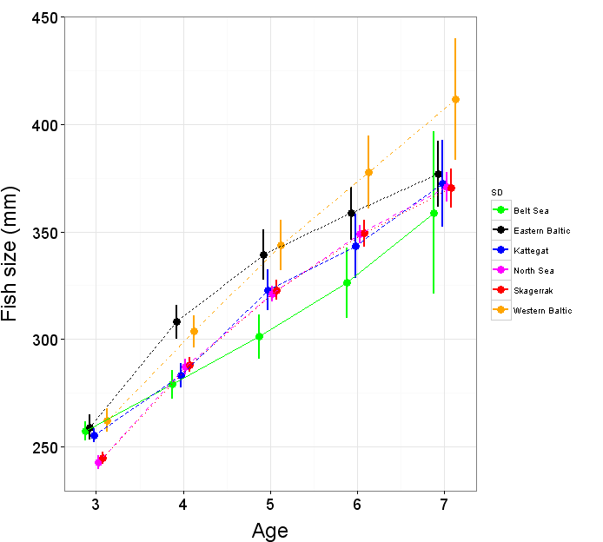

Figure 3. Growth by area back-calculated from otoliths. Top: at the scale of management areas scale (all fish). Bottom: at the scale of ICES (2012) Eastern and Western areas within Skagerrak and Kattegat (females only). The dots are slightly shifted along the x-axis for better visualization

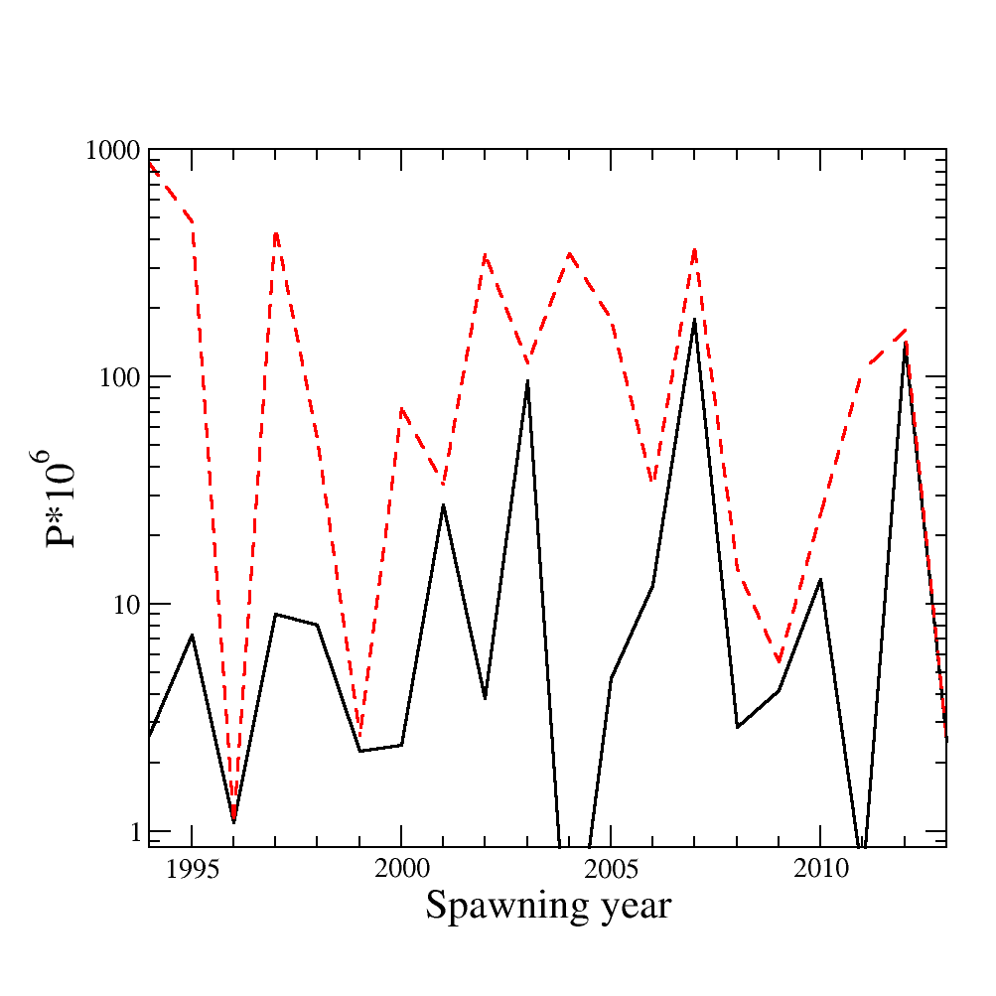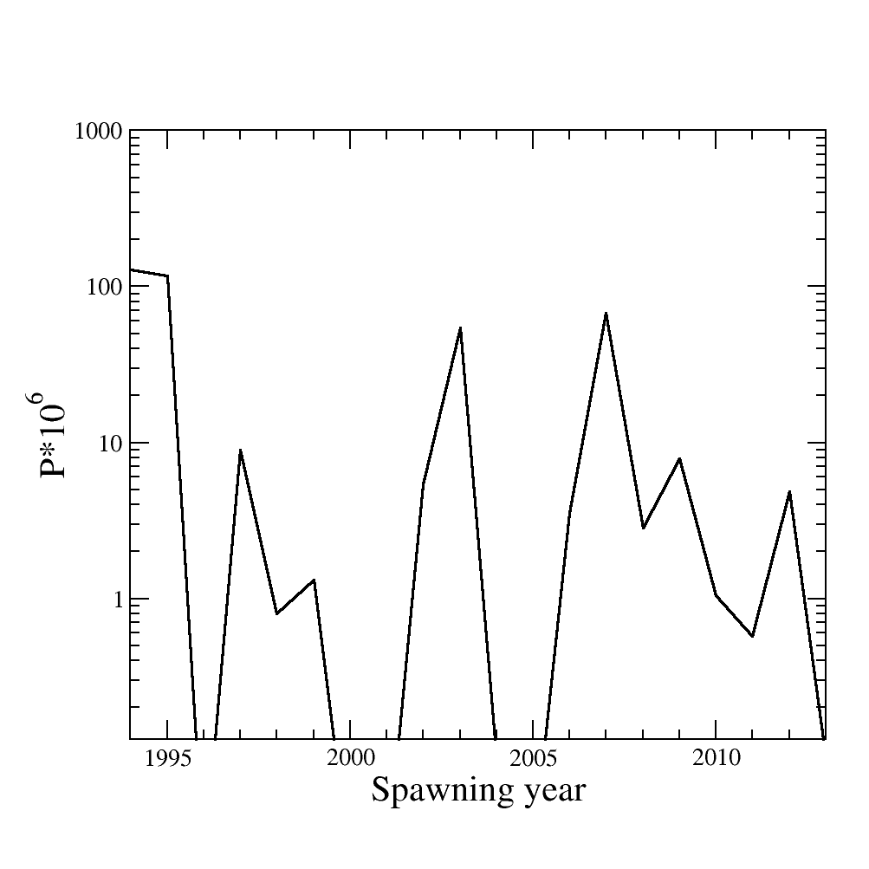

Figure 4. Time series of recruitment variability. Left: Survival (total fraction that survives, summed across all settlement areas, dotted line) and retention (part of survival that stays in Skagerrak, plain line) for larvae spawned in Skagerrak area, multiplied by 10^6. Right: North Sea (German Bight + Dogger Bank) influx probability to Kattegat/Skagerrak nurseries.



Figure 5 Proportion of seasonal movement of adult fish towards the North Sea, the Baltic Sea or residency, Danish tagging data 1903–1964. Top: released in July-November (feeding season) and recaptured in January-April (spawning season). Bottom: released in January-April (spawning season) and recaptured in July-November (feeding season). Black: Residency. Grey: migration towards Baltic Sea. White: migration towards North Sea. In bracket: number of recaptures.



Figure 6. IBTS abundance index for the Skagerrak only (left) and the North Sea and Skagerrak combined (right).

|  |
| --- |
|  |

Figure 7. Internal consistency plot of IBTS first quarter 1991-2015 (Left) and third quarter 1991-2014 (Right) survey index (log(mean CPUE)) in the combined area North Sea + Skagerrak. Upper left panel: Regression plot of the survey index between one age *a* in one year *y* and another age *a+i* in another year *y+i.* Ages 1 to 9 are displayed in the diagonal. Bottom right panel: corresponding coefficient of determination (R2) with colour scaled to the [0,1] interval.