Achieving Maximum Sustainable Yield in mixed fisheries. A management approach for the North Sea demersal fisheries

Clara Ulrich⁽¹⁾, Youen Vermard^{(2),} Paul J. Dolder⁽³⁾, Thomas Brunel⁽⁴⁾, Ernesto Jardim⁽⁵⁾, Steven J. Holmes⁽⁵⁾, Alexander Kempf⁽⁶⁾, Lars Olof Mortensen⁽¹⁾, Jan-Jaap Poos⁽⁴⁾, Anna Rindorf⁽¹⁾

- DTU Aqua, Charlottenlund, Denmark
- IFREMER, Nantes, France
- CEFAS, Lowestoft, United Kingdom
- IMARES, IJmuiden, The Netherlands
- JRC, European Commission, Ispra, Italy
- TI, Hamburg, Germany
Contact Author : Pr Clara Ulrich, DTU Aqua, Charlottenlund Castle, 2920 Charlottenlund, Denmark. Tel 21157486, mail clu@aqua.dtu.dk.

Abstract
Achieving single species objectives in complex and dynamic fisheries targeting multiple species (mixed fisheries) is challenging as achieving the objective for one species may mean missing the objective for another. This particularly applies to the concept of Maximum Sustainable Yield (MSY) in mixed fisheries in the North Sea, where the diversity of species and fisheries induce numerous biological and technical interactions. These interactions are though increasingly well understood and quantified for the most important stocks, allowing for new approaches to emerge. Recent paths towards operationalising MSY at the regional scale have suggested the expansion of the concept into a desirable area of “Pretty Good Yield”, materialised by a range around F_{MSY} that would allow for more flexibility in management targets. This paper investigates the potential of F_{MSY} ranges to combine long-term single-stock targets with flexible short-term mixed-fisheries management requirements, based on the main North Sea demersal stocks. It is shown that sustained fishing at the upper bound of the range may not be appropriate when technical interactions occur. An objective method is suggested that minimises the risk of mixed-fisheries imbalance, using advantageously the flexibility of the ranges to address explicitly the trade-offs between the most and least productive stocks.

Keywords
Conflicting objectives, choke species, fleet modelling, long term objectives, pretty good yield, F_{MSY} ranges

Introduction
The European Union (EU) has been managing commercially exploited fish stocks in European waters since 1983 under the Common Fisheries Policy (CFP) (Holden, 1994). The main management instrument within the CFP is the setting of annual single-stock Total Allowable Catches (TACs), which limit the tonnage to be landed for each stock (Daan, 1997). Since 2002 (Framework Regulation (EC) No 2371/2002), decisions on TACs have been increasingly based on long-term considerations, reducing annual political battles over the setting of TACs by providing a framework under which stock sustainability and quota stability for fishermen are jointly considered. These considerations have been operationalised into multi-annual or long-term management plans (MAPs or LTMPs), and in recovery plans for stocks outside safe biological limits. Such plans contain the goals for management of stocks, typically expressed in terms of fishing mortality and/or targeted stock size. How to attain the goals in the plans is defined by a Harvest Control Rule (HCR). The HCR is then translated into an annual TAC on the basis of stock assessments. Additional measures, such as area closures or changes to fishing gear, are sometimes included as well. In 2015, many important stocks in the North Sea are managed by means of a LTMP.
However, while single-stock plans have contributed to the recovery of European stocks in varying degrees (STECF, 2015b), other conflicts have appeared. The most serious arises from mixed-fisheries interactions, when several stocks with different productivity are caught together. In such cases, a reduction in TAC resulting from a HCR may not lead to the expected reductions in fishing mortality and to recovery if fisheries continue to catch (but not land) the vulnerable stock while targeting healthier stocks (Batsleer, Hamon, Overzee, Rijnsdorp, & Poos, 2015; Gillis, Pikitch, & Peterman, 1995). The mixed demersal roundfish fisheries in the North Sea are a famous example: fisheries targeting North Sea haddock (Melanogrammus aeglefinus), have contributed to a decline of the North Sea cod (Gadus morhua) stock, and discards increased as the cod quota were reduced (Bannister, 2004). Indeed, the annual fishing mortality of these two stocks is highly correlated (ρ=0.55, p<0.01; ρ=0.82 for the years since 2000 (ICES, 2015g). Despite emergency measures in 2001 followed by a recovery plan for cod in 2004 the situation deteriorated inexorably, until a range of actions were finally triggered in the mid-2000s. On the policy side, a number of initiatives were launched to incentivise cod avoidance, such as Catch Quota Management with Fully Documented Fisheries (Needle et al., 2015; Ulrich et al., 2015; van Helmond, Chen, & Poos, 2015) and Real-Time Closures (Holmes et al., 2011; Little, Needle, Hilborn, Holland, & Marshall, 2014).
On the scientific side new tools to quantify and monitor mixed fisheries interactions were developed. In particular, the FCube approach (Fleets and Fisheries Forecast, (Ulrich, Reeves, Vermard, Holmes, & Vanhee, 2011)) has delivered mixed-fisheries considerations as part of the ICES advice since 2009 (ICES 2015b), measuring the inconsistencies across the different single-stock advice on fishing opportunities for the following year when stocks are caught together by the same fleets. Until now, these ICES considerations did not aim to provide a single-best mixed-fisheries TAC advice, but to raise managers’ awareness of the potential imbalance and tensions at the regional level, that could lead to ‘choke species’ effects, over-quota discarding, and higher fishing mortalities than advised in the single-stock advice. Understanding and predicting fishers behaviour and adaptation is still a major difficulty in fisheries modelling (Andersen et al. 2010; Fulton et al. 2011), so as an alternative FCube has been developed as an envelope modelling approach contrasting extreme options. The model builds on a fairly simple idea: F-based fishing opportunities for each stock are translated into an equivalent level of effort for each fleet-stock combination (“effort-by-stock”), assuming unchanged effort and catchability patterns compared to the last data year (fishers would engage in the same metiers and metiers would induce the same fishing mortality on stocks per unit of effort and effort patterns). Since each fleet can only have one unique amount of total effort over one year, this effort is set through an option. For example, for each fleet, fishing would stop when the catch for any one (“Min” option) or all (“Max” option) of the stocks meet the fleet’s stock catch share. (Ulrich et al. 2011; ICES 2015b). The Min option is the most conservative scenario, forecasting the underutilization of the single-stock opportunities of other stocks. Conversely, the Max option predicts the overfishing of the single -stock advice possibilities of most stocks. Neither of these two options is considered plausible under the current management framework. Nevertheless they frame the range of the plausible outcomes considering the fleet’s decision options, with the distance between the two being considered as an indicator of the overall mixed-fisheries imbalance. Strong imbalance is interpreted as an increased risk of tensions with the fishing industry, of poorer implementation of management objectives and of postponed recovery of the most exploited stocks (Kraak et al. 2013; ICES 2015b). An intermediate option is the “Value” option, a simple scenario accounting for the economic importance of each stock for each fleet, where the effort by fleet is equal to the average of the efforts required to catch the fleet’s stock shares of each of the stocks, weighted by the historical catch value of that stock.
But while the mechanisms creating over-quota discards are increasingly understood, no regional management solutions have yet been brought to address incompatibilities across single stocks management objectives. Rather, the recent history of the North Sea cod illustrates that a persistent single-stock focus ignoring these mechanisms may fail in achieving management objectives. A new cod management plan was implemented in 2008 (Council Regulation (EC) No1342/2008), with more stringent TACs as well as effort reductions, aiming to reduce fishing mortality. These stringent measures however, did not reduce fishing mortality during the first years of implementation (Kraak et al., 2013). The fishing industry strongly opposed effort reductions, and discard mortality remained high. In 2012 the North Sea cod stock did start showing signs of recovery, but this led to a situation where stock biomass and catch rates were increasing while the legally binding HCR still called for further TAC and effort reductions. As a result, the annual HCR advice was rejected after long and conflictual negotiations between 2013 and 2015. In the meantime, NGOs and the civil society expressed increasing concerns about the high quota-induced discards and the insufficient recovery of the cod stock (Borges, 2013).
This situation in the North Sea mixed demersal fisheries influenced significantly the outcomes of the 2013 reform of the CFP (EU, 2013), calling for a more integrated and ecosystem-based approach to management plans and for the ending of discarding practices under the so called landings obligation (LO). The reform has established new objectives for sustainable fisheries, including the objective of achieving an exploitation rate consistent with Maximum Sustainable Yield (F_{MSY}) at the latest by 2020 for all stocks. The CFP foresees the adoption of management measures in the context of regional multi-annual plans. The three elements of the CFP (the landings obligation, the requirement for achievement of MSY by 2020, and the mixed-fisheries management plans) may seem inconsistent, or even contradictory if the mixed-fisheries are highly dependent on an overexploited stock with low productivity, as has long been the case with the North Sea cod stock. In such cases, it seems unlikely to achieve all these objectives within five years without immediate effort reductions and/or major changes in the current fishing practices. Recognising this fundamental mixed-fisheries issue, new approaches have emerged out of intense political, institutional and scientific activity (Kempf et al., n.d.). A task force (EU, 2014) comprising the three main EU Institutions (EU Commission, EU Parliament and EU Council of Fisheries Ministers) suggested to use F_{MSY} ranges as flexible targets for the regional management plans rather than prescriptive HCRs (STECF 2015a), thus considering MSY as a desirable multi-dimensional area rather than a point estimate. The International Council for the Exploration of the Sea (ICES, 2015b) was then requested to provide precautionary estimates of single-stock F_{MSY} delivering at least 95% of the maximum yield, an approach referred to as Pretty Good Yield (PGY, (Hilborn, 2010). Two values have been estimated that define the range of F with high yields and low risk of severe stock depletion, MSY F_{lower} and MSY F_{upper}. (ICES, 2015b) advised nevertheless that sustained fishing with values above F_{MSY} would have adverse consequences including lower biomass and more variable fishing opportunities.
The objectives of the present study are to evaluate the ability of using F_{MSY} ranges to diminish the conflict between MSY management of single species and the possibility to deliver operational fisheries management at regional level based on mixed fisheries considerations. The present study thus extends the approach that has been followed using FCube since 2009.

Material and Methods

FCube modelling framework
The FCube model (Ulrich et al., 2011) builds on FLR (Fisheries Library in R) objects and functions for the modelling of fisheries (Kell et al., 2007). Inputs data are a vector of target fishing mortality by stock, as well as historical data of stock assessments, effort and catch by fleet and metier. Being initially developed for deterministic short-term forecasts, the model has been extended to operate as a stochastic medium-term Management Strategies Evaluation (MSE,(Butterworth & Punt, 1999)) tool, with or without technical interactions (ICES 2014; STECF 2015a). The MSE includes a full feedback loop, i.e. it simulates the management procedure (HCR) where a TAC is defined every year based on a short-term forecast, mimicking the actual conditions of management advice where the true (realised) fishing mortality can differ from the target (intended) mortality (ICES, 2013). MSY-based HCRs follow the ICES advice sliding rule, i.e. the target fishing mortality is reduced if the spawning stock biomass falls below MSY B_{trigger}. Without technical interactions the method performs independent MSEs for each stock. As a minimum, variability of future recruitment is included. Other sources of parameter uncertainty (e.g. in weight at age, selectivity, discard ratio) can be added, as well as observation and assessment error. When technical interactions are implemented, the vector of true fishing mortality by stock enters the FCube module. Implementation error in the form of over – or underquota catches is estimated accordingly, following the standard FCube options (Min, Max or Value) as usually done in the ICES mixed-fisheries advice (ICES, 2015c). The resulting vector of true fishing mortality by stock is then used in replacement of the initial value in the operating model to project the stocks.
In this study, an optimisation process was also developed, that can be applied for a single-year deterministic short-term forecast. It identifies the set of fishing mortality by stock maximising a given objective function (“what’s best”) in addition to the usual (“what if”) set-up (ICES, 2015f). Ranges of fishing mortalities by stock are used as inputs, instead of a single vector. The optimisation is carried out using a genetic algorithm implemented in the function rbga() from the R package genalg. We aimed to minimise the mixed-fisheries imbalance, so the objective function to be minimised was defined as the catch difference between FCube Min and Max options (sum of squared differences by stock in total tonnes).

Data and conditioning
This extended FCube model model involves projections for 5 stocks (Cod in the North Sea, Skagerrak and Eastern Channel (COD); Haddock in the North Sea and Skagerrak (HAD); Saithe Pollachius virens in the North Sea, Skagerrak, Kattegat and West of Scotland (POK); Sole Solea solea in the North Sea (SOL); Plaice Pleuronectes platessa in the North Sea (PLE). The model is conditioned on the 2015 assessments and forecasts (ICES, 2015g) and the 2014 international catch and effort data by fleet and metier (ICES, 2015e). The stock recruitment relationships used in the MSE are consistent with those used to derive F_{MSY} ranges (ICES, 2015d), using the “Hockey Stick” segmented regression model in FLR fitted on the entire time series, except for North Sea cod where only the recent low recruitments (since 1988) are used as in ICES (ICES, 2015g). Growth and selectivity parameters are fixed at the 2012-2014 average, and no observation or assessment error is included. The F_{MSY} ranges were taken from (ICES, 2015b) (Table 1).
The MSE presented here was run with 200 iterations over a 30 year period, but the main focus of the analysis is the short-term impact for the annual management advice. All runs presented assume also a perfect implementation of the landings obligation as in (ICES 2015b; STECF 2015a), i.e. that all catches are landed from 2016 on, but without changes of the selectivity patterns.

Analyses
(STECF 2015a) investigated a large number of management scenarios formulated by the EU Commission, including options allowing for longer time periods (five or ten years) before reaching F_{MSY}. Based on the outcomes of this first screening, only a subset of scenarios has been selected and updated here (Table 2). Four evaluation aspects were analysed:
1) Performance of the different single-stock HCR without accounting for technical interactions. These runs are used as a baseline, and they also evaluate the outcomes of the MSY ranges, which were identified through long-term simulations with multiple sources of uncertainty using the EqSim model (ICES, 2015d), in a short/ medium approach using FCube. Four HCRs are compared for the five stocks: F_{MSY}, MSY F_{upper}, MSY F_{lower}, (all three with ICES advice sliding rule (ICES, 2015a)), and current single-stock management plans (LTMP, including the respective sliding rules where appropriate, (ICES, 2015e)).
2) Robustness of these four HCRs to mixed-fisheries implementation error, where the true catches for each stock differ from the expected catches due to quota over- or under-shoots. For each HCR, 3 FCube options are run (Min, Max, Value). In addition, a run is performed fixing fishing effort at its 2014 level (thus assuming constant fishing mortality). The outcomes of this analysis were the comparison of levels of imbalance and risk in the system under different target fishing mortalities.
3) Minimum imbalance. The optimisation module was used to identify which vector of target fishing mortalities in 2016 within the MSY ranges would minimise the mixed-fisheries imbalance, in the deterministic short-term forecast setup as used in (ICES, 2015c). The resulting vector of fishing mortalities is referred to as Foptim.
4) Impact assessment of the different HCR on stocks and fleets accounting for technical interactions, performed using the “Value” FCube scenario ((ICES, 2015b; (STECF, 2015a). Although the validity of this proxy in an economic perspective is questionable (Hoff et al., 2010), this scenario is a convenient intermediate between the Min and the Max options in the absence of an accurate behaviour algorithm predicting future effort by fleet, It has also historically predicted effort levels reasonably close to the observed effort (Ulrich et al., 2011). More specifically, we compared the impact in 2016 of applying TAC based on F_{MSY} point estimate, or with the Foptim.

Results

Medium-term performance of single-stocks HCRs
Using the MSY F_{upper} mortality values in our medium term MSE appeared potentially risky, mainly for sole and saithe, with more than 5% risk to fall below B_{lim} in 2020 (Figure 1). This is higher than the risk identified in the (ICES, 2015b) long-term stochastic projections which consider large fluctuations across several generations. Also, the risk of falling below B_{trigger} is very high for these two stocks (around 40% in 2020), implying increased inter-annual variability in the advised fishing opportunities including frequent TAC reductions to rebuild the stock above B_{trigger}, and higher dependency of the biomass on incoming year classes.
In accordance with the PGY concept, it is observed that for most stocks except haddock, landings levels in 2020 are fairly similar across the range of fishing mortality targets (Figure 1), but arising from large differences in the underlying biomass.

Medium-Term robustness of the single stock HCR to mixed-fisheries implementation error
The robustness of the HCR is primarily investigated by inspecting the worst case Max option. In these simulations high effort increases lead to increases of fishing mortality for all stocks except the least limiting ones, such as plaice and haddock (Figure 2). Interestingly, the risk to the stocks is higher with the current set of long-term management plans than with MSY F_{upper}. This result arises from the fact that plaice is the least limiting stock for many fleets, and is also the only stock for which MSY F_{upper} is lower than the current LTMP target, so fishing effort is comparatively higher with the LTMP target. In comparison, setting the target at F_{MSY} is robust to mixed-fisheries interactions, as the risk remains low for all stocks even in the Max option.
For the FCube scenarios Max and to a less extent also Value the results obtained when the F_{MSY} point estimate is used as a management target are close to those obtained with the “status-quo Effort” FCube option (Table 3). Indeed, considering the landings only (corresponding to catches in the results presented here), many options provide fairly similar yield. In 2020, most scenarios display a total yield within [-20, +10] % of the sum of the single-stock projections at F_{MSY} (Table 3), which itself is almost twice the level of 2014 catches for these five stocks. This means that for any of the considered targets, preventing short-term increases in fishing mortality will largely pay off within a few years.

Minimum imbalance within the MSY ranges.
The genetic algorithm is permitted to run for up to 30 generations but a stable solution was reached after 15 generations. The optimal fishing mortality values obtained (Figure 3) were close to the lower bound of the F_{MSY} range for haddock and plaice, while they were higher than the F_{MSY} value for cod, saithe and sole, approximately halfway between F_{MSY} and MSY F_{upper}. It is noticeable that the 2016 F_{optim} values were quite close to current (2014) fishing mortalities. This is in accordance with the latest mixed fisheries advice (ICES, 2015c), which underlined that the North Sea fisheries were in better balance in 2014 than in the previous decade, with cod not being estimated to be the most limiting stock.
The FCube model was then run again to mimic the short-term mixed fisheries advice comparing the single-stock advice based on either the F_{MSY} point estimates or F_{optim} (Figure 4). The differences in the 2016 single-stock advice (horizontal bars on Figure 4) are direct consequences of the different vectors of target fishing mortality applied in the three management scenarios (Table 4). Projections based on the optimised F values resulted in larger TACs for cod, saithe and sole, and smaller TACs for plaice and haddock. Plaice is the least limiting stock, requiring the largest effort to fully catch the TAC. With F_{optim} the “effort-by-stock” required for catching the plaice TAC became smaller while the effort needed to take the TACs for cod, saithe and sole became larger. In consequence the overall TAC overshoot in the Max scenario was smaller than for the single species F_{MSY} point estimate projection. Conversely, in the Min scenario, the limiting TAC (for sole) became higher, and the largest TACs became reduced, leading to the overall magnitude of the TAC under-consumption being reduced. The overall difference in the predicted 2016 catches between the Max and Min scenarios is thus much smaller when the single species TAC are given based on the Foptim values, reflecting a trade-off between the most and the least productive stocks. Incidentally, the Min option returned less quota undershoot than with a constant effort at 2014 level, indicating very little risk of a ‘choke’ effect of a given stock compared to the current situation of the fishery.

Short-term Impact assessment of the different management scenarios on stocks and fleets
The potential effect of using the optimised F values within the F_{MSY} range rather than the F_{MSY} point estimate in 2016 were investigated, using the FCube “Value” scenario (Figure 5). For most countries, the outcomes of 2016 would be within 20% of the 2014 levels, and F_{optim} would lead to slightly higher catches than with F_{MSY}. As the difference in F is largest for haddock, the impact would be greatest for the countries catching this stock, and primarily Scotland. Conversely, the effect is negative on the fleets catching plaice, as the F_{optim} is lower than F_{MSY} for this stock. Nevertheless, this impact assessment assumes full uptake of the TAC, which has not happened for North Sea plaice since 2010, and therefore it is not unlikely that the actual F will be below F_{MSY} in 2016.

Discussion
The work presented here is the outcome of a process developed over several years, where scientists, managers and stakeholders have together matured new conceptual thinking on the design of mixed-fisheries management plans (Kempf et al., n.d.). The objectives have been shaped by the various institutional and legal constraints within the European fisheries management system, which are different from other regions in the world (Marchal et al., 2016). MSY is the overall objective stated in the basic regulation, but the need to account for mixed-fisheries and ecosystem interactions is also written in the law (EU, 2013) article 9). Scientific evidence has accumulated since the seventies to show that MSY is inherently variable and difficult to define, not only due to multi-species and mixed-fisheries interactions (Mackinson, Deas, Beveridge, & Casey, 2009), but even in the narrow single-stock approach, where the productivity and the growth of fish populations are constantly changing. In addition, the agreement between the Council of Ministers and the EU parliament resulted in the removal of binding harvest control rules, in order to maintain some room for political flexibility in the annual TAC negotiations (EU, 2014). As a consequence, identifying ranges of fishing mortality around F_{MSY} has emerged as a pragmatic fisheries management approach integrating these institutional and ecological constraints (Rindorf, Mumford, et al., n.d.), potentially allowing some flexibility in decision-making within the framework of MSY and the precautionary objectives (STECF 2015a). Our work is intended to inform this debate on the potential challenges, risks and opportunities of moving along this path, and hopefully to contribute to informed decision-making for the management plans in development. Progresses are also on the way to include management objectives for data-poor and bycatch stocks, where the ranges of options for the commercial stocks may be reduced if they lead to unprecautionary risks to the other stocks (Rindorf, Dichmont, et al. n.d.; ICES 2015e; STECF 2015a).
In banning discards the European institutions hope to trigger bottom-up mechanisms of adaptation through changes in fishing practices and uptake of more selective gears by the fishing industry. However, the paths that this adaptation will take are still uncertain at present, depending on whether the proper incentives will be activated towards more selective fishing or not (Condie, Grant, & Catchpole, 2014; de Vos et al., 2016; Sigurðardóttir et al., 2015). Before this adaptation has fully taken place, it is possible that discarding will continue to take place illegally and unreported under the limited capacity of control. Therefore, it is necessary to develop top-down mechanisms addressing the conditions underlying overquota discarding, and relax some of the sources of pressure. The ideas presented here have explored operational options to reconcile single-stock management objectives in the mixed-fisheries context. These are mainly useful when one or few important commercial stocks are less productive and require managers to make important trade-offs between conservation and exploitation of healthier stocks. There, we suggest that applying annual sets of cohesive TACs defined within the range, potentially supplemented by limited effort and/or capacity reductions, may build a path towards progressively achieving fishing mortality objectives by improving the governance around the TACs setting. The basic idea of this regional mixed-fisheries approach is to limit the situations where TAC increase for one stock and TAC decrease for another stock if they are caught together. Such a situation has prevailed long in the North Sea because of the poor status of the cod stock, driving the development of the approach presented here. In 2016 though the situation is more balanced, with many stocks now exploited at fishing mortality close to F_{MSY} (ICES, 2015g), within the ranges proposed by (ICES, 2015b). We suggest that applying annual sets of cohesive TACs defined within a range, i.e. those resulting from the Foptim forecasts potentially supplemented by limited effort and/or capacity reductions, may help in achieving fishing mortality objectives. At the same time, applying fishing mortality ranges will provide explicit bounds for political negotiations, within the CFP framework. of sustainable fishing.
On the one hand, the ranges may provide an explicit precautionary bound for political negotiations, within the CFP framework. On the other hand, the major caveat of providing ranges for fishing mortality for the operational management target, is the risk that managers and stakeholders may systematically and blindly set TACs at the upper limit of the range of the advice for each stock. This may occasionally satisfy short-term societal goals such as maintaining employment. However, such a strategy, if maintained over longer time periods, would lead to poor outcomes. It would maintain higher fishing pressure on all stocks, slowing, or reversing, the recovery of the least productive stocks.these stocks limiting the entire fishery. Furthermore, the imbalance problem The same inconsistencies that exist with F_{MSY} point estimates would simply be transferred to incompatible TACs and increased discards would remain, though now at lower biomass and higher fishing levels. F_{MSY} should effort. F_{MSY} will remain the primary reference point used in ICES advice (ICES 2016), but the ranges would be best used by managers as a flexible buffer to reduce the worst short-term imbalance effects and enhance compliance and controllability.
Our MSE results were in this sense more pessimistic than the outcomes of (ICES, 2015b). While (ICES, 2015b) defined MSY F_{upper} as having a low risk to the biomass in the long-term, we obtained much higher risks in the short- and medium-term for some stocks. The scope, assumptions and incorporation of uncertainty differ between FCube and the EqSim model used by (ICES, 2015d). , so it is difficult to ascertain what is causing this difference, and which of these models capture the most likely outcome. But this highlights the need for caution against the use of MSY F_{upper} as a management target, even more so when technical interactions occur. Particular attention should be paid to mixed fisheries stocks in the next years, in order to prevent undesirable increases of fishing mortality if productivity is below average or deviate from the long term assumptions. This highlights also the uncertainties linked with any projection model, especially when complex interactions occur. There are many assumptions which may lead to quite different outcomes on what is the optimum target and how to get there (Kempf et al., n.d.; Mackinson et al., 2009), and this problematic is generic to all mixed-fisheries models worldwide e.g. (Dichmont, Pascoe, Kompas, Punt, & Deng, 2010; Gourguet et al., 2015; Guillen et al., 2013; Hilborn, Stewart, Branch, & Jensen, 2012; Pelletier et al., 2009). Above all, the likely future changes in fishers behaviour and fishing patterns will always remain the largest unknown (Fulton, Smith, Smith, & Van Putten, 2011).
Ultimately, this calls for that avoiding risks (“staying away from where we do not want to be”) should be prioritised to achieving a given optimum (“being where it is exactly best”) (Degnbol, 2015; Hilborn et al., 2015).

Acknowledgments
This work is the result of scientific and policy developments channelled over multiple forums for the different authors. This includes various ICES and STECF Working Groups as well as research projects, including fundings from the European Community’s Seventh Framework Programme (FP7/2007–2013) under grant agreements MYFISH number 289257 and SOCIOEC number 289192, as well as Horizon 2020 Programme under grant agreement DiscardLess number 633680. This support is gratefully acknowledged.

References
Bannister, R. C. A. (2004). The Rise and Fall of Cod (Gadus morhua, L.) in the North Sea. In A. I. L. Payne, C. M. O’Brien, & S. I. Rogers (Eds.), Management of Shared Fish Stocks (pp. 316–338). Oxford, UK: Blackwell Publishing Ltd. http://doi.org/10.1002/9780470999936.ch19
Batsleer, J., Hamon, K. G., Overzee, H. M. J. van, Rijnsdorp, A. D., & Poos, J. J. (2015). High-grading and over-quota discarding in mixed fisheries. Rev Fish Biol Fisheries, 25, 15–736. http://doi.org/10.1007/s11160-015-9403-0
Borges, L. (2013). The evolution of a discard policy in Europe. Fish and Fisheries, 1–7. http://doi.org/10.1111/faf.12062
Butterworth, D. S., & Punt, a. E. (1999). Experiences in the evaluation and implementation of management procedures. ICES Journal of Marine Science, 56, 985–998. http://doi.org/10.1006/jmsc.1999.0532
Condie, H. M., Grant, A., & Catchpole, T. L. (2014). Incentivising selective fishing under a policy to ban discards; lessons from European and global fisheries. Marine Policy, 45, 287–292. http://doi.org/10.1016/j.marpol.2013.09.001
Daan, N. (1997). TAC management in North Sea flatfish fisheries. Journal of Sea Research, 37, 321–341. http://doi.org/10.1016/S1385-1101(97)00026-9
de Vos, B. I., Döring, R., Aranda, M., Buisman, F. C., Frangoudes, K., Goti, L., … Vasilakopoulos, P. (2016). New modes of fisheries governance: Implementation of the landing obligation in four European countries. Marine Policy, 64, 1–8. http://doi.org/10.1016/j.marpol.2015.11.005
Degnbol, P. (2015). Linking targets and limits to practical fisheries management. In ICES/MYFISH symposium on targets and limits for long-term fisheries management. Athens. Retrieved from http://myfishproject.eu/images/MYFISH/symposium/Talks/PoulDegnbol.pdf
Dichmont, C. M., Pascoe, S., Kompas, T., Punt, a E., & Deng, R. (2010). On implementing maximum economic yield in commercial fisheries. Proceedings of the National Academy of Sciences of the United States of America, 107(1), 16–21. http://doi.org/10.1073/pnas.0912091107
EU. (2013). REGULATION (EU) No 1380/2013 OF THE EUROPEAN PARLIAMENT AND OF THE COUNCIL of 11 December 2013, on the Common Fisheries Policy, amending Council Regulations (EC) No 1954/2003 and (EC) No 1224/2009 and repealing Council Regulations (EC) No 2371/2002 and (E. Official Journal of the European Union, L354(28.12.2013), 22–61.
EU. (2014). Task Force on multiannual plans. Final report April 2014. Retrieved from http://www.europarl.europa.eu/meetdocs/2009_2014/documents/pech/dv/taskfor/taskforce.pdf
Fulton, E. a., Smith, A. D. M., Smith, D. C., & Van Putten, I. E. (2011). Human behaviour: The key source of uncertainty in fisheries management. Fish and Fisheries, 12(1), 2–17. http://doi.org/10.1111/j.1467-2979.2010.00371.x
Gillis, D. M., Pikitch, E. K., & Peterman, R. M. (1995). Dynamic discarding decisions : foraging theory for high-grading in a trawl fishery. Behavioral Ecology, 6, 146–154. http://doi.org/10.1093/beheco/6.2.146
Gourguet, S., Thébaud, O., Jennings, S., Little, L. R., Dichmont, C. M., Pascoe, S., … Doyen, L. (2015). The Cost of Co-viability in the Australian Northern Prawn Fishery. Environmental Modeling & Assessment, 1–19. http://doi.org/10.1007/s10666-015-9486-y
Guillen, J., Macher, C., Merzéréaud, M., Bertignac, M., Fifas, S., & Guyader, O. (2013). Estimating MSY and MEY in multi-species and multi-fleet fisheries, consequences and limits: An application to the Bay of Biscay mixed fishery. Marine Policy, 40(1), 64–74. http://doi.org/10.1016/j.marpol.2012.12.029
Hilborn, R. (2010). Pretty Good Yield and exploited fishes. Marine Policy, 34(1), 193–196. http://doi.org/10.1016/j.marpol.2009.04.013
Hilborn, R., Fulton, E. A., Green, B. S., Hartmann, K., Tracey, S. R., & Watson, R. A. (2015). When is a fishery sustainable? Canadian Journal of Fisheries and Aquatic Sciences, 72(9), 1433–1441. http://doi.org/10.1139/cjfas-2015-0062
Hilborn, R., Stewart, I. J., Branch, T. a., & Jensen, O. P. (2012). Defining Trade-Offs among Conservation, Profitability, and Food Security in the California Current Bottom-Trawl Fishery. Conservation Biology, 26(2), 257–268. http://doi.org/10.1111/j.1523-1739.2011.01800.x
Hoff, A., Frost, H., Ulrich, C., Damalas, D., Maravelias, C. D., Goti, L., & Santurtún, M. (2010). Economic effort management in multispecies fisheries: The FcubEcon model. ICES Journal of Marine Science, 67(8), 1802–1810. http://doi.org/10.1093/icesjms/fsq076
Holden, M. (1994). The Common Fisheries Policy: origin, evaluation and future. Fishing News Books.
Holmes, S. J., Bailey, N., Campbell, N., Catarino, R., Barratt, K., Gibb, A., & Fernandes, P. G. (2011). Using fishery-dependent data to inform the development and operation of a co-management initiative to reduce cod mortality and cut discards. ICES Journal of Marine Science, 68(8), 1679–1688. http://doi.org/10.1093/icesjms/fsr101
ICES. (2013). Report of the Workshop on Guidelines for Management Strategy Evaluations (WKGMSE), 21 -23 January 2013, ICES HQ, Copenhagen, Denmark. Retrieved from http://www.ices.dk/sites/pub/Publication Reports/Expert Group Report/acom/2013/WKGMSE/Report of the Workshop on Guidelines for Management Strategy Evaluations.pdf
ICES. (2014). Report of the Working Group on Mixed Fisheries Methods (WGMIXFISH-METH). Retrieved from http://www.ices.dk/sites/pub/Publication Reports/Expert Group Report/acom/2014/WGMIXFISH-METH/Report of the WGMIXFISH-METH 2014.pdf
ICES. (2015a). Advice Basis. Copenhagen, Denmark. Retrieved from http://www.ices.dk/sites/pub/Publication Reports/Advice/2015/2015/General_context_of_ICES_advice_2015.pdf
ICES. (2015b). EU request to ICES to provide FMSY ranges for selected North Sea and Baltic Sea stocks. In ICES Advice 2015, Book 6 (p. 11 pp). Retrieved from http://www.ices.dk/sites/pub/Publication Reports/Advice/2015/Special_Requests/EU_FMSY_ranges_for_selected_NS_and_BS_stocks.pdf
ICES. (2015c). Mixed-fisheries advice for Subarea IV (North Sea) and Divisions IIIa North (Skagerrak) and VIId (Eastern Channel). In ICES Advice 2015, Book 6 (p. 13 pp). Retrieved from http://www.ices.dk/sites/pub/Publication Reports/Advice/2015/2015/mix-nsea.pdf
ICES. (2015d). Report of the Joint ICES-MYFISH Workshop to consider the basis for FMSY ranges for all stocks (WKMSYREF3), 17–21 November 2014, Charlottenlund, Denmark. Retrieved from http://www.ices.dk/sites/pub/Publication Reports/Expert Group Report/acom/2014/WKMSYREF3/WKMSYREF32014.pdf
ICES. (2015e). Report of the Working Group on Mixed Fisheries Advice (WGMIXFISH- ADVICE), 25–29 May 2015 (Vol. 21). Copenhagen.
ICES. (2015f). Report of the Working Group on Mixed Fisheries Advice Methodology (WGMIXFISH-METH), 5–9 October 2015, DTU-Aqua, Charlottenlund, Denmark. Retrieved from http://www.ices.dk/sites/pub/Publication Reports/Expert Group Report/acom/2015/WGMIXFISH/01 WGMIXFISH-METH report 2015.pdf
ICES. (2015g). Report of the Working Group on the Assessment of Demersal Stocks in the North Sea and Skagerrak (WGNSSK), 28 April-7 May 2015. Copenhagen, Denmark. Retrieved from http://www.ices.dk/sites/pub/Publication Reports/Expert Group Report/acom/2015/WGNSSK/01 WGNSSK report 2015.pdf
Kell, L. T., Mosqueira, I., Grosjean, P., Fromentin, J. M., Garcia, D., Hillary, R., … Scott, R. D. (2007). FLR: An open-source framework for the evaluation and development of management strategies. ICES Journal of Marine Science, 64(4), 640–646. http://doi.org/10.1093/icesjms/fsm012
Kempf, A., Mumford, J., Polina, L., Adrian, L., Ayoe, H., Hamon, K. G., … Rindorf, A. (n.d.). The MSY concept in a multi-objective fisheries environment – lessons learned from the North Sea. Marine Policy, submitted.
Kraak, S. B. M., Bailey, N., Cardinale, M., Darby, C., De Oliveira, J. A. A., Eero, M., … Vinther, M. (2013). Lessons for fisheries management from the EU cod recovery plan. Marine Policy, 37(1), 200–213. http://doi.org/10.1016/j.marpol.2012.05.002
Little, A. S., Needle, C. L., Hilborn, R., Holland, D. S., & Marshall, C. T. (2014). Real-time spatial management approaches to reduce bycatch and discards: experiences from Europe and the United States. Fish and Fisheries, n/a–n/a. http://doi.org/10.1111/faf.12080
Mackinson, S., Deas, B., Beveridge, D., & Casey, J. (2009). Mixed-fishery or ecosystem conundrum? Multispecies considerations inform thinking on long-term management of North Sea demersal stocks. Canadian Journal of Fisheries and Aquatic Sciences, 66(7), 1107–1129. http://doi.org/10.1139/F09-057
Marchal, P. (2016). A comparative review of fisheries management experiences in the European Union and in other countries worldwide: Iceland, Australia and New Zealand. Fish and Fisheries.
Needle, C. L., Dinsdale, R., Buch, T. B., Catarino, R. M. D., Drewery, J., & Butler, N. (2015). Scottish science applications of Remote Electronic Monitoring. ICES Journal of Marine Science, 72(4), 1214–1229. http://doi.org/10.1093/icesjms/fsu225
Pelletier, D., Mahevas, S., Drouineau, H., Vermard, Y., Thebaud, O., Guyader, O., & Poussin, B. (2009). Evaluation of the bioeconomic sustainability of multi-species multi-fleet fisheries under a wide range of policy options using ISIS-Fish. Ecological Modelling, 220(7), 1013–1033. http://doi.org/10.1016/j.ecolmodel.2009.01.007
Rindorf, A., Dichmont, C., Levin, P., Mace, P., Pascoe, S., Prellezo, R., … Clausen, L. W. (n.d.). Food for thought: Pretty good multispecies yield. Submitted to ICES Journal of Marine Science (Topic issue on targets and limits in long term fisheries management). ICES Journal of Marine Science, submitted.
Rindorf, A., Mumford, J., Baranowski, P., Clausen, L. W., Garcia, L., Hintzen, N., … Reid, D. (n.d.). Expanding the MSY concept to reflect multidimensional fisheries management objectives Submitted to ICES Journal of Marine Science (Topic issue on targets and limits in long term fisheries management). ICES Journal of Marine Science, submitted.
Scientific Technical and Economic Committee for Fisheries (STECF). (2015a). Evaluation of management plans: Evaluation of the multi-annual plan for the North Sea demersal stocks (STECF-15-04). Luxembourg: Publications Office of the European Union. Retrieved from https://stecf.jrc.ec.europa.eu/documents/43805/969556/2015-05_STECF+15-04+-+NSMAP_JRC95959.pdf
Scientific Technical and Economic Committee for Fisheries (STECF). (2015b). Monitoring the performance of the Common Fisheries Policy (STECF-15-04). Luxembourg: Publications Office of the European Union. Retrieved from https://stecf.jrc.ec.europa.eu/documents/43805/55543/2015-03_STECF+15-04+-+Monitoring+the+CFP_JRC95185.pdf
Sigurðardóttir, S., Stefánsdóttir, E. K., Condie, H. M., Margeirsson, S., Catchpole, T. L., Bellido, J. M., … Rochet, M.-J. (2015). How can discards in European fisheries be mitigated? Strengths, weaknesses, opportunities and threats of potential mitigation methods. Marine Policy, 51, 366–374. http://doi.org/10.1016/j.marpol.2014.09.018
Ulrich, C., Olesen, H. J., Bergsson, H., Egekvist, J., Håkansson, K. B., Dalskov, J., … Storr-Paulsen, M. (2015). Discarding of cod in the Danish Fully Documented Fisheries trials. ICES Journal of Marine Science: Journal Du Conseil, 72(6), 1848–1860. http://doi.org/10.1093/icesjms/fsv028
Ulrich, C., Reeves, S. a., Vermard, Y., Holmes, S. J., & Vanhee, W. (2011). Reconciling single-species TACs in the North Sea demersal fisheries using the Fcube mixed-fisheries advice framework. ICES Journal of Marine Science, 68(7), 1535–1547. http://doi.org/10.1093/icesjms/fsr060
van Helmond, A. T. M., Chen, C., & Poos, J. J. (2015). How effective is electronic monitoring in mixed bottom-trawl fisheries? ICES Journal of Marine Science, 72(4), 1192–1200. http://doi.org/10.1093/icesjms/fsu200

Stock | LTMP target | F_{MSY} | MSY F_{upper} | MSY F_{lower} | F2014 | MSY B_{trigger} | B_{lim}
COD | 0.4 | 0.33 | 0.49 | 0.22 | 0.39 | 165 000 | 118 000
HADDOCK | 0.3 | 0.37 | 0.52 | 0.25 | 0.24 | 88 000 | 63 000
PLAICE | 0.3 | 0.19 | 0.27 | 0.13 | 0.18 | 230 000 | 160 000
SAITHE | 0.3 | 0.32 | 0.43 | 0.20 | 0.30 | 200 000 | 106 000
SOLE | 0.2 | 0.2 | 0.37 | 0.11 | 0.25 | 37 000 | 25 000
Table 1. Current management target, F_{MSY}, MSY F_{upper}, MSY F_{lower} for the five North Sea demersal stocks (ICES, 2015b), biomass reference points and current fishing mortality from the latest assessment (ICES, 2015g)

Analysis type | Simulation type | Projected years | iterations | HCRs | Number of FCube runs
Performance of single-stock HCR | Medium term stochastic MSE without technical interactions | 30 years | 200 | Current LTMP | 1 (single-stock MSE)
 |  |  |  | F_{MSY} | 1 (single-stock MSE)
 |  |  |  | MSY F_{lower} | 1 (single-stock MSE)
 |  |  |  | MSY F_{upper} | 1 (single-stock MSE)
Robustness of HCR to mixed fisheries implementation error | Medium term stochastic MSE with technical interactions | 30 years | 200 | Constant Effort | 1 (all stocks together)
 |  |  |  | Current LTMP | 3 (Max, Min, Value)
 |  |  |  | F_{MSY} | 3 (Max, Min, Value)
 |  |  |  | MSY F_{lower} | 3 (Max, Min, Value)
 |  |  |  | MSY F_{upper} | 3 (Max, Min, Value)
Minimum imbalance | Optimisation of 2016 fishing opportunities | 2 years | 1 | MSY ranges | 1 (Optim = minimised difference between Max and Min)
Impact Assessment | Impact in 2016 of different HCR | 2 years | 1 | F_{MSY} | 1 (Value)
 |  |  |  | Foptim | 1 (Value)

Table 2. Summary of the various analyses and runs performed

HCR | sq-E | current LTMP |  |  |  | MSY F_{lower} |  |  |  | F_{MSY} |  |  |  | MSY F_{upper} |  |  |  | 2014
Stock |  | SS | Max | Min | Value | SS | Max | Min | Value | SS | Max | Min | Value | SS | Max | Min | Value
COD | 91005 | 93804 | 87817 | 38411 | 87617 | 72754 | 87848 | 59911 | 77345 | 86211 | 91249 | 76360 | 89058 | 91872 | 83639 | 81422 | 93075 | 45266
HAD | 197482 | 107913 | 252288 | 66341 | 140445 | 187659 | 181113 | 93749 | 132500 | 230545 | 214066 | 131553 | 171737 | 261704 | 244841 | 148286 | 205801 | 46317
PLE | 145173 | 161334 | 161722 | 45147 | 148340 | 120118 | 127409 | 64588 | 101612 | 146332 | 153319 | 80897 | 133540 | 163515 | 157065 | 86350 | 156931 | 133623
POK | 130459 | 112750 | 132538 | 57867 | 121766 | 108755 | 131481 | 96085 | 109030 | 134381 | 139456 | 111186 | 129980 | 138472 | 129230 | 114488 | 136344 | 75176
SOL | 18496 | 16734 | 18241 | 7103 | 18329 | 12957 | 17127 | 8576 | 14367 | 17040 | 18555 | 9364 | 17596 | 19033 | 17778 | 9598 | 18692 | 12758
Total | 582615 | 492535 | 652606 | 214869 | 516497 | 502243 | 544978 | 322909 | 434854 | 614509 | 616645 | 409360 | 541911 | 674596 | 632553 | 440144 | 610843 | 313140
ratio to baseline | 0.95 | 0.80 | 1.06 | 0.35 | 0.84 | 0.82 | 0.89 | 0.53 | 0.71 | 1.00 | 1.00 | 0.67 | 0.88 | 1.10 | 1.03 | 0.72 | 0.99 | 0.51

Table 3 – Median catch 2020 by stock for different target F, with or without FCube technical interactions included. Sq-E : scenario of constant fishing effort at 2014 level. SS : single-stock projection without technical interactions. Max, Min, Value : FCube options. Catch in 2014 are also displayed. The last line is the ratio between total landings by column and the total landings for the single-stock F_{MSY} scenario.

Stock | Value | F_{MSY} | F_{upper} | F_{lower} | LTMP | Foptim
COD | F 2016 | 0.327 | 0.486 | 0.218 | 0.33 | 0.407
COD | catches 2016 | 47907 | 66761 | 33406 | 48270 | 57705
COD | SSB 2017 | 176835 | 155878 | 193217 | 176427 | 165892
HAD | F 2016 | 0.37 | 0.52 | 0.25 | 0.37 | 0.27
HAD | catches 2016 | 75273 | 99814 | 53361 | 75683 | 57248
HAD | SSB 2017 | 194152 | 170175 | 215992 | 195109 | 212090
PLE | F 2016 | 0.19 | 0.27 | 0.13 | 0.293 | 0.149
PLE | catches 2016 | 148906 | 204667 | 104502 | 220074 | 118565
PLE | SSB 2017 | 1026413 | 970244 | 1071238 | 954750 | 1057032
POK | F 2016 | 0.278 | 0.373 | 0.173 | 0.298 | 0.312
POK | catches 2016 | 65285 | 83782 | 42953 | 68600 | 72208
POK | SSB 2017 | 174417 | 157669 | 194832 | 168129 | 168130
SOL | F 2016 | 0.2 | 0.37 | 0.11 | 0.2 | 0.286
SOL | catches 2016 | 12804 | 21534 | 7419 | 12834 | 17420
SOL | SSB 2017 | 53920 | 45057 | 59410 | 54027 | 49226

Table 4. Outcomes of short-term forecast for different HCR in 2016.

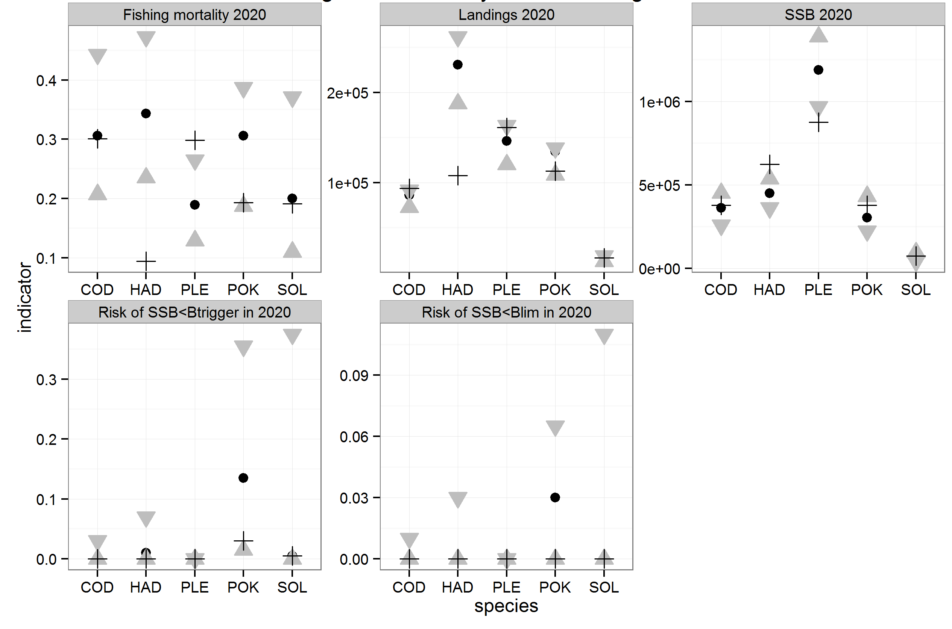
Figure 1. Diagnostics in 2020, single-stock MSE without technical interactions. Median values of fishing mortality, landings and SSB, and risk of falling below MSY B_{trigger} and B_{lim}. Black circle : F_{MSY}. Downward triangle : MSY F_{upper}. Upward triangle : MSY F_{lower}. Cross : current LTMP.

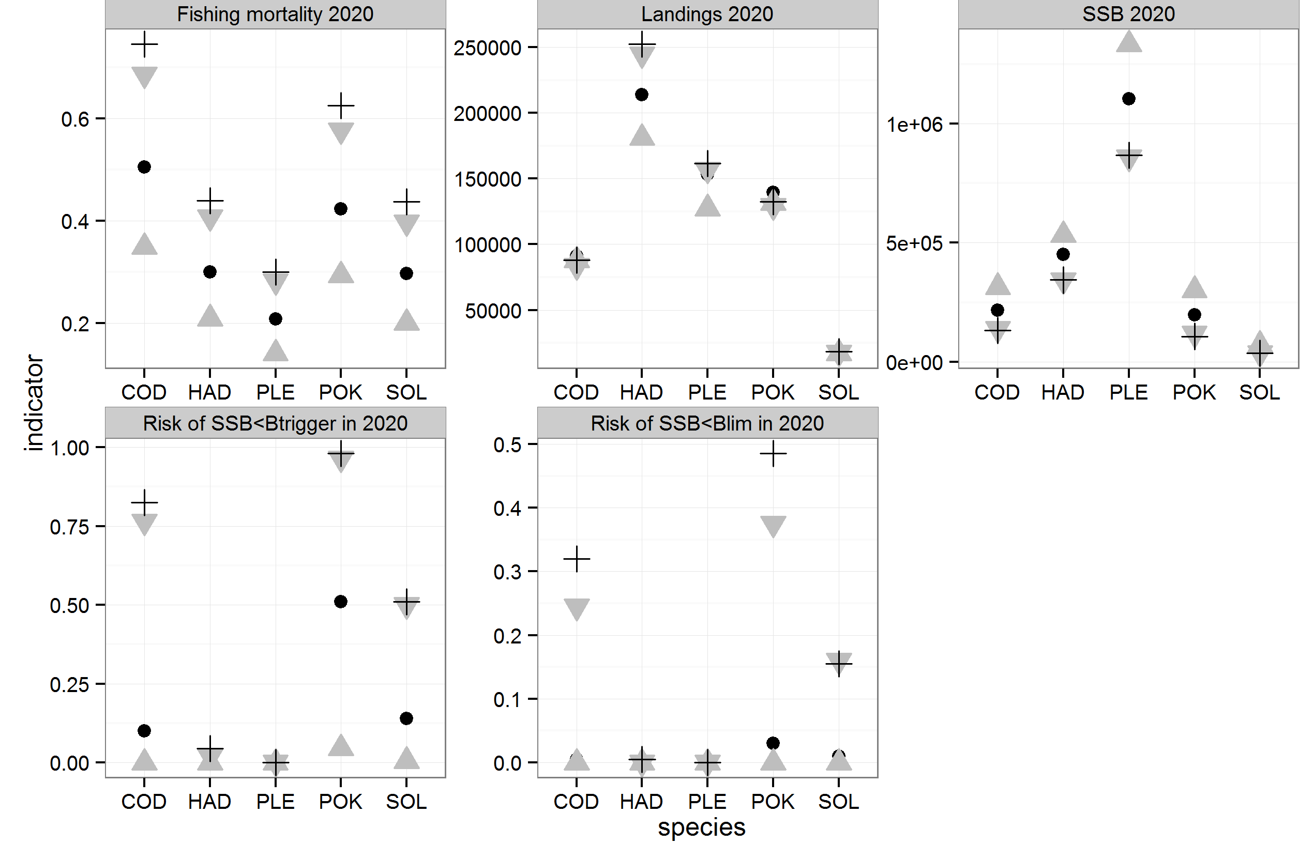
Figure 2. Diagnostics in 2020, single-stock MSE with FCube Max technical interactions assuming an imperfect implementation of the landing obligation and that all quotas are fished out . Black circle : F_{MSY}. Downward triangle : MSY F_{upper}. Upward triangle : MSY F_{lower}. Cross : current LTMP.

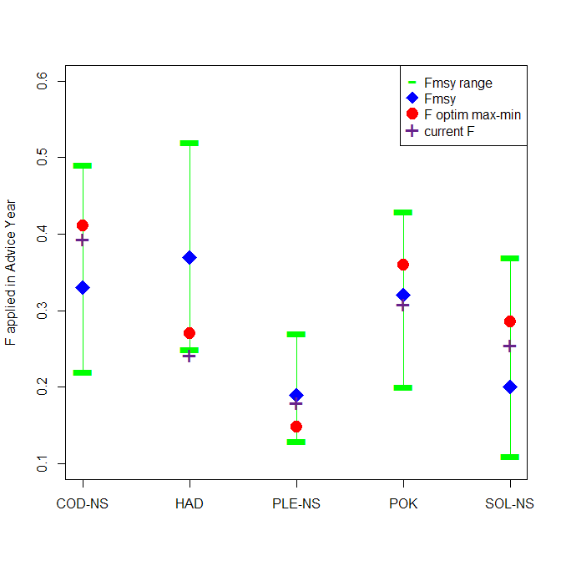
Figure 3. Fishing mortality by stock : F_{MSY}, F_{MSY} ranges, F2014 and outcome of the deterministic ‘Max-Min’ optimisation in 2016.

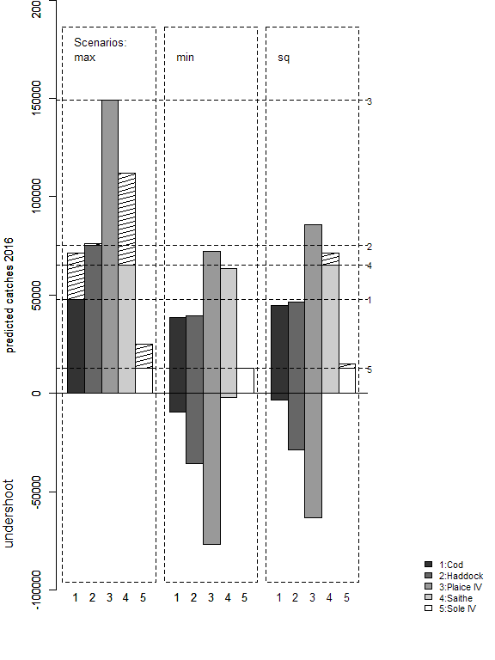 | 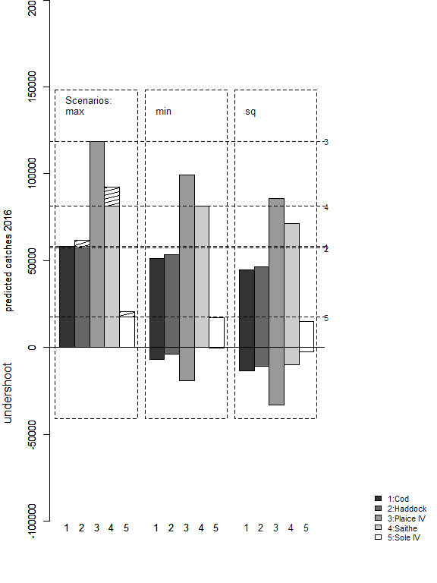
Figure 4. North Sea mixed fisheries projections for 2016, following standard display as in (ICES, 2015c). FCube options Max, Min and Status-Quo effort at 2014 level. Left F_{MSY} target. Right : Foptim target. Estimates of potential catches (in tonnes) by stock and by scenario. Horizontal lines correspond to the single-stock projection with the given target. Bars below the value of zero show undershoot (compared to single-stock) where catches are predicted to be lower when applying the FCube option. Hatched columns represent catches in overshoot of the single-stock projection.

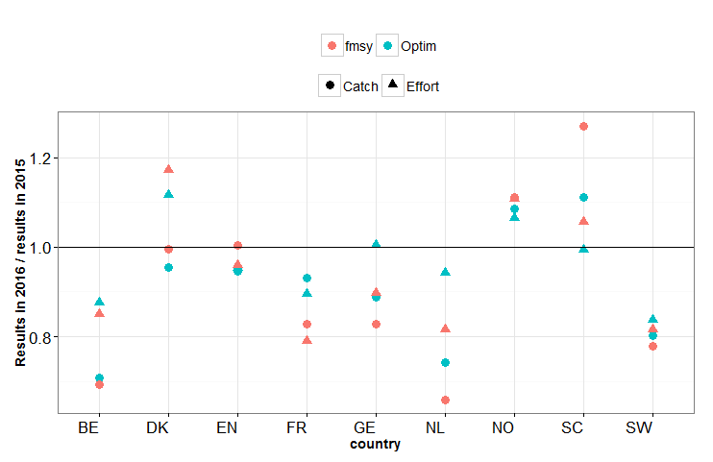
Figure 5. Impact of the alternative target F in 2016 on the potential landings and effort of all fleets by country (Scotland displayed separately from England), compared to the 2015 level, using FCube “Value” scenario

