The sex specific metabolic footprint of Oithona davisae
Jan Heuschele^{1,2*}, Louise Nemming³, Lea Tolstrup³, Thomas Kiørboe¹, Göran M. Nylund⁴ and Erik Selander^{1,4}
1: Centre for Ocean Life, National Institute of Aquatic Resources, Technical University of Denmark, Kavalergården 6, 2920 Charlottenlund, Denmark
2: Department of Biosciences, University of Oslo, PO Box 1066, Blindern, 0316 Oslo, Norway
3: DTU Environment, Miljoevej, Building 113, 2800 Kgs. Lyngby Denmark
4: Department of Marine Sciences, University of Gothenburg, P.O. Box 461, SE-40530 Göteborg, Sweden
*Corresponding author

Abstract
In pelagic copepods, the group representing the highest animal abundances on earth, males and females have distinct morphological and behavioural differences. In several species female pheromones are known to facilitate the mate finding process, and copepod exudates induce changes in physiology and behaviour in several phytoplankton species. Here we tested whether the sexual dimorphism in morphology and behaviour is mirrored in the exudate composition of males and females. We find differences in the exudate composition, with females seemingly producing more compounds. While we were able to remove the sex pheromones from the water by filtration through reverse phase solid phase extraction columns, we were not able to recover the active pheromone from the solid phase.

Introduction
Copepods are small crustaceans that inhabit a wide range of habitats ranging from small waterbodies in plants, to groundwater reservoirs and the open ocean. Although they usually escape the human eye due to their small size and transparency, they may represent the animal class with the largest abundances on Earth (Humes, 1994). Pelagic copepods are a crucial link between primary production and higher trophic levels (Naganuma, 1996). As key component of marine food webs, copepods serve either directly or indirectly as food sources for most commercially important fish species and in recent years their importance as live feed is also increasing in intensive aquaculture (Drillet et al., 2011).
Copepods have a complex lifecycle and typically go through six naupliar and five copepodite stages before becoming sexually mature adults. Once adult, most species show distinct morphological and behavioural differences between males and females (Maly and Maly, 1999; Ohtsuka and Huys, 2001). Females are normally bigger than males and have a different body shape and number of urosome segments. They also have sexually dimorphic antennules, with pelagic males typically having either one or two geniculated antennules that allows them to grasp females by folding the antennule(s) during the mating process (Boxshall and Huys, 1998). In several pelagic species an additional doubling in the number of aesthetascs (chemical sensilla) on the antennules of males occurs during the final moult (Boxshall and Huys, 1998; Ohtsuka and Huys, 2001). These morphological differences are also accompanied by distinct swimming behaviours of the sexes. Adult copepod males mostly engage more in energetically costly mate searching behaviour, while females have a more passive role and concentrate on feeding. In some species males cease foraging completely and spend their short adult life searching for potential mating partners (Yen, 1988). Their mate search efforts are aided in several species by females producing pheromone trails that are followed by the males (i.e. Doall et al. 1998; Bagøien and Kiørboe, 2005). These trails can be relatively long compared to the size of the animals and their three-dimensional shape depends on the female's swimming pattern and the amount of released pheromones. While cruising copepods produce a continuous trail, the trail of an ambush feeding copepod that occasionally repositions itself by jumps will resemble a series of unconnected pheromone patches (Kiørboe, 2008; Heuschele and Selander, 2014).
In the cyclopoid copepod Oithona davisae males search for females following such a patchy pheromone “trail” (Uchima and Murano, 1988). However the presence of even low concentrations of female scent triggers a distinct search pattern that is characterized by faster swimming speeds and a more convoluted swimming path (Heuschele and Kiørboe, 2012) (Figure 1A). In this species females can also distinguish between the scent of mated and virgin females, and adjust their search behaviour accordingly. This ability has also been shown in Diaptomus leptopus (Leeuwen and Maly, 1991). Besides information about species and sex, the scent of copepods thus also contains information about the individual reproductive state (juvenile, virgin, or mated) and probably the age of the partner.
Copepod exudates also trigger phytoplankton cells to initiate countermeasures to avoid predation. These responses include increases in toxin contents (Long et al., 2007; Bergkvist et al., 2008), adjustments of colony size (Bergkvist et al., 2012) and alterations of their swimming behaviour (Selander et al., 2011).
Despite the importance of pheromones and other infochemicals for copepods for all aspects of their life and regarding the related non-consumptive effects on lower trophic levels (Heuschele and Selander, 2014) not much is known about the sex specific differences of copepod exudates, except for one study on Temora longicornis (Selander et al., 2016) One reason for this is that the pheromone amounts necessary to elicit for example the trail following responses are very small and only represent a small fraction of their body weight (Bagøien and Kiørboe, 2005; Heuschele and Selander, 2014), which makes the detection against a complex sea water matrix difficult. While the main and abundant excretion products like ammonium and urea have been studied in copepods (reviewed in Gardner and Paffenhöfer, 1982; Regnault, 1987), those studies did not report on sex specific differences, with the exception of Butler et al. (1969) who found slightly higher rates of nitrogen and phosphorus exudates in females compared to males.
In this project we tested a) whether the ambush feeding cyclopoid Oithona davisae has a sex specific exudate signature similar to the one described in the cruising calanoid Temora longicornis (Selander et al., 2015) and b) if we can extract and capture the female sex pheromone that triggers the search behaviour in male copepods. To detect the differences in the chemical exudate signatures between treatments we used an untargeted metabolomics approach. We modified the experimental approach outlined in Selander et al. (2016) to improve signal to noise ratio in order to enable extractions from the substantially smaller copepods such as Oithona davisae. In addition we isolated copepods from laboratory cultures before they become sexually mature, as virgin females emit more pheromones (Heuschele and Kiørboe, 2012).

Materials and Methods

Model species
As a model species we used Oithona davisae due to its clear sexual dimorphism in morphology and behaviour. It is a Pacific species and member of one of the most numerous copepod genera on the planet (Fransz and Gonzalez, 1995; Gallienne and Robins, 2001). It is relatively small copepod, where males are significantly smaller than females. Virgin females trigger strong search reactions in males (Heuschele and Kiørboe, 2012), and compared to bigger species like Temora longicornis and Calanus finmarchicus it is feasible to incubate them separately in high numbers to ensure the virginity of the tested animals (Ceballos and Kiørboe, 2011). This may be important as some species do not emit pheromones when they have been mated (Heuschele and Kiørboe, 2012), which may compromise the efforts to sample pheromones (Selander et al., 2016).
We isolated individual copepodites of O. davisae from laboratory stock cultures that were kept at 20°C at a salinity of 32 PSU. We separated individual C3-C5 copepodites into single wells of 24 well culture plates (Sarstedt 83.1836) filled with seawater supplemented with the prey species Oxhyrris marina. We replaced 1 ml of the food suspension every other day and determined copepods that had reached maturity. Virgin adult females and males from the well plates, as well as males from the stock culture were transferred into separate holding bottles, where they were kept until use in the extraction or bioassays.

Exudate extraction
The following protocol is based on the exudate extraction procedure described for Temora longicornis in Selander et al. (2016). We washed all glassware with methanol prior to usage to reduce the chemical background from other sources. To obtain a low and constant background of dissolved organic compounds in the incubation water we prepared a 2 litre batch of purified sea water (pSW) that was subsequently used in all incubations. The water (32 psu) was suction filtered through a GF/F filter (Whatman) to remove particles and pumped (~7 ml min-1) through two serial isolute ENV+ (Biotage) 200 mg solid phase extraction (SPE) columns, one on the inlet and one on the outlet of a piece of tubing connected to a peristaltic pump. The ENV+ resin consists of a polystyrene resin functionalized with phenolic groups. The SPE purification reduced the background of retainable dissolved organic compounds (DOC) and increase the signal to noise ratio in the samples from copepod incubations substantially (Selander et al., 2016). SPE columns were activated with 3 ml Methanol followed by 5 ml distilled water prior to use.
Matured animals were transferred to a centrifuge tube with an 80 µm mesh bottom submerged in a glass beaker with pSW and left to empty their guts for a period of 30-45 minutes. Afterwards we dipped the tubes sequentially in two more beakers with pSW to eliminate carry-over of culture water, feed algae, or faecal pellets. The number of animals per replicate varied between 106 and 189 (see Table 1) depending on the availability of recently matured adults. Given that the sex-specific sorting of individual copepods was a bottleneck in our study, we had 3 separate extraction efforts. In each of these, we extracted exudates from two replicates for each treatment (see Table 1). One male replicate did for unknown reasons not show any exudate structures during the LCMS and was therefore excluded from the analysis.

The exudates were stripped from the water using a recirculate system, where water was drawn into an ENV+ (Biotage 100 mg) solid phase extraction (SPE) column. The matured and rinsed females and males were placed in purified filtered seawater inside the reservoir of the SPE column (figure 1). The animals remained in the compartment of the SPE column just below the filter material. Each incubation ran for 12-13 hours at a pump speed of 0.8 ml min⁻¹ (Table 1). Control replicates (following the same procedure but without animals) to measure the components of pure seawater and potential bacterial activity were run simultaneously.
After the incubation the animals were removed, checked for survival and counted. We then desalted the columns with 1 ml MilliQ and the compounds that were retained on the column resin were eluted with 2 ml methanol into glass scintillation vials. 600 µl of the eluate were transferred to another vial for later use in bioassay experiments. The remaining 1400 µl were used for the mass spectrometry. The samples were stored at -80°C until analysis or bioassay (13-20 days).

Mass spectrometry analysis

Mass spectrometry
We analysed our exudate samples using an Agilent 1100 HPLC with Q-ToF 6540 MS as detector equipped with a 150 mm long C18 column (Licrosphere 2.1 *150 mm, 3 µm C18 silica column (Poroshell, Agilent)). The eluent gradient started at 2% acetonitrile and 0.1% formic acid in water (eluent A) that was maintained for one minute followed by a linear gradient up to 100% acetonitrile over 14 minutes. 100% AcN was maintained for 5 min before the following injection. The injection volume was 4 µl and the eluent flow rate 250 µl min⁻¹. Positive and negative mass spectra were acquired at a scan rate of 1.3 spectra s⁻¹ within a scan range of 80 to 1100 m/z. ESI conditions were gas temperature 300°C, drying gas 8 l min⁻¹, nebulizer 35 psig, sheath gas temperature 350°C, sheath gas flow 11 L min⁻¹, nozzle voltage 1000 V, fragmentor 176 V, and skimmer 65 V.

Exudate analysis
We analysed the raw data obtained from the mass spectrometer using the XCMS R package for the analysis of metabolomic data (Tautenhahn et al., 2012). The settings for the peak finding procedure for the positive ion mode were optimized using a dilution series of a mixed exudate sample as outlined in (Eliasson et al., 2012).
Peak lists were generated and aligned using the following XCMS settings: polarity = "positive" (or “negative” in negative ion mode), full width at half maximum of matched filtration (Gaussian model peak = 30), signal to noise ratio cutoff = 20, maximum number of peaks per extracted ion chromatogram = 10, step size to use for profile generation= 0.1, number of steps to merge prior to filtration = 2, minimum difference in m/z for peaks with overlapping retention times = 0.01).
We compared female and control samples, as well as male and control samples to look for features that were upregulated in copepods. Features that were statistically significant (p < 0.05, Welch t-test) and without peak in the control samples were considered to be of copepod origin. We then compared feature lists and those that were detected in both males and females were considered to be common exudates in males and females.

Bioassays
We tested in three different tests whether (i) water conditioned with virgin Oithona davisae females did elicit the mate searching behaviour in males, (ii) the pheromones could be retained on a solid phase column, and (iii) the active pheromone(s) could be recovered from the SPE columns.
In all three cases we tested the bioactivity of the samples by quantifying the swimming behaviour of O. davisae males in a scintillation vial (25 ml) filled with 10 ml filtered seawater and with the respective treatment added. This was done in an infrared illuminated filming setup to avoid phototactic behaviour in response to visible light (Fig 2).
(i) To validate the bioassay we tested untreated water in which virgin females had been incubated. These females were individually incubated in 3 ml vials for 48 hours. On one occasion we also tested the water from the closed loop setup with the filtering pump shut down and containing virgin females (Table A1). Each scintillation vial with 10 males received 1.3 ml stimuli water by glass pipette before filming.
(ii) To evaluate if the active copepod exudates were retained on the SPE column we tested the SPE purified female conditioned water (incubation water) for pheromone activity at the end of an incubation period. As in procedure (i) 1.3 ml of that water was transferred to a scintillation vial with 15 males. This was done for 2 overnight incubations (Table A1)
(iii) To test if pheromones could be recovered from SPE columns, we dried down the frozen 600 µl methanoleluates under a stream of nitrogen. The dry sample was resolved in 10 ml of filtered pasteurized seawater, vortexed, and 10s sonication in an ultrasonic bath. These samples were then tested for bioactivity within 30 minutes. In this bioassay the vial with the scent was placed in the setup shortly after sonication and 15 male copepods were added with a small (<0.5 ml) volume of filtered seawater. Here we conducted 3 over-night incubations and 3 corresponding days bio-assaying the extracted exudates (Table 1). The order of the treatments during the bioassays was randomized.
In all bioassays we analysed a 2-minute video sequence starting 40 seconds after the addition of the stimuli (i and ii) or in case of (iii) the addition of the males. This delay was necessary to allow the copepods to acclimatize to the novel conditions and the influence of initial water movement.

Video analysis
We visually screened all 2-minute movie sequences for the aforementioned typical spiralling behaviour of males in the presence of female scent (Figure A1), which is a key component of their normal reaction to female pheromones (Heuschele and Kiørboe, 2012). In addition we measured the general activity level of the copepods by comparing the track signatures between the treatments. This was done by first converting the movie frames to a grey-scaled image stack using ImageJ (Abràmoff, 2004). We then calculated the difference of the average and the maximal pixel value integrating all images in the stacks. The resulting picture was then thresholded to obtain a binary image that showed clear tracks in black on a white background. Of this we measured the mean grey value, with high values indicating more tracks and activity. We also checked again whether the spiralling behaviour is visible on the image stacks. It is a visually striking behaviour and if present clearly visible on the integrated stacks (Figure A1). Thus, images were analysed activity level and for presence/absence of spiralling behaviour, and not for more subtle changes in swimming speeds or direction.
Differences in activity level were tested using a linear mixed model with treatment as fixed factor, grey value as dependent, and day of incubation as random factor. To test the difference between the filtered incubation water between the treatments (male, female, control) we used a Kruskal-Wallis test due to the non-normal distribution of the data. We also used a Kruskal-Wallis test to test for the general difference between the copepod reaction to exudates and SPE filtered incubation water with the mean gray level of the bioassay as dependent variable and cue source (exudates; filtered incubation water) as independent factor.

Results

Main extraction

Differences in the metabolic footprint
In positive ion mode 6 features were significantly different in the female samples compared to the controls, however 2 of those belonged to the same monoisotopic peak. In the male samples only 2 features were statistically more common compared to the controls. Both of these were also detected in female exudates. One of the significant features in the female samples also had higher mean intensity (>3 fold change) in male samples, although the difference was not statistically different. This feature was therefore considered as a sex unspecific feature. In summary this leaves 2 features that we considered to be of predominantly female origin (Figure 2, Table 2).
In negative ion mode 11 features were significantly more common in females and 5 in males, all of which were also detected in the female samples. Three of the features found significantly more common in females had also a high fold change in males compared to controls (> 6), and therefore they were attributed to be sex unspecific features, although the features were not found significantly different between male and control samples. Table 2 lists the masses and retention times of these features, as well as their average fold change between female and male samples.

Bioassay
Unfiltered water conditioned with virgin females always induced an increase in the male swimming activity (bioassay (i)), which also always included the characteristic mate finding spiralling behaviour (Figure 3 and A1, see also Table A1 for an overview over the bioassay tests).
The SPE filtered incubation water from the loop did not elicit any differences in the general activity of the males between the treatments (Kruskal-Wallis chi-squared = 4.2, df = 2, p-value = 0.12), nor could we detect any spiralling behaviour (Bioassay (ii)). Therefore we concluded that the active pheromone compounds are retained on the SPE column.
We could also not detect any change in the general activity levels or the occurrence of spiralling behaviour of the males exposed to the re-eluted extracts from the closed loop extraction with respect to the 3 treatments (Bioassay (iii), virgin females, mated females, and males, F_{2,12} = 3.20, P = 0.077, see Figure 3). We therefore conclude that the active compounds of female pheromones were either irreversibly bound to the column, degraded in the process, or evaporate during drying.
The detected activity levels while testing the re-eluted SPE extracts were however higher compared to the filtered incubation water independent of the specific treatment (Kruskal-Wallis chi-squared = 6.56, df = 1, p-value = 0.01, Figure 3). This suggests that the males detected and reacted to the re-eluted extracts.

Discussion
Our experiment revealed a difference in the metabolomic profile of male and females, mirroring the known sexual dimorphism observed in morphology and behaviour (Gilbert and Williamson, 1983; Maly and Maly, 1999; Ohtsuka and Huys, 2001). Females seem to produce more unique features and larger amounts of the common exudates as more of the exuded compounds were detectable against the water matrix compared to males. All the male features we could pick up using the solid phase extraction column were also present in the female samples. This may to some extent be related to the slightly bigger body size and metabolic activity of the females (Gilbert and Williamson, 1983) but may also be due to the release of female sex pheromones. A similar pattern, with females producing more and a greater variety of compounds, was also seen in Temora longicornis where 2 exclusive female signals and 7 of higher abundance were found compared to only 1 more abundant male signal out of in total 87 compounds of copepod origin (Selander et al., 2016). The higher number of compounds detected from Temora longicornis is probably due to the larger size of these copepods resulting in higher concentration of exudates and more compounds reaching the detection limit of the mass spectrometer.
That exudates from female and male copepods must contain species and sex specific information was already known from the observed changes in swimming behaviour in reaction to the scent of the opposite sex (Lonsdale et al.,1998). Here, we show that using solid phase extraction we are able to retain these differences and determine the molecular mass of the features. The eluate from the SPE columns did however not elicit the characteristic mate searching behaviour (spiralling behaviour) in Oithona, indicating that more or other compounds are needed to elicit the response. For this reason we did not pursue the molecular structure of the compounds.
The lack of activity of the SPE filtered water of the incubation shows that either all or essential parts of the sex pheromone signature are retained in the solid phase extraction column. Bioassays with unfiltered water directly coming from incubated females always elicited elevated activity and a spiralling behaviour in the males. We can exclude the possibility that the plastics of the SPE columns and of the tubing of the circular incubation system absorbed the compounds as testing unfiltered water from the closed loop also elicited a response in males (see Table A1). The lack of activity in the SPE eluate suggest that the compounds were either irreversibly bound to the SPE resin, degraded in the process, or were volatile enough to evaporate while drying down the samples. In several insect species pheromones often elicit a full response only if several components are present at a specific ratio (e.g. Roelofs, 1995; Tóth et al., 2008; Symonds and Elgar, 2008). Assuming a similar principle in copepods it is possible that we might have captured only parts of the pheromone mix. We used a highly retentive extraction column that captures more polar compounds than traditional silica based reversed phase resins. However, future studies aiming to detect the copepod sex pheromone structures should aim for an even broader extraction method by using a more comprehensive combination of solid phase extraction columns that capture also the extreme polar and fatty compounds as well as large molecules and volatiles.
Knowledge about exudates and infochemicals in plankton is essential to understand the intra- and interspecific interactions in the ocean. Female pheromones guide the males in many pelagic copepod species and are therefore an important component of reproduction and thus population dynamics. Also, several defence mechanisms in phytoplankton prey, such as toxin production and behavioural adjustments, are induced by chemical cues released by copepods (Bergkvist et al., 2008; Selander et al., 2011). The important role of copepods in the aquatic food web and the role of chemical mediated behaviours in copepods (Heuschele and Selander, 2014) extents the topic beyond purely academic interests. Knowledge about sex pheromones could also be used to increase the yield of live feed in intensive copepod culture and to reduce the infestation of salmon and other fish farms with parasitic copepods, e.g. the salmon lice Lepeophtheirus salmonis and Caligus spp. (Costello, 2006 2009). The presented methods of exudate extraction and uncomplicated visual bioassay are an important step to help to uncover the mechanism and compounds of infochemicals in the sea.

Acknowledgments
J. Melbye for maintenance of the copepod cultures. R. Gonçalves for help with the high-speed camera. This work was supported by the Danish National Strategic Research Council - IMPAQ - grant no. 10-093522, and FORMAS grant no 223-2012-693 to ES. GMN was supported by a Linnaeus-grant from the Swedish Research Councils FORMAS and VR, and Olle Engkvist Byggmästare Foundation.

References
Abràmoff, M., 2004. Image processing with ImageJ. Biophotonics Int .11,36–40.
Bagøien, E., Kiørboe, T., 2005. Blind dating —mate finding in planktonic copepods. I. Tracking the pheromone trail of Centropages typicus. Mar. Ecol. Prog. Ser. 300, 105–115. doi: 10.3354/meps300105
Bergkvist, J., Selander, E., Pavia, H., 2008. Induction of toxin production in dinoflagellates: the grazer makes a difference. Oecologia 156, 147–54. doi: 10.1007/s00442-008-0981-6
Bergkvist, J., Thor, P., Jakobsen, H., Selander, E., 2012. Grazer-induced chain length plasticity reduces grazing risk in a marine diatom. Limnol. Oceanogr. 57, 318–324. doi: 10.4319/lo.2012.57.1.0318
Boxshall, G.A., Huys, R., 1998. The ontogeny and phylogeny of copepod antennules. Philos. Trans. R. Soc. B Biol. Sci. 353, 765–786. doi: 10.1098/rstb.1998.0242
Butler, E.I., Corner, E.D.S., Marshall, S.M., 1969. On the nutrition and metabolism of zooplankton VI. Feeding efficiency of Calanus in terms of nitrogen and phosphorus. J. Mar. Biol. Assoc. United Kingdom 49, 977–1001. doi: 10.1017/S0025315400038054
Costello, M.J., 2006. Ecology of sea lice parasitic on farmed and wild fish. Trends Parasitol. 22, 475–83. doi: 10.1016/j.pt.2006.08.006
Costello, M.J., 2009. The global economic cost of sea lice to the salmonid farming industry. J. Fish Dis. 32, 115–8. doi: 10.1111/j.1365-2761.2008.01011.x
Doall, M.H., Colin, S.P., Strickler, J.R., Yen, J., 1998. Locating a mate in 3D: the case of Temora longicornis. Philos. Trans. R. Soc. B Biol. Sci. 353, 681–689. doi: 10.1098/rstb.1998.0234
Drillet, G., Frouël, S., Sichlau, M.H., Jepsen, P.M., Højgaard, J.K., Joarder, A.K., Hansen, B.W., 2011. Status and recommendations on marine copepod cultivation for use as live feed. Aquaculture 315, 155–166. doi: 10.1016/j.aquaculture.2011.02.027
Eliasson, M., Rännar, S., Madsen, R., Donten, M.A., Marsden-Edwards, E., Moritz, T., Shockcor, J.P., Johansson, E., Trygg, J., 2012. Strategy for optimizing LC-MS data processing in Metabolomics: A design of experiments approach. Anal. Chem. 84, 6869–6876.
Fransz, H., Gonzalez, S., 1995. The production of Oithona similis (Copepoda: Cyclopoida) in the Southern Ocean. ICES J. Mar. Sci. 52, 549–555.
Gallienne, C., Robins, D., 2001. Is Oithona the most important copepod in the world’s oceans? J. Plankton Res. 23, 1421–1432.
Gardner, W., Paffenhöfer, G. 1982. Nitrogen regeneration by the subtropical marine copepod Eucalanus pileatus. J. Plankton Res. 4, 725–734.
Gilbert, J., Williamson, C., 1983. Sexual dimorphism in zooplankton (Copepoda, Cladocera, and Rotifera). Annu. Rev. Ecol. Syst. 14, 1–33.
Heuschele, J., Kiørboe, T., 2012. The smell of virgins: mating status of females affects male swimming behaviour in Oithona davisae. J. Plankton Res. 34, 929–935. doi: 10.1093/plankt/fbs054
Heuschele, J., Selander, E., 2014. The chemical ecology of copepods. J. Plankton Res. 36, 895–913. doi: 10.1093/plankt/fbu025
Humes, A.G., 1994. How many copepods ? Hydrobiologia 292/293, 1–7.
Kiørboe, T., 2008. A mechanistic approach to plankton ecology. Princeton University Press
Leeuwen, A.H.C. Van, Maly, E.J., 1991. Changes in Swimming Behavior of Male Diaptomus leptopus (Copepoda : Calanoida) in Response to Gravid Females. Limnol. Oceanogr. 36, 1188–1195.
Long, J.D., Smalley, G.W., Barsby, T., Anderson, J.T., Hay, M.E., 2007. Chemical cues induce consumer-specific defenses in a bloom-forming marine phytoplankton. Proc. Natl. Acad. Sci. U S A 104, 10512–7. doi: 10.1073/pnas.0611600104
Lonsdale, D.J., Frey, M.A., Snell, T.W., 1998. The role of chemical signals in copepod reproduction. J. Mar. Syst. 15, 1–12. doi: 10.1016/S0924-7963(97)00044-4
Maly, E., Maly, M. 1999. Body size and sexual size dimorphism in calanoid copepods. Hydrobiologia 391, 173–179.
Naganuma, T., 1996. Calanoid copepods: linking lower-higher trophic levels by linking lower-higher Reynolds numbers. Mar. Ecol. Prog. Ser. 136, 311–313.
Ohtsuka, S., Huys, R. 2001. Sexual dimorphism in calanoid copepods: morphology and function. Hydrobiologia 453/454, 441–466.
Regnault, M., 1987. Nitrogen excretion in marine and fresh‐water crustacea. Biol. Rev. 62, 1–24.
Roelofs, W.L., 1995. The chemistry of sex attraction. Proc. Natl. Acad. Sci. U S A 92, 44–49.
Selander, E., Heuschele, J., Nylund, G.M., Pohnert, G., Pavia, H., Bjærke, O., Pender-Healy, L., Tiselius, P., Kiørboe, T., 2016. Solid phase extraction and metabolic profiling of exudates from living copepods. PeerJ 4:e1529 https://doi.org/10.7717/peerj.1529
Selander, E., Jakobsen, H.H., Lombard, F., Kiørboe, T., 2011. Grazer cues induce stealth behavior in marine dinoflagellates. Proc. Natl. Acad. Sci. U S A 108, 4030–4. doi: 10.1073/pnas.1011870108
Symonds, M.R.E., Elgar, M.A., 2008. The evolution of pheromone diversity. Trends Ecol. Evol. 23, 220–8. doi: 10.1016/j.tree.2007.11.009
Tautenhahn, R., Patti, G.J., Rinehart, D., Siuzdak, G., 2012. XCMS Online: a web-based platform to process untargeted metabolomic data. Anal. Chem. 84, 5035–9. doi: 10.1021/ac300698c
Tóth, M., Furlan, L., Xavier, A., Vuts, J., Toshova, T., Subchev, M., Szarukán, I., Yatsynin, V., 2008. New sex attractant composition for the click beetle Agriotes proximus: similarity to the pheromone of Agriotes lineatus. J. Chem. Ecol. 34, 107–111. doi: 10.1007/s10886-007-9398-7
Uchima, M., Murano, M., 1988. Mating behavior of the marine copepod Oithona davisae. Mar. Biol. 45, 39–45.
Yen, J., 1988. Directionality and swimming speeds in predator-prey and male-female interactions of Euchaeta rimana, a subtropical marine copepod. Bull. Mar. Sci. 43, 395–403.

Tables
Table 1: Overview over the incubation duration, number of animals, and number of dead animals used in the pheromone extraction experiments.
Incubation date | Treatment | Replicate | Incubation duration (h)  [hours] | No of animals | Dead animals
12-09-2013 | Female | 1 | 13 | 126 | 4
 | Female | 2 | 13 | 157 | 4
 | Male | 1 | 13 | 140 | 8
 | Male | 2 | 13 | 165 | 20
 | Control | 1 | 13 | --- | ---
 | Control | 2 | 13 | --- | ---
16-09-2013 | Female | 1 | 12.5 | 106 | 0
 | Female | 2 | 12.5 | 189 | 13
 | Male | 1 | 12.5 | 122 | 10
 | Control | 1 | 12.5 | --- | ---
 | Control | 2 | 12.5 | --- | ---
19-09-2013 | Female | 1 | 13 | 147 | 9
 | Female | 2 | 13 | 167 | 7
 | Male | 1 | 13 | 131 | 9
 | Male | 2 | 13 | 121 | 6
 | Control | 1 | 13 | --- | ---
 | Control | 2 | 13 | --- | ---

Table 2: List of significant features of exudate samples from female and male Oithona davisae each compared to controls. m/z is the mass charge ratio measured in the mass spectrometer. The statistical analysis is based on the Welch t-test for unequal variances. *These peaks were only statistically significant in females, but still had a high fold change (> 3) in males compared to the controls and therefore considered gender unspecific features. Superscript in the peak id marks the same peak groups based on isotope and adduct analysis using CAMERA.
peakID | female to male fold change | t-statistics | p-value | mz value | retention time (min)
Positive ion mode
Female signal
M277T699 | 1.71 | -3.05 | 0.024 | 277.180 | 11.65
M407T1030 | 1.65 | -3.50 | 0.013 | 407.238 | 17.17
Common signal
M144T69* | 1.77 | -3.74 | 0.013 | 144.104 | 1.15
M454T834 | 1.23 | -3.74 | 0.020 | 454.292 | 13.90
M480T858 | 1.07 | -3.10 | 0.035 | 480.302 | 14.29
Negative ion mode
Female signal
M196T536 | 1.92 | -2.71 | 0.026 | 196.004 | 8.93
M419T701 | 1.41 | -3.04 | 0.021 | 419.040 | 11.69
M611T701 | 2.17 | -2.91 | 0.030 | 611.330 | 11.69
Common signal
M228T350 | 1.54 | -4.83 | 0.008 | 228.011 | 5.83
M294T490 | 1.85 | -4.76 | 0.009 | 294.059 | 8.16
M450T764 | 1.14 | -3.68 | 0.021 | 450.242 | 12.74
M450T590* | 1.03 | -3.64 | 0.015 | 450.270 | 9.84
M452T839 | 1.29 | -3.58 | 0.023 | 452.259 | 13.99
M478T861 | 1.01 | -3.46 | 0.026 | 478.277 | 14.35
M481T794* | 1.09 | -3.38 | 0.019 | 481.238 | 13.23
M509T931* | 0.96 | -3.32 | 0.021 | 509.272 | 15.52

Figures
Figure 1: a) Experimental setup of the extraction procedure. The copepods are placed inside the compartment of the SPE column (ENV+), and a circular current is provided by the peristaltic pump at low speeds. b) Illustration of the bioassay setup (dimensions not in scale) used to record the swimming behaviour of males in a scintillation vial containing female exudates. The vial is placed in a small water-filled transparent aquarium to compensate the optical distortion of the rounded vial. Infrared illumination is provided from below to give dark field illumination, and the copepods are filmed using an infrared sensitive camera (SONY DCR-TRV738E).
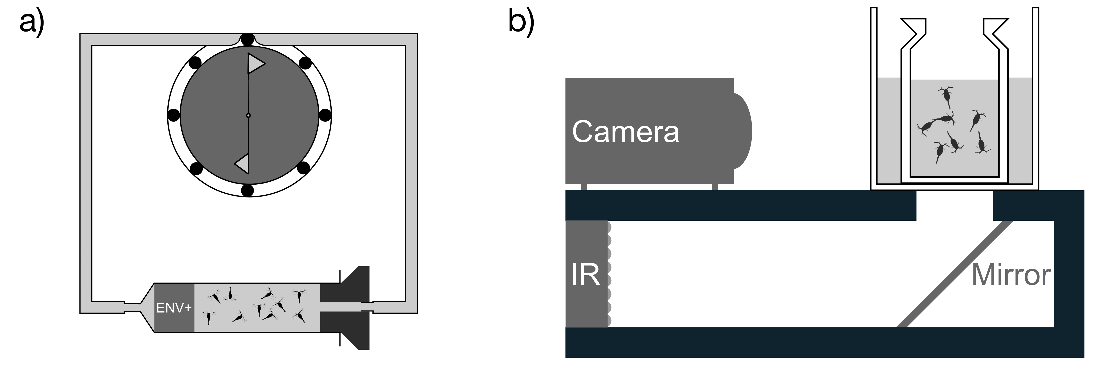

Figure 2. Venn diagram showing the differences and accordance in the exudate composition of the features that were significantly different from the controls. Black numbers are from positive ion mode, while white numbers indicate negative ion mode.

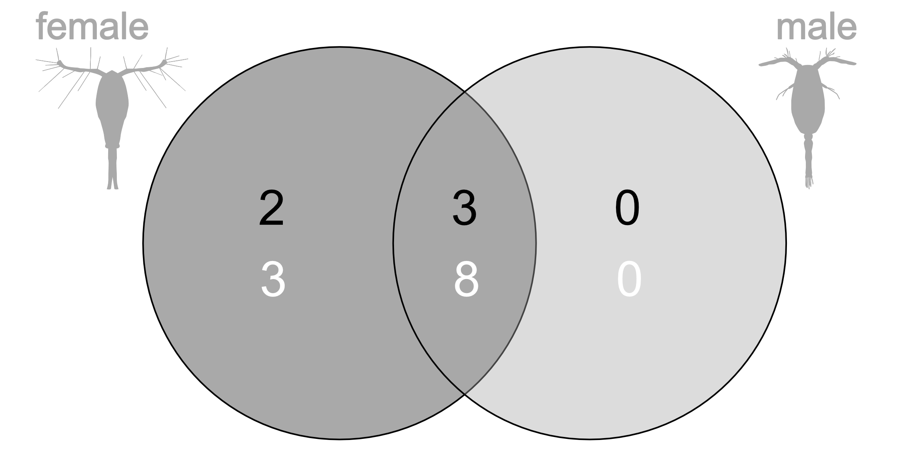

Figure 3: The mean and standard error of the activity level of male copepods when exposed to female, male and control water sample compounds, as well as when exposed to filtered incubation water (i.e. water that passed through the SPE column), and fresh female scent. Higher values correspond to darker images, hence more tracks covering the image area.
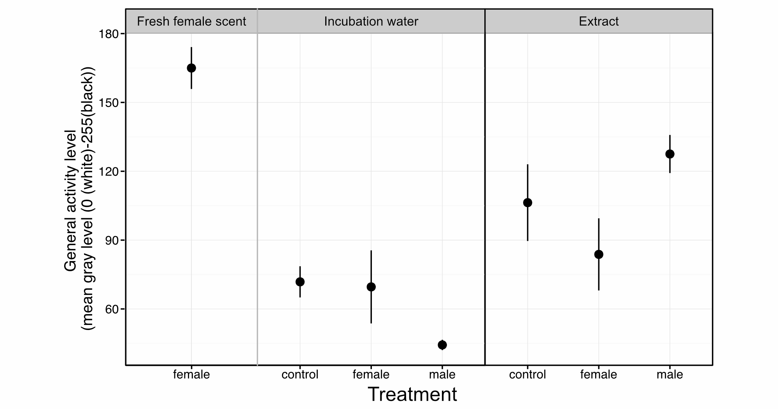

Electronic appendix
Table A1 Overview over the bioassay testing experiments (NA = not applicable) . Incubation water is water that was tested after passing through the SPE columns. Virgin scent is water that was extracted from females incubated individually in wells, incubation time (h) refers to the duration the virgin females where placed inside the compartment of the SPE column (ENV+), number of animals represents the number of females during the incubation, dead animals is the number of dead individuals at the end of the incubation.
Incubation date | SPE column type | Experiment | Treatment | Spiralling behaviour | Replicate | Incubation time (h) | Number of animals | Dead animals
3/3/2014 | ENV+ | Incubation Water | Control | no | 1 | 18 | 0 | 0
 | ENV+ | Incubation Water | Female | no | 1 | 18 | 38 | 0
 | ENV+ | Incubation Water | Female | no | 2 | 18 | 67 | 3
 | ENV+ | Incubation Water | Female | no | 3 | 18 | 115 | 0
 | ENV+ | Incubation Water | Male | no | 1 | 18 | 120 | 21
 | NA | Virgin Scent | Female | yes | 1 | NA | 3 | 0
 | NA | Virgin Scent | Female | yes | 2 | NA | 3 | 0
3/24/2014 | ENV+ | Incubation Water | Control | no | 1 | 16 | 0 | 0
 | ENV+ | Incubation Water | Female | no | 1 | 16 | 123 | 7
 | ENV+ | Incubation Water | Males | no | 1 | 16 | 29 | 0
 | ENV+ | Incubation Water | Female | no | 2 | 16 | 60 | 3
 | ENV+ | Incubation Water | Control | no | 2 | 16 | 0 | 0
 | NA | Virgin Scent | Female | yes | 1 | NA | 1 | 0
 | NA | Virgin Scent | Female | yes | 2 | NA | 1 | 0
2/26/2014 | NA | Incubation water unfiltered (pump off) | Females | yes | 1 | 18 | >140 | NA

Figure 1A. (A) Picture showing superimposed male tracks (30 sec duration) using virgin scent filmed in a scintillation vial. It clearly shows the spiralling behaviour of the males. (B) Close-up of the spiralling behaviour of one male filmed using a high-speed camera at 2000 frames per second. Sequential images are superimposed.
