Swim and fly. Escape strategy in neustonic and planktonic copepods
Leonid Svetlichny^{1,*}, Poul S. Larsen² and Thomas Kiørboe ³
¹Schmalhausen Institute of Zoology, National Academy of Sciences of Ukraine, Str. B. Khmelnytskogo, 15,Kyiv 01601, Ukraine
²DTU Mechanical Engineering, Fluid Mechanics, Technical University of Denmark, Building 403, Kgs. Lyngby, DK-2800, Denmark
³Centre for Ocean Life, Danish Technical University, DTU Aqua, Building 202, Kgs Lyngby, DK-2800 Denmark.

*Author for correspondence (leonid.svetlichny@gmail.com) Final version, Nov.22 2017

ABSTRACT
Copepods may respond to predators by powerful escape jumps that in some surface dwelling forms may propel the copepod out of the water. We studied the kinematics and energetics of submerged and out-of-water jumps of two neustonic pontellid Anomalocera patersoni and Pontella mediterranea and one pelagic calanoid copepod Calanus helgolandicus (euxinus). We show that jumping out of the water does not happen just by inertia gained during the copepod’s acceleration underwater, but also requires the force generated by the thoracic limbs when breaking through the water's surface to overcome surface tension, drag, and gravity. Such timing appears necessary for success. At the moment of breaking the water interface the instantaneous velocity of the two pontellids reaches 125 cm s⁻¹, while their maximum underwater speed (115 cm s⁻¹) is close to that of similarly sized C. helgolandicus (106 cm s⁻¹). The average specific powers produced by the two pontellids during out-of-water jumps (1700-3300 W kg⁻¹ muscle mass) is close to that during submerged jumps (900-1600 kg⁻¹ muscle mass) and, in turn, similar to that produced during submerged jumps of C. helgolandicus (1300 W kg⁻¹ muscle mass).The pontellids may shake off water adhering to their body by repeated strokes of the limbs during flight, which imparts them a slight acceleration in the air. Our observations suggest that out-of-water jumps of pontellids are not dependent on any exceptional ability to perform this behavior but have the same energetic cost and are based on the same kinematic patterns and contractive capabilities of muscles as those of copepods swimming submerged.

KEY WORDS: Copepoda, escape velocity, acceleration, muscle power, out-of-water

INTRODUCTION

Powerful escape jumps of planktonic copepods is a typical reaction to the threat of a predator (Fields and Yen, 1997), and the accelerations and speeds achieved are impressive: speeds exceeding 500 body lengths s⁻¹ may be achieved within a few milliseconds (Buskey et al. 2002). These high speeds are accomplished by the sequential beating of the 4 or 5 pairs of thoracic swimming legs in metachronal waves, which produces an exceptionally high force during the power stroke, and mass-specific forces are much higher than the highest reported for other organisms (Kiørboe et al. 2010). The ability of copepods to perceive their predators at distance and escape at these exceptional speeds have been cited as a key to the evolutionary success of copepods (Kiørboe 2013), arguably the most abundant metazoans in the ocean (Humes 1994).
While escape jumps typically occur beneath the surface of the ocean, some surface-dwelling (neustonic) copepods may in fact jump out of the water during escapes. Such aerial jumps were first observed by Ostroumoff (1894) and Lowndes (1935) and described in some detail by Zaitsev (1971), who reported jumps reaching heights of 15 cm and lengths of 15-20 cm in 3-mm sized Pontella mediterranea. Out of water jumps have the advantage over submerged jumps that they may allow much longer escape distances and bring the copepod beyond the visual range of an attacking fish (Gemmell et al. 2012). However, to become airborne, the copepod has to overcome drag and surface tension, which requires a relatively much larger power than necessary for larger organisms jumping out of the water, such as flying fish. Using high speed video recordings at 250-500 fps, Gemmell et al. (2012) reported detailed data on the kinematics of such jumps by the neustonic pontellid copepods Anomalocera ornata and Labidocera aestiva and provided an analysis of their energetics. Gemmell et al. (2012) arrived at the fundamentally important conclusions that pontellids jump out of the water and overcome the surface tension due to the kinetic energy gained when accelerating below the water surface and that the underwater velocity (and therefore energy expenditure) of pontellid copepods is higher than the maximum velocities reported for other similarly sized copepods. They also suggested that “pontellids may have special adaptations to make it easier for them to jump out of the water”, such as a body surface “that is less wettable than other copepods” and possibility that “the copepods inject chemicals during breaking of the surface” to reduce the surface tension.
Planktonic Calanoid copepods that live well beneath the surface of the ocean are, however, also able to jump out of the water in artificial laboratory situations, e.g., when placed in a drop of water on the microscope slide, as noted by Lowndes (1935) and observed multiple times by us, suggesting that no special adaptations are required to perform this behavior. Here, we hypothesize that out-of-water jumps of neustonic copepods are made thanks to the same mechanism and the same muscular efforts and energy possessed by similarly sized planktonic copepods jumping submerged in the water. We use high-speed video filming for a comparative analysis of the kinematics and energetics of escape jumps in two neustonic copepods, Pontella mediterranea and Anomalocera patersoni, jumping both under water and out of the water, as well as the kinematics of the submerged avoidance response in a pelagic copepod Calanus helgolandicus (euxinus). We show that submerged jump speeds, propulsive forces, and power expenditures are similar between similarly size copepods, irrespective of their habitat and taxonomic affiliation, and that no particular adaptations are required for neustonic copepods to jump out of the water.

MATERIALS AND METHODS

Laboratory experiments
Copepods were collected in the Black Sea 2 miles off Sevastopol Bay during the morning between late spring-early autumn 2011-2014. Anomalocera patersoni and Pontella mediterranea were collected in the surface layer with a 300-µm mesh size hyponeustonic net, and Calanus helgolandicus with a 200-µm Nansen net hauled vertically from the depth of 40 to 60 m. Within ½ h, 20 to 30 individuals were transferred with a wide-mouthed pipette into 200 ml glasses filled with filtered seawater, salinity 18 psu and 25ºC. For observations, 1 to 3 individuals were placed in a small glass cuvettes filled with filtered sea water (0.22 µm pore size). We used a small cuvette (1.5 cm high, 3 cm wide and 3 cm long) to study out-of-water jumps, and a larger cuvette (4 x 6 x 1.5 cm³) to study submerged swimming. In the first case the camera was positioned so that the free water surface was in the middle of the field of view in order to capture both water and aerial phases of an escape response. In the second case the camera covered the water phase.
A high-speed camera (Nikon 1V1 of 1.2 firmware version) equipped with an extension sliding piece for macro photography with 100 mm lens (Industar 100U) (field of view: either 2.5 x 1 cm² or 5 x 2 cm²) was used to capture the escape behavior. A collimated beam of light from a 10W LED lamp pointed towards the camera was used to illuminate the cuvette. Escape jumps were recorded at 1200 fps. To stimulate the escape reaction, copepods were exposed to electrical impulses with a frequency of 2 Hz, a pulse width of 5 ms and current density of 0.05 А cm⁻² established between silver electrodes located along the cuvette edges (see Svetlichny, 1987). After each period of stimulation the copepods were replaced with new animals. Video sequences showing specimens moving in the focal plane were selected for frame-by-frame analysis. We digitized the geometric center of the prosome of the copepod in each frame and computed velocities and accelerations; accelerations were obtained by numerical differentiation of velocity records. We analyzed 8 out-of-water jumps of P. mediterranea and one of A. patersoni, in addition to 21 and 19, respectively, of submerged jumps as well as 15 submerged jumps of C. helgolandicus (Table 1). Morphometric measurements were taken on 20 individuals of each species (Table 1). Body surface area (A_{s}) was estimated using the equation for the ellipsoid with the longitudinal axis equal to the distance from the end of the head to the end of the genital segment, and the transverse axis equal to maximum body width (D) measured dorsally. Body frontal area (A_{f}), was calculated as A_{f} = 0.25πD². Body volume (V) was calculated according to Svetlichny et al. (2012) and body mass (M) was calculated as M = V ρ, where ρ is body density body, taken to be 1.05 g cm⁻³.
We estimated the mass of longitudinal and dorsolateral muscles of the thorax as 27% of the body mass as estimated for Calanus helgolandicus (Svetlichny, 1988, Supplementary material S1). The values presented in tables and figures are means ± standard deviation.

Data analysis
The video sequences provide the change of position ∆s of the geometric center of the prosome during time step ∆t, hence the velocity U = ∆s/∆t and acceleration ∆U/∆t. For submerged motion the added (virtual) mass should be included, but for a prolate ellipsoid approximation of the copepods studied of aspect ratio L/D ≈ 3 the added-mass coefficient is less than 0.1 (Vogel, 1994, Fig.16.1 therein) and, hence, ignored. This is in accordance with the experimental result of Svetlichny (1992), who showed that the hydrodynamic resistance of Calanus helgolandicus with its antennae pressed to the body is similar in a uniform flow of water and at an accelerated motion with the same instantaneous velocity. Probably added mass effects are important in mechanistic models and analyses of beating appendages (see, e.g. Morris et al. 1985 and 1990, or Jiang and Kiørboe 2011) but in the present phenomenological interpretation of experimental data from video records such effects do not appear significant.
The equation of motion is then

M dU/dt = F_{p} – F_{d} , (1)

where M denotes body mass, F_{p} a propulsive force and F_{d} the drag force when submerged. Gravity and buoyancy forces cancel and we ignore other forces such as of the so-called Basset history term. For non-propulsive deceleration, Eq.(1) provides an estimate of the drag force as a function of velocity, F_{d}(U) = – M dU/dt , and using this relation for propulsive acceleration in Eq.(1) provides an estimate of the propulsive force F_{p}. We used periods of uninterrupted, non-propulsive, submerged decelerations to estimate drag force as a function of velocity, which was then used during events of uninterrupted accelerations to estimate propulsive force F_{p}.
Alternatively, the drag force is calculated from

F_{d} = C_{d} S ½ρU² ; C_{d} = C_{d}(Re) ; Re = UD/ν, (2)

where S denotes the surface area of the prosome, D its diameter, ρ density and ν kinematic viscosity of seawater, and C_{d} is the Reynolds number dependent drag coefficient. The latter has been determined experimentally for copepods, including the three species considered here (Fig. 1, based on data from Kurbatov and Svetlichny, 1981, Stepanov and Svetlichny, 1981, and Svetlichny, 1983).
Given F_{d}, the mass-specific propulsive forces can be estimated from F_{p}/M , and F_{p}/M_{muscle} , and mass-specific propulsive powers from
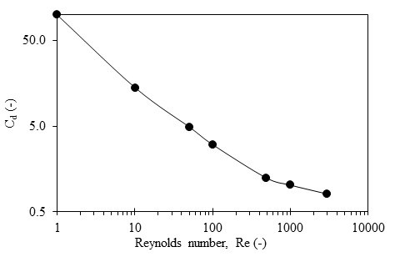
Figure 1. Drag coefficient versus Reynolds number. Re < 40: Measured on immobilized copepods of the genera Calanus, Pseudocalanus and Centropages sinking in water with the head down and antennules folded along the body (Svetlichny 1983) (increased body weight obtained by placing microparticles of lead in mouth of copepods). 1 < Re < 3000: Enlarged model of same copepods sinking in the same manner in glycerol solutions (Kurbatov and Svetlichny, 1981; Stepanov and Svetlichny, 1981).

P_{m} = F_{p}U/M ; P_{muscle} = F_{p}U/M_{muscle}, (3)

where M_{muscle} denotes the total mass of longitudinal and transverse muscles of the thorax associated with the action of the swimming legs.
We also want to estimate the energy expended by a copepod to jump out of the water to become airborne, say from the submerged state (a) to state (b), (c) or (d) (Fig. 4, insert) (see also Gemmell et al. 2012). In state (b) one half of the prosome is above the free surface level, in (c) all of the prosome is just above level, while in (d) the copepod is airborne as the liquid filament snaps. The energy needed is provided by a certain loss of the copepod’s kinetic energy plus its work by propulsive kicks during the escape. From a physical point of view this energy, W_{esc}, is the sum of work done to overcome (i) the resistance due to surface tension, (ii) the drag during motion through water (ignoring that through air as being negligible), and (iii) the increase in potential energy by gaining height when out of the water where buoyancy no longer compensates gravity.
Multiplying Eq.(1) by U gives the mechanical energy balance. Integrated from the fully submerged state (a) to, e.g., the fully airborne state (d) over time ∆t_{a-d} corresponding to the displacement ∆s_{a-d} = U×∆t_{a-d}, this gives ½ M (U_{d}²–U_{a}²) = Σ (F×∆s)_{a-d} , where the right hand side is the sum of work done by the acting forces, i.e., power strokes, surface tension, drag, and gravity. This equation may be rearranged to

½ M (U_{a}² – U_{d}²) + W_{kick} = σ_{s}(A_{d} – A_{a}) + ½LF_{d} + LMg. (4)

The left hand side of Eq.(4) is the energy expended by a copepod. The right hand side may be called the escape work W_{esc}, which is the work to be overcome by the copepod to become airborne. The first term in Eq.(4), the change (loss) in kinetic energy, is readily obtained from the mass M and velocities derived from video records. The second term, the work done by a propulsive kick, can be estimated from a similar energy balance now applied to a fully submerged acceleration as the sum of change in kinetic energy and work by the drag force F_{d}, say from state 1 to 2:
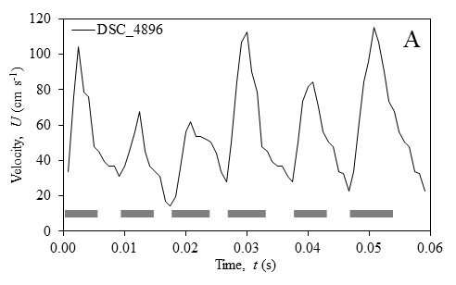
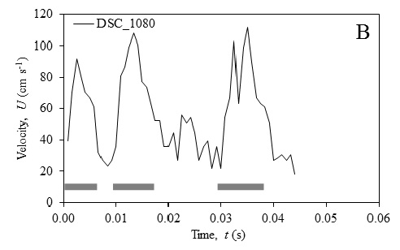
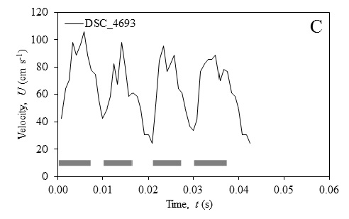
Figure 2. Instantaneous speed during submerged horizontal escape swimming. Gray rectangles mark stroke phases. Pontella mediterranea (A), Anomalocera patersoni (B), and Calanus helgolandicus (C).

$W_{kick}=½M\left(U_{2}^{2}- U_{1}^{2}\right)+ \int_{1}^{2}{F_{d}}Udt,$ (5)

where F_{d} depends on U according to Eq.(2) and velocity versus time is obtained from video records of underwater accelerations. In practice, kicks are often overlapping leading to considerable uncertainty. The right hand side of Eq.(4) has three contributions: (i) the contribution to resistance due to surface tension is calculated as the work needed to create new, stretched free surface, σ_{s}(A_{d} – A_{a}), where σ_{s} denotes the air-water surface tension; the contribution due to (ii) submerged drag is based on the mean velocity over a distance of one-half the length L of the prosome; and (iii) the increase in potential energy is calculated as the lifting of the center of gravity a distance of the prosome length L above the free surface, where g denotes the acceleration of gravity.
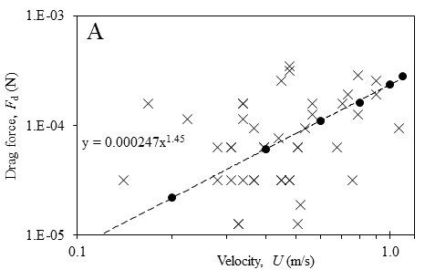
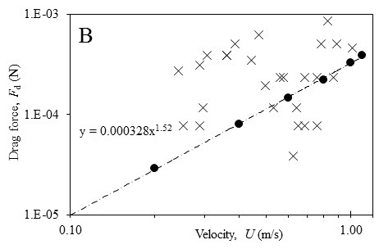
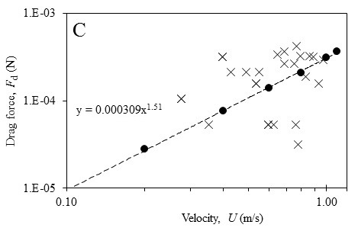
Figure 3. Drag force versus velocity. Predictions from observed coasting decelerations and Eq.(1) (×) and from empirical Cd versus Re of Fig. 1 (•) with regression equation given. Pontella mediterranea (A), Anomalocera patersoni (B), and Calanus helgolandicus (C).

To illustrate the calculation of the contribution (i) from surface tension we consider the change from (a) to (b) because observations (see Results) show that there is often a significant dip in velocity when the copepod reaches position (b), after which the velocity increases again due to a new stroke of the limbs. At stage (b) one half of the vertical prosome (½L) is above the free surface level. Based on single frames of the video records showing a variety of shapes of the deformed surface contour z(r), it is approximated by that generated by rotating a half period of a cosine about the axis of the prosome, leading to the equation

z(r) = 1/4×L×[1 + cos(πr/R)], (6)

where z denotes vertical height, r radial distance, L length of prosome (= 2.02 mm for Pontella mediterranea), and R the radius to the outer point of deformed surface, observed to be typically of the order of the diameter of prosome (= 0.73 mm). The area of the axisymmetric surface given by Eq.(6) is

A_{b} = ∫₀^{R} 2πr [1 + {πL/(4R)×sin(πr/R)}²] ^{½} dr, (7)

while the corresponding initial area of un-deformed surface is

A_{a} = πR². (8)

An expression similar to Eq.(7) has been derived for the lifted cusp at state (d) to which we add the surface area of the prosome assumed to have been covered by a liquid film due to the dynamics of the process (see Discussion).

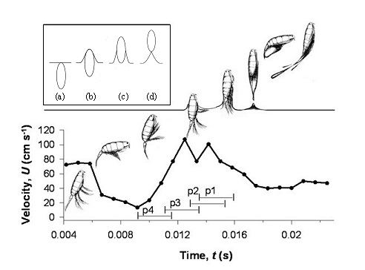
Figure 4. Pontella mediterranea. Velocity of vertical motion during escape event terminated with an out-of-water jump. Position of body and limbs of the crustacean are shown by images synchronized with the time scale. Time bars p4 to p1 mark the metachronal strokes of 4 pairs of thoracic legs. During the second kick (p3) the body approaches and penetrates the free surface while kicks p2 and p1 lead to an airborne escape. Insert (upper left) shows stages a, b, c and d during out-of-water jump (schematic).

RESULTS

Submerged jumps
Submerged jumps of all three species were rather similar. Individuals respond to electrical stimulations by a series of kicks with the swimming legs giving rise to rapid escape jumps. Each kick-cycle consists of sequential power strokes of the four or five pairs of swimming legs, and subsequent simultaneous recovery stroke of all legs. The antennules are folded backwards at the first stroke. In the pontellids the fifth pair of swimming legs is not involved. The jumps can be directed upwards towards the surface leading to occasional out-of-water jumps, or follow various submerged paths. Typical records of the fluctuating velocity versus time for the three species during submerged jumps consisting of a series of consecutive kick cycles are shown in Fig. 2. Note that in Calanus finmarchicus strokes of the five pairs of thoracic swimming legs may partially act together and the joint action of legs 4 and 5 and of 1 to 3 produce bimodal force impulses and double peaks in velocities. Peak velocities, stroke duration, acceleration, and other kinematic characteristics are strikingly similar between the three species (Tables 1 and 2). The large values of standard deviations of results in Table 2 are indications of natural variations between individual events observed and are probably not exceeded by the uncertainties associated with model assumptions.
We used the decelerations of coasting phases between power strokes for the three species to estimate the species-specific velocity-dependent drag forces from Eq.(1), and compared these with estimates based on the empirical C_{d} versus Re relation in Fig. 1 and Eq.(2) (Fig. 3). These two independent estimates of the drag forces are of similar order of magnitude, which is encouraging. The estimates based on Eq.(1) are rather variable, and so we favor the (slightly smaller) estimate based on the empirical drag coefficient. The velocity range is about 0.1-1.0 ms⁻¹ for most data of the present study, corresponding to Re ≈ 70-900 where C_{d} ≈ Re^{-0.5} according to Fig.1, hence F_{d} ≈ U^{1.5} as seen in Fig.3.
With the estimate of drag and observed accelerations, we can now compute propulsive forces and specific power output of the submerged escapes for the three species (Table 2). Again, they are rather similar between species. The largest species, A. patersoni, produces the largest propulsion force during escape, about 2.5 times higher than that of the smaller P. mediterranea. This difference is reduced when comparing mass specific power productions, with the performance of the pelagic C. helgolandicus being between the two neustonic species.
Finally, we estimate the magnitude of W_{kick} from Eq.(5) applied to periods of observed accelerations in Figs. 2A-C and Fig. 4 using the velocity dependent drag F_{d} from correlations shown in Figs. 3A-C (Fig. 5). W_{kick} increases linearly with velocity for all three species and the data clearly show A. patersoni to be most powerful, followed by C. helgolandicus and P. mediterranea.

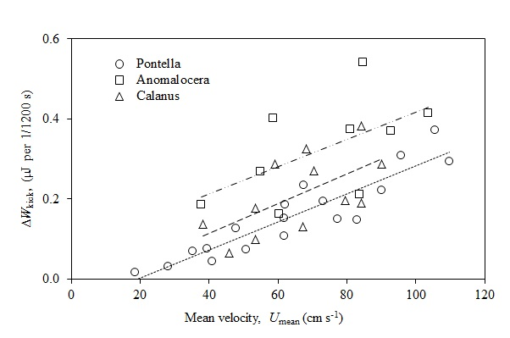
Figure 5. Pontella mediterranea , Anomalocera patersoni and Calanus helgolandicus. Contribution of kick energy during submerged acceleration in one 1/1200 s period of video record versus mean velocity during the period. Lines are linear regressions of kick energy (y) versus velocity (x) and are y=0.003x+0.077 (R²=0.32) for A. patersoni, y=0.004x-0.034 (R²=0.39) for C. helgolandicus, and y=0.004x-0.067 (R²=0.84) for P. mediterranea.

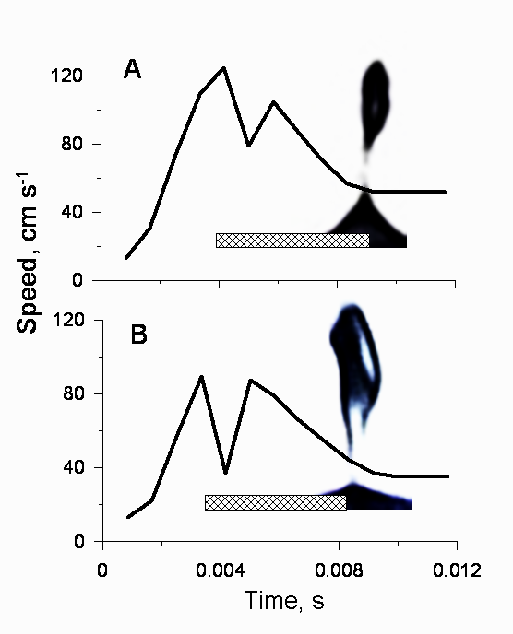
Figure 6. Pontella mediterranea. The velocity of vertical motion during out-of-water jump resulting in velocity dip (А and B). Rectangles indicate the period when the crustaceans break through the surface film of the water.

Out-of-water jumps
The spectacular out-of-water jumps in Pontella mediterranea are illustrated in the online Supplementary material S2. The analysis of 8 out-of-water jumps to airborne flight in P. mediterranea, as well as some unsuccessful jumps with the animal not leaving the water, showed that success occurs only when the beginning of a kick immediately precedes the contact of the top part of the body with the water surface. This is illustrated in Fig. 4 that shows body velocity versus time during three kicks of which the first is completely underwater. During the second kick the copepod jumps out of the water and with the third kick it is completely airborne. The second kick starts with strokes of the fourth and third swimming leg that accelerates the body towards the surface. As the copepod penetrates the surface (stage b in insert of Fig. 4) the speed drops and then increases again with the strokes of third (p3) and second (p2) pairs legs (to stage c in Fig. 4), to finally decline again as the body is raised above the water at its full length and airborne flight is achieved. The third kick cycle in the air yields another slight increase in velocity due to ejection of an adhering water drop. Two other sequences showing the variation of velocity during out-of-water jumps and airborne flight are shown in Figs. 6А and 6B, confirming the dip in velocity as the free surface is penetrated. We managed to record only one out-of-water jump of Anomalocera patersoni. The female made a jump from a horizontal position, immediately below the surface film and from almost zero speed. A kick from the limbs made it move up through the surface and away with complete detachment from the surface, an event captured in 6 frames

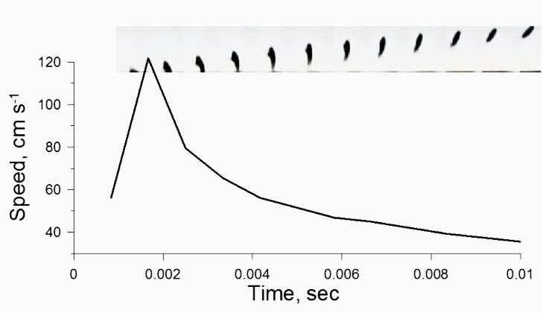
Figure 7. Anomalocera patersoni. Instantaneous speed during out-of-water jump with synchronized storyboard.

(~5 ms) (Fig. 7). Note that we observed no dip in velocity as the surface is penetrated because accelerated movement out
of water in A. patersoni begins directly from the surface. This is because A. patersoni has special hairs on the dorsal side of the body that keeps it directly in contact with the surface of the water. Photos of such hairs and a discussion of their role in A. patersoni are given by Ianora et al. (1992).
Average kinematics of all 8 cases of P. mediterranea analyzed plus the one case for A. patersoni demonstrate similar stroke kinematics and velocity variation (Figs 5 and 6) and that the appendage kinematics does not differ markedly from the kinematics of submerged jumps (Table 1). Successful out-of-water jumps show on average higher accelerations and specific power production than submerged jumps within the same species (Table 2).The dip in velocity during penetration of the water surface was observed in 5 out of 8 cases in Pontella mediterranea and corresponds to the loss of kinetic energy. We use the data of Fig. 4 to illustrate the calculations. The dip in velocity after contact with the surface (from U_{a} = 108cm s^{–1} to U_{b} = 77 cm s^{–1}) for a mass of M = 0.63 mg, corresponds to a loss of kinetic energy of 0.18 µJ (or 48%) according to Eq.(4) applied from (a) to (b) of Fig. 4 (insert). Contributions to the energy expenditure W_{esc} comprise three components: (i) the increase of surface energy, which according to Eqs.(7) and (8) for L = 2 mm, R = 0.73 mm and σ_{s} = 0.075 N m^{–1} becomes σ_{s}(A_{b} – A_{a}) = 0.075×(2.86 – 1.67)×10^{–6} = 0.0886×10^{–6} J = 0.09 µJ; (ii) the drag estimated by using the mean velocity from (a) to (b) in Eq.(2), ½LF_{d} = 0.22 µJ; and (iii) the potential energy 1/4×LMg = 0.003 µJ. The 3 terms add up to W_{esc} = 0.31 µJ which is 0.14 µJ greater than the loss of kinetic energy (0.18 µJ). This difference in energy is provided by a small part of the two kicks p3 and p2 shown in Fig. 4 to occur during the event. At a velocity of the order of 90 cm s⁻¹ a kick lasting a full video frame (1/1200 s) would contribute an energy addition of 0.25 µJ according to Fig. 5 which is more than needed (0.14 µJ). Including similar calculations for 4 other cases of observed velocity dip when P. mediterranea starts the out-of-water jump we find the average of 5 events to involve a reduction of kinetic energy (mean ± S.D.) of 0.17 ± 0.08 µJ while the energy expenditure added up to W_{esc} = 0.27 ± 0.05 µJ, leaving a difference of 0.11 µJ.
We also considered 2 cases of out-of-water jumps from the time the copepod arrives at the surface till it is fully airborne, state (a) to (d) (Fig. 4, insert). First, for Pontella mediterranea (Fig. 4) the loss of kinetic energy is estimated to 0.25 µJ while the 3 contributions to energy expenditure (0.40, 0.22, 0.013 µJ) add to W_{esc} = 0.63 µJ, the difference of 0.38 µJ being ascribed to part of kick p3 plus kicks p2 and p1 lasting about 4 frames (Fig. 4). But according to Fig. 5 at a copepod velocity of the order of 60 cm s⁻¹ one kick for the duration of one video frame would provide the additional energy of 0.14 µJ. Second, for Anomalosera patersoni (Fig. 7) the loss of kinetic energy was estimated to 0.70 µJ while the 3 contributions to energy expenditure (0.53, 0.76, 0.03 µJ) add to W_{esc} = 1.3 µJ, a difference of 0.62 µJ. This escape lasted about 4 video frames but it was not possible to establish kicks, yet according to Fig. 5 at a velocity of the order of 90 cm s⁻¹ one kick for the duration of one video frame would provide the additional energy of about 0.4 µJ.
From these examples it is seen that the energy expenditure required to overcome drag contributes about 2/3 of the total work, breaking of the water surface tension about 1/3, while the cost of increase in potential energy only contributes ~ 2 % of the total.

DISCUSSION

Kinematics and energetics
The kinematics of copepod escape reactions have been described by many researchers based on high-speed filming of free swimming individuals (Strickler 1975; Svetlichny 1986; Morris et al., 1990; Kiørboe et al., 2010) and of attached individuals (Svetlichny 1987; Alcaraz and Strickler 1988; Lenz and Hartline1999; Lenz et al. 2004). The escape reaction exhibited by copepods is realized mostly due to metachronal power strokes of the swimming limbs. It has long been realized that the specific muscle force required for the high accelerations and velocities archived during such jumps is high, and much higher – by an order of magnitude or more - than recorded for startle responses in any other organisms, including flying insects and escaping fish (Marden 2005). The resulting specific power production is also high and appears to outperform other invertebrates and is similar to or higher than observed in the most powerful vertebrates (Josephson 1985, Askew and Marsh 2002). Thus, the power output integrated over one complete jump beat cycle measured in copepods tethered to a force sensor yield estimates of 300-1000 W per kg muscle mass in Calanus helgolandicus, Calanus finmarchicus, and Undinula vulgaris (Svetlichny 1988, Lenz and Hartline 1999, Lenz et al., 2004), similar to that calculated for free jumping C. finmarchicus (300 W kg⁻¹, Kiørboe et al., 2010). The mean values reported here for both C. helgolandicus and the two pontellids are somewhat higher (~–1000 - 3300 W kg⁻¹ of muscles, Table 2). The advantage of the present estimates is (i) that they are based on free-swimming rather than tethered copepods that may have a 50% slower power strokes (Svetlichny 1987), and (ii) that the calculations are based on drag that agrees with values inferred from observed coasting decelerations rather than based on idealized drag laws. At any rate it is the unusual force and power production that allows these small animals to rather easily break the surface tension and overcome liquid drag, provided the timing of kicks are right. Such capabilities are otherwise normally ascribed larger organisms, like fish, where the energy required to break the surface tension is low relative to that required to overcome drag and gravity.
The resistance to escape from surface tension was based on the work done to stretch the free surface from a given initial area to a larger area when the copepod rapidly emerged above the water level. Single frames from the video records clearly showed that liquid surrounding the prosome was lifted and at no point revealed dry prosome surface with a point of contact indicating a contact angle. The stretched water-air surface appeared smooth. These observations lead us to propose the surface form of Eq.(5) for state (b) and that of state (d) as the sum of the raised cusp plus a film covering the prosome. The key is the rapid dynamics of the process and the associated hysteresis effects of wetting and de-wetting of solid surfaces (de Gennes, 1985). This model of the physics is quite different from that of Gemmell et al. (2012) who determined the energy loss as the change in surface energy of static states from when the prosome surface area A was fully in contact with water to fully in contact with air. They then used Young’s law to obtain their Eq.(2.4), loss = σ_{s}A cos θ, where the contact angle θ was measured from video records. The authors also state “in order to maintain a useful level of kinetic energy after breaking the surface the copepod body surface has to be hydrophobic, i.e. much larger contact angle in the 68 – 81º range”. As θ approaches 90º this loss becomes zero, so it may be a questionable contribution to the energy changes particularly because its validity is based on static states.
Our estimates of energy cost of penetrating the free surface (either to explain the velocity dip of Fig. 4 or the full escape to become airborne) exceeds the corresponding loss of kinetic energy by amounts that are of the order of 0.11 to 0.14 µJ and 0.38 to 0.62 µJ, respectively. We ascribe these amounts to additional contributions from propulsive kicks that may last one or two frames of video record, and depending on velocity the magnitude may be judged from the estimates shown in Fig. 5. Although this only provides a qualitative explanation, the main conclusion is that Pontella mediterranea needs W_{esc} = 0.63 µJ to become airborne and Animalosera patersoni needs W_{esc} = 1.3 µJ for the cases analyzed, and that these amounts are not provided by the observed losses of kinetic energy alone. In fact we can calculate the minimal initial velocity required to become airborne, i.e. U_{min} = U_{a}, U_{d} = 0 in Eq.(4) and ignoring W_{esc}, as U_{min} = (2×W_{esc}/M)^{1/2} = (2×0.63/0.63)^{1/2} = 1.42 m s⁻¹ and U_{min} = (2×1.32/1.2)^{1/2} = 1.49 m s⁻¹, respectively, for the two cases. Such high values of velocity have not been observed.
Gemmell et al. (2012) estimated that ~2/3 of the kinetic energy loss at the moment when the copepod starts to break the water surface is due to the penetration of the surface, but only ~1/3 if integrated over the entire phase, from state (a) to (d). Our estimates show that observed loss of kinetic energy is insufficient to overcome the resistance from surface tension and submerged drag, and that escape requires well timed propulsive kicks when breaking through the water surface. This has been established due to a finer temporal resolution of the observations (250-500 Hz vs 1200 Hz). Taken together, these observations suggest that relative to the power production of these copepods during out-of-water jumps, overcoming the surface tension is a significant yet affordable cost.
The large variation of the values in Table 2 partly reflects natural variations between analyzed events. Thus, the relative contribution to propulsive acceleration and drag varies significantly among events: Drag contributes from 23 to 67% for the 8 out-of-water jumps of Pontella mediterranea mainly because a give magnitude of acceleration may occur at relatively low or high velocity, respectively, and drag increases with velocity to the power about 1.5 (Fig. 3). While accelerations are well estimated, excessive drag may therefore lead to an overestimation of propulsive force and specific power. The heights and lengths of airborne jumps of several tenths of cm in copepods reported by early observers (cited in the introduction) appear unrealistic as they are much further than the 4 cm heights and 8 cm lengths of jumps observed by us and by Gemmel et al (2012) and would require initial airborne velocities of ~2 m s⁻¹ or more, much higher than any observations reported later.

Different or similar?
Are neustonic copepods that routinely do out-of-water jumps more powerful than copepods that live far from the surface? Our data suggests that the specific force and power production vary between the three species, yet are rather similar, and the submerged C. helgolandicus is in all respects intermediate between the two neustonic species (Table 2). This being said, within species, acceleration, propulsive force, and mass specific powers are about 1.6 to 2.1 times larger on average for out-of-water jumps than for submerged jumps. While the values for the former are still within the range of observed values for the latter, it does suggest that it is only the most powerful jumps that bring the copepods into the air. Also, the analysis of unsuccessful out-of-water jumps of Anomalocera patersoni and Pontella mediterranea indicates that stroke phase synchronization when approaching the water surface is crucial to overcome surface tension and gravity forces successfully. In this regard the sensory system of pontellids, unique among copepods, including numerous eyes placed both on dorsal and ventral surfaces of the head, may play a key role.
Gemmel et al (2012) suggested that Pontellids jumping out of the water may have a less wettable surface than mesopelagic species. However, Pontellids can carry water droplets adhering to their body as they jump out of the water, according to our estimates amounting to about 1/4 of the body weight for Pontella mediterranea. Such observations suggest that neustonic copepods, leaping into the air to escape fish predators, have not acquired any adaptations to reduce the wetting properties or drag force of their body. The maximum instantaneous velocities registered in P. mediterranea and Anomalocera patersoni at the moment they overcome the surface film (125 cm s⁻¹ and 122 cm s⁻¹, respectively) are faster than the maximum speed of underwater swimming of the two species and of Calanus helgolandicus (106 cm s⁻¹). However, these peak speeds happened when the top part of the pontellids’ body was in the air already while the thoracic limbs made strokes in the water (Fig. 4).
Finally, our conclusion that out-of-water jumps in copepod require no particular adaptations is supported by the fact that copepods normally living far from the surface of the ocean in artificial situations can likewise jump out of the water, as reported for calanoid copeods (Lowden (1935, Tanaka 2014). The physical model with spherical particles shooting towards the liquid surface to mimic planktonic copepods jumping (Kim et al., 2015) cannot fully simulate an out-of-water jump of a copepod but similarly suggests “that it is unlikely that aerial jumping of copepods requires special adaptations to their body surface properties in order to make it easier for them to jump out of the water”.
Kim et al. (2015) argued that small copepods like Acartia tonsa cannot jump out of the water because they are not capable of generating high enough speed before reaching the free surface, according to the kinetic energy concept of Gemmell et al. (2012). However, Anomalocera patersoni makes a jump into the air directly from still position and from the surface film to which it is attached by dorsal setae. According to the concept and analysis developed here the success and speed of the flight depends only on the speed and force of the limbs and abdomen.
Although propulsive force and counteracting surface tension both can be proportional to the square of the linear dimensions of the body, the ability of copepods to jump out of the water can be limited by the insufficient step length of legs and the usual jump distance of small copepods. The success of jumping out of the water still depends on the ability to create a well-timed propulsive force by the limbs.

Acknowledgements
The experimental part of this study was carried out at Institute of Biology of the Southern Seas, Sevastopol, Ukraine.

Competing interests
The authors declare no competing interests.
Author contributions
L.S. conceived, designed and performed the experiments; L.S., P.S.L. and T.K. analyzed the data; all authors contributed to writing and have approved the final version of the manuscript.
Funding
The Centre for Ocean Life is a Villum Kann Rasmussen Centre of Excellence supported by the Villum Foundation.

References
Alcaraz, M. and Strickler, J. R. (1988). Locomotion in copepods: pattern of movements and energetics of Cyclops. Hydrobiologia. 167/168: 404-414.
Askew, G. N. and Marsh, R. L. (2002). Muscle design for maximum short-term power output: quail flight muscle. J. Exp. Biol. 205: 2153–2160.
Buskey, E. J., Lenz, P. H. and Hartline, D. K. (2002). Escape behavior of planktonic copepods in response to hydrodynamic disturbances: high speed video analysis. Mar. Ecol.: Prog. Ser.. 235:135-146.
de Gennes, P.G. (1985). Wetting: statics and dynamics. Rev. Mod. Phys. 57 (3): 827–863.
Fields, D. M. and Yen, J. (1997). The escape behavior of marine copepods in response to a quantifiable fluid mechanical disturbance. J. Plankton Res. 19: 1289–1304.
Gemmell, B., Jiang, H., Strickler, J. and Buskey, E. (2012). Plankton reach new heights in effort to avoid predators. Proc. R. Soc. B. 279: 2786-2792. doi: 10.1098/rspb.2012.0163.
Humes, A. G. (1994). How many copepods? Hydrobiologia. 292/293: 1-7. Jiang, H. and Kiørboe, T. (2011). Propulsion efficiency and imposed flow fields of a copepod jump. J. Exp. Biol. 214: 476-486.Ianora, A., Miralto, A. and Vanucci, S. (1992). The surface attachment structure: a unique type of integumental formation in neustonic copepods. Mar. Biol. 113:401-407.
Josephson, R. K. (1985). Mechanical Power output from Striated Muscle during Cyclic Contraction. J. Exp. Biol. 114: 493-512.
Kim, S J., Hasanyan, J., Gemmell, B. J., Lee, S. and Jung, S. (2015). Dynamic criteria of plankton jumping out of water. J. R. Soc. Interface. 12:20150582.
Kiørboe, T. (2013). Attack or Attacked: The Sensory and Fluid Mechanical Constraints of Copepods’ Predator–Prey Interactions. Integr. Comp. Biol. 53 (5): 821-831.
Kiørboe, T., Andersen, A., Langlois, V. and Jakobsen, H. H. (2010). Unsteady motion: escape jumps in planktonic copepods, their kinematics and energetics. J. R. Soc. Interface. 7: 1591-1602.
Kurbatov, B. V. and Svetlichny, L. S. (1981). Hydrodynamic resistance indices of locomotion organs in Calanus helgolandicus. Okeanologiya. 21 (6): 1092–1097.(in Russian).
Lenz, P. H. and Hartline, D. K. (1999). Reaction times and force production during escape behavior of a calanoid copepod, Undinula vulgaris. Mar. Biol.133: 249-258.
Lenz, P. H., Hower, A. E. and Hartline, D. K. (2004). Force production during pereiopod power strokes in Calanus finmarchicus. J. Mar. Sys. 49:133-144.
Lowndes A.G. (1935). The swimming and feeding of certain calanoid copepods. Proc. Zool. Soc. Lond. 3:687-715.
Marden, J. H. (2005). Scaling of maximum net force output by motors used for locomotion. J. Exp. Biol. 208: 1653–1664.
Morris, M. J., Kohlhage, K. and Gust, G. (1990). Mechanics and energetics of swimming in the small copepod Acanthocyclops robustus (Cyclopoida). Mar. Biol. 107:83-91.
Ostroumoff, A. (1894). Ein fliegender Copepoda. Zool. Anz. Jhrg, 17(459): 369. (22-x-1894).
Stepanov, V. N. and Svetlichny, L. S. (1981). Research into the hydromechanical characteristics of planktonic copepods. Naukova Dumka, Kiev (In Russian.).
Strickler, J.R. (1975). Swimming of planktonic Cyclops species (Copepoda, Crustacea): Pattern, movements and their control. p. 599–613. In Wu TT, Brokaw CJ, Brennan C, [eds.], Swimming and flying in nature. New York. Plenum Press.
Svetlichny, L. S. (1983). Hydrodynamic resistance of motionless copepods during their passive sinking in water. Oceanology. 23:104–108.
Svetlichny, L. S. (1986). Escape reaction in the copepod Calanus helgolandicus. Zool. J. 65 (4): 506-515. (in Russian).
Svetlichny, L. S. (1987). Speed, force and energy expenditure in the movement of copepods. Oceanology, Wash 27:497–502.
Svetlichny, L. S. (1988). Morphology and functional parameters of body muscles of Calanus helgolandicus (Copepoda, Calanoida). Zool. J. 67 (1): 23-30. (in Russian).
Svetlichny, L. S. (1992). Concerning biohydrodynamics of the steady and unsteady locomotion of copepods. Ekologiya Morya, 40, 84-89 (in Russian).
Svetlichny, L., Hubareva, E. and Khanaychenko, A. (2012). Calanipeda aquaedulcis and Arctodiaptomus salinus are exceptionally euryhaline osmoconformers as evident from mortality, oxygen consumption and mass density patterns. Mar. Ecol. Progr. Ser. 470: 15-29.
Tanaka, Yu. (2014). High-speed imaging in copepod behavior. pp. 145-156. In L. Seuront [eds] Copepods: Diversity, Habitat, and Behavior Nova Publishers.
Vogel S. (1994). Life in moving fluids, 2nd ed. Princeton University Press, Princeton, N.J.
Zaitsev, Yu. P. (1971). Marine neustonology, K.A. Vinogradov [eds], National Technical Information Service Springfield.

Table 1. Pontella mediterranea, Anomalocera patersoni and Calanus helgolandicus. Body morphology, speed (U, cm s⁻¹) and distance (S, cm) of submerged and out-of-water jumps.

 | Pontella mediterranea | Anomalocera patersoni | Calanus helgolandicus
Number of observations, n | 20 | 20 | 20
L_{t}, total length, mm | 2.68±0.32 | 3.43±0.12 | 3.38±0.17
L, prosome length, mm | 2.02±0.24 | 2.54±0.16 | 2.63±0.13
D, prosome diameter, mm | 0.73±0.05 | 0.88±0.06 | 0.85±0.04
A_{s}, body surface area, mm² | 4.5±0.9 | 6.3±0.7 | 6.4±0.6
A_{f}, body frontal area, mm² | 0.42±0.06 | 0.61±0.08 | 0.57±0.07
V, body, mm³ | 0.61±0.14 | 1.16±0.15 | 0.93±0.1
M, body mass, g | 6.3×10^{–4} | 1.2 ×10^{–3} | 9.6 ×10^{–4}
 | Submerged jumps
Number of observations, n | 21 | 19 | 15
U max, cm s⁻¹ | 82.0±17.9 | 89.8±17.9 | 92.4±9.1
U mean in stroke, cm s⁻¹ | 61.4±15.3 | 65.4±14.2 | 68.9±11.9
U mean of all jumps, cm s⁻¹ | 48.3±11.3 | 58.5±13.8 | 58.1±10.9
Stroke phase duration, ms | 4.9±0.7 | 5.5±0.9 | 6.4±1.1
Total duration of kick, ms | 10.4±1.6 | 9.4±1.5 | 11.6±1.5
S stroke phase, cm | 0.31±0.09 | 0.37±0.11 | 0.44±0.078
S total kick, cm | 0.50 ±0.12 | 0.55±0.11 | 0.67±0.108
 | Out-of-water jumps
Number of observations, n | 8 | 1
U before surface film, cm s⁻¹ | 90.4±20.4 | 56.2
U max in film, cm s⁻¹ | 101.06±11.9 | 121.8
U detachment from film, cm s⁻¹ | 45.9±7.0 | 51.5
U mean after water breaking, cm s⁻¹ | 43.05±5.7 | 42.5±5.6
U after ejecting drop, cm s⁻¹ | 46.0±7.3
Stroke phase duration, ms | 6.7±0.9 | 4.9
Duration until U_{max}, ms | 3.45±0.7 | 1.7
Time to penetrate surface, ms | 5.5±0.4 | 4.9
Total duration of kick, ms | 9.7±1.4
Duration of jump during flight, ms | 10.2±0.9

Table 2. Pontella mediterranea, Anomalocera patersoni and Calanus helgolandicus. Maximal and mean ± S.D. values of acceleration dU/dt, drag force F_{d} (Fig. 3), propulsive force F_{p} (Eq.1), mass specific powers P_{m} and P_{muscle} (Eqs.2 and 3) for a number (n) of observations of submerged and out-of-water jumps.
 | Unit | Pontella mediterranea | Anomalocera patersoni | Calanus helgolandicus
 |  | Submerged jumps
Number of observations, n | - | 8 | 4 | 5
Acceleration, dU/dt | m s⁻² | 405, 212 ± 121 | 540, 443 ± 72 | 419, 353 ± 50
Drag force, F_{d} (U in m s⁻¹) | µN | 247 U^{1.45} | 328 U^{1.52} | 309 U^{1.51}
Propulsive force, F_{p} | µN | 395, 250 ± 104 | 794, 724 ± 102 | 556, 500 ± 72
Mass specific force, F_{p,body mass} | N kg⁻¹ | 627, 398 ± 166 | 661, 603 ± 85 | 564, 521 ± 75
Mass specific force, F_{p,muscle mass} | N kg⁻¹ | 2324, 1472 ± 614 | 2449, 2235 ± 315 | 2090, 1928 ± 276
Mass specific power, P_{m} | W kg⁻¹ | 611, 252 ± 177 | 545, 426 ± 129 | 487, 341 ± 121
Mass specific power, P_{muscle} | W kg⁻¹ | 2020, 932 ± 696 | 2020, 1579 ± 477 | 1805, 1263 ± 447
 |  | Out-of-water jump
Number of observations, n | - | 8 | 1
Acceleration, dU/dt | m s⁻² | 389 ± 180 | 787
Mass specific force, F_{p,body mass} | N kg⁻¹ | 637 ± 158 | 1015
Mass specific force, F_{p,muscle mass} | N kg⁻¹ | 2358 ± 586 | 3761
Mass specific power, P_{m} | W kg⁻¹ | 459 ± 165 | 903
Mass specific power, P_{muscle} | W kg⁻¹ | 1701 ± 612 | 3345

2nd revision, 2.Oct.2017

