Title: Routes and survival of anadromous brown trout Salmo trutta L. post-smolts during early marine migration through a Danish fjord system

Authors: Martin Lykke Kristensen¹, Kim Birnie-Gauvin¹ and Kim Aarestrup¹

¹ Technical University of Denmark, National Institute for Aquatic Resources, 8600 Silkeborg, Denmark

Author for correspondence: Martin Lykke Kristensen, makri@aqua.dtu.dk, +4540987793.

Declarations of interest: none

Abstract
We examined the survival and progression rates of 101 anadromous brown trout Salmo trutta L. post-smolts from two Danish river systems, Karup and Simested, with acoustic telemetry as they migrated through a large Danish fjord system (the Limfjord). No fish were documented to residualize permanently within the fjord, and the minimum survival in the fjord was low (26 %) while the mortality per km of migrated linear distance (0.8 % km⁻¹) was similar to that found in adjacent and smaller Danish fjords. Survival was positively correlated with length (P = 0.003) but not with condition and river of origin. The fjord has an eastern outlet into the Kattegat and a western outlet into the North Sea, but the western outlet did not exist until 1825. No fish left the fjord in the western direction in the study and all surviving fish (n = 20) left the fjord in the eastern direction. The results suggest that fish from rivers Karup and Simested may have over time become adapted for leaving the Limfjord in the eastern direction and that predation rates and environmental characteristics of the fjord are more important for the fjord’s ability to function as a suitable growth habitat for post-smolts than size and the availability of food within it.

Keywords: Anadromous species, fjords, marine, migration, trout, survival

1. Introduction
Salmonids are some of the best studied fish species in the world. While our knowledge on their migratory behaviour is quite extensive, our understanding of the causes for individual survival at sea is limited. Brown trout (Salmo trutta L.) are of particular interest as their stocks have seen a decrease in recent decades likely due to high mortality at sea for anadromous individuals (sea trout) (Butler and Walker 2006; Gargin et al. 2006). Mature adults spawn in freshwater, after which alevins will emerge from the eggs and move up the water column to begin feeding (Klemetsen et al. 2003). Individuals spend anywhere between 1 to 8 years in freshwater streams or rivers before migrating to marine environments as smolts where they spend between 0.5 to 4 years before returning to freshwater to spawn (Elliott 1994; Crisp, 2000; Thorstad et al. 2016). The fish are termed post-smolts after entering the marine environment. Growth at sea and survival of marine stages is important for future recruitment, though large knowledge gaps still remain in this area (Lucas and Baras, 2001; Klemetsen et al. 2003; Drenner et al. 2012).
Seaward migration is energetically costly, and involves high predation risks. This is true for both smolts and mature individuals, though the early marine stage is critical for post-smolt survival, and mortality has been shown to be particularly high in this period (Nathan et al. 2008; Koed et al. 2006; Jepsen et al. 2006; Middlemas et al. 2009; Thorstad et al. 2012). Local adaptations may help individual fish overcome the dangers associated with this migration, and have been observed commonly in brown trout and other salmonids (Quinn and Brannon, 1982; Svärdson and Fagerström 1982; Fraser et al. 2011). Svärdson and Fagerström (1982) found that sea trout from streams entering the Baltic maintained their inherited migration strategy even when transferred to other river systems, while Järvi et al. (1996) found that newly emerged sea trout fry from small streams migrated directly to sea in streams of the Baltic region, apparently as an adaptation to the frequent occurrences of low summer water levels that characterized the streams.
For post-smolts, migration success to marine waters and travel speeds are thought to be affected by species and watershed size (Melnychuk et al. 2010), fish size (Bohlin et al. 1993, Aarestrup et al. 2015) as well as route choice, with especially high mortality in river inlets and coastal regions (Healy et al. 2017). Migration route choice and regions of high mortality are of particular interest for the management and conservation of these species. The Limfjord (Northern Jutland, Denmark) offers a peculiar site to study these route-specific movements and survival of post-smolts because it runs into both the North Sea and the Kattegat on the western and eastern sides, respectively, and because the western outlet to the sea did not exist until a stormflood created it in 1825 (Meesenburg 1996). The post-smolts may therefore be evolutionarily adapted for going east in the fjord, but as of yet, the behaviour of post-smolts within the Limfjord has not been well described.
Brown trout post-smolts have been shown to leave the neighboring fjords Randers and Mariager, though some individuals possibly stayed in the larger Mariager fjord (del Villar-Guerra et al. 2013; Aarestrup et al. 2014). In Norwegian fjords, which are significantly larger in size, brown trout post-smolts and adult individuals have a greater tendency to reside within the fjords in comparison to Danish fjords (Thorstad et al. 2007; Jensen et al. 2014; Eldøy et al. 2015, Flaten et al. 2016). Food resources in the Limfjord are reported to be plentiful for sea trout (Ebert 2004) despite a recent decline in the environmental quality of the fjord (Olesen 1996; Markager et al. 2006). An overall decision to leave the fjord may therefore indicate that fjord size and food availability are not the most important factors determining whether brown trout post-smolts reside in the fjord, or take the risk associated with migrating out of it.
In the present study, we investigated the migration route of downstream migrating brown trout post-smolts through the Limfjord. We aimed to investigate which outlet the post-smolts used to reach the sea and whether they stayed in the fjord as seen in Norwegian fjords of similar size, or left it as seen in smaller Danish fjords. We hypothesized that smolts would migrate east as a result of adaptations developed over time and that some of them would residualize in the fjord to forage for extended periods given the abundance of food items. Furthermore, we evaluated survival of the post-smolts and aimed to identify areas of particularly high mortality, with the objective of providing valuable information for the management of this brown trout population.

2. Materials and methods
2.1 Study area
The fish were caught and tagged in the rivers Karup and Simested in Northern Jutland, Denmark. The rivers have respective catchment areas of 763 km² and 241 km², and mean discharges of 9300 l s⁻¹ and 2000 l s⁻¹. Both rivers run into the Limfjord; a 160 km long fjord with a western outlet to the North Sea and an eastern outlet to the Kattegat (Figure 1). The Limfjord is generally shallow with depths rarely exceeding 15 meters and a maximum depth of 24 meters at Hvalpsund. The fjord was not connected to the North Sea in the west until 1825 when a stormflood created the western opening which has been maintained since (Meesenburg 1996). At present, the western opening is approximately 780 meters wide, while the eastern opening is approximately 450 meters wide. The fjord therefore connects the saline North Sea (30 – 33 at the western outlet using the Practical Salinity Scale) with the more brackish Kattegat (20 – 25 at the eastern outlet) and as a consequence, salinity levels generally decrease towards the eastern part of the fjord. The fjord switches between stratified and mixed conditions as differences in sea surface level, diffuse freshwater inflow and periodic events with inflow of saline water from the North Sea during storms occur (Hofmeister et al. 2009). There are no measurements of current speed and direction in the fjord, but the flow pattern in the fjord is mainly chaotic with wind-driven currents during strong easterly or westerly winds. Westerly winds generally dominate the region, except during spring when easterly winds are more frequent and wind speeds are generally less intense (Sand-Jensen and Møller 2010).

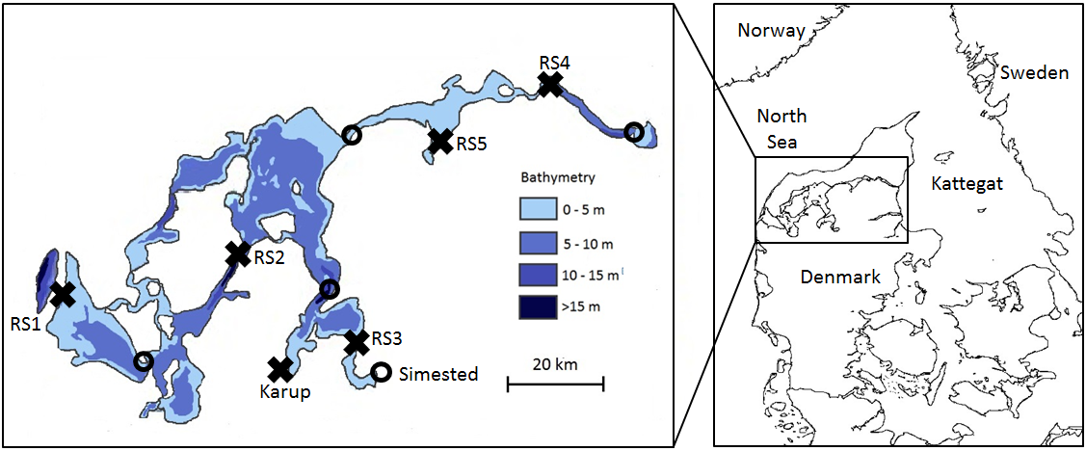
Figure 1. Water depths of the Limfjord (left) and map of Denmark with adjacent seas (right). Receiver stations (RS) are marked with crosses while lost receiver stations during the study period are marked with circles. Bathymetry data was provided by the Danish Shellfish Centre.

The fjord received a large influx of nutrients in the second half of the 20th century and today, the Limfjord remains heavily eutrophicated despite a reduced nutrient load in recent years (Olesen 1996; Markager et al. 2006). An investigation of anadromous brown trout stomach content in the fjord compared stomach contents between years 1958-1963 and 1994-1996. Findings suggest that food was still plenty in 1994-1996 despite reduced environmental quality in the fjord, but that the sea trout diet had changed to consist of mainly polychaetes and fish in 1994-1996 rather than crustaceans, insects and fish in 1958-1963 (Ebert 2004).
The fjord has a population of harbour seal (Phoca vitulina) and great cormorants (Phalacrocorax carbo) that likely predate on trout smolts (Andersen et al. 2007). In recent years, grey seals (Halichoerus grypus) have also started foraging in the fjord. The position of seal and cormorant colonies in or around the fjord has not been mapped, but the areas surrounding RS3 and the river mouths of rivers Karup and Simested (Figure 1) are known to be very active predator areas; both harbour seals and cormorants were spotted at RS3 on every visit to maintain the equipment, while cormorants were spotted at each visit to the river mouths.
2.2 Smolt capture and tagging
Brown trout smolts were captured via electrofishing. Selected fish were above 13.0 cm in length, and had completely smoltified (i.e., silver in color and elongated pectoral fins). Fish were obtained from two sites, rivers Karup and Simested, with 50 and 51 smolts tagged in each river respectively (Table 1). In river Karup, smolts were caught at a site located 31 km from the river mouth, while the smolts in Simested were caught at three different sites: 1 km from the outlet (N = 34), 31 km from the outlet (N = 10) and 37 km from the outlet (N = 7). Upon capture, fish were kept in freshly oxygenated water until processing. They were then anesthetized (benzocaine at 300 ppm until their opercular rate had slowed significantly), weighed (±0.1 g), and measured (±0.1 cm). The fish were subsequently placed in a V-shape surgical table and tagged with acoustic transmitters (Thelma Biotel, 7.3 by 18 mm, 1.2 g in water, power output of 139 dB re 1 uPa at 1 m, www.thelmabiotel.com) inserted into the body cavity through a mid-ventral incision (4±2 mm), anterior to the pelvic girdle. The incision was then closed with 2-3 sutures. The entire operation lasted between 1 and 2 minutes. Fish were then left to recover in fresh oxygenated water for 10-20 minutes, before being returned to the river at their site of capture. All procedures were carried out according to the Danish Experimental Animal Committee (2017-15-0201-01164).
The average transmission delay for the tags was 60 seconds, giving the tags a guaranteed battery life time of 114 days, meaning that tags were guaranteed to last until 23rd of July. Thelma tags are not programmed to stop and therefore continue to transmit until the battery runs out, which was expected to happen after 190 days, on 10th of October.

River | Fish tagged | Length (cm) | Mass (g), | No. exiting fjord | Time in fjord (days)
Simested | 51 | 15.3± 1.8 (13.2 - 20.1) | 33.5± 12.9 (19.0 - 69.2) | 9 | 19.5
Karup | 50 | 16.0± 1.8 (14.0 - 23.0) | 40.9± 17.7 (25.6 - 111.8) | 11 | 38.3

Table 1. Mean body length (cm, ±SD), weight (g, ±SD), number that exited the Limfjord, and mean time (days) spent in the Limfjord for tagged brown trout (Salmo trutta) from rivers Simested and Karup. Only fish that left the fjord are included in the calculations. Note that the fjord for the Simested-fish is defined as the compartment between RS3 (11.2 km from the river mouth) and the fjord outlets as the hydrophone at the river outlet was lost.

2.3 Hydrophone deployment
A total of 20 Vemco VR2W-69 kHz receivers were deployed at the river outlets and narrow parts of the Limfjord to track the migratory patterns of the fish (Figure 1). Two hydrophones were placed at each receiver site except in the river mouths where only one hydrophone was placed in each river. The location of the hydrophones was carefully planned to ensure that there were no “deaf zones” caused by depth morphology or other obstacles across the site. Detailed bathymetry charts were therefore used to select sites where the depth profile of the fjord was u- or v-shaped. Extensive sand drift occurs at some sites, resulting in a frequently maintained navigation channel for larger ships in the middle of the site. The receivers at these sites were therefore placed below buoys with one buoy being placed at the edge of the navigation channel to enable it to hear if a tagged fish moved across in the deeper waters of the navigation channel.
 | RS1 | RS2 | RS3 | RS4 | Karup
Width at site | 780 m | 1030 m | 190 m | 350 m | 20 m
No. of receivers | 2 | 2 | 2 | 2 | 1
Receivers mounted to | Buoys | Buoys | Beacons | Harbor front | Bridge pillar
Distance between receivers | 480 m | 470 m | 180 m | 350 m | NA
Table 2. Receiver site information for the sites that were operational through the entire study period with width at the site, number of receivers deployed, mounting method and distance between the receivers.
Some variability in detection range was to be expected as documented by Mathies et al. (2014), and several factors like stratification of the water column, currents and bubbles suspended into the water column by waves may cause these variations (Thorstad et al. 2000). Based on site conditions like distance between receivers, depth, chance of stratification and exposition to waves, we considered RS1 and RS2 as the sites with the highest chance of not detecting a fish. Range testing was therefore performed at RS2, to ensure that the lack of detections in the western part of the fjord was not due to poor coverage across the receiver sites. Range testing was carried out during the morning in 4-6 ms⁻¹ south-westerly winds and waves at moderate size for this site. Testing was done by deploying a 7 mm Thelma test tag emitting a signal at 139 dB every 10 seconds for three minutes at 12 different positions across the fjord with 50-100 metres between each station. The tag was deployed at a depth of 1 metre below a floating device that was dragged 15 metres behind the boat.
The hydrophones at the river outlets were deployed in January 2017 and the receiver at the outlet of River Karup was emptied on 26th of May while the hydrophone at the outlet of river Simested was found missing on the same date. A new hydrophone was deployed at the outlet of River Simested on 30th of May, but the old hydrophone with the smolt-run data was not recovered and no smolts were registered on the new hydrophone. Unfortunately, there was a substantial loss of hydrophones during the migration season, and eight hydrophones were lost within the Limfjord (Figure 1). RS4 25 km from the eastern outlet of the fjord was therefore used to determine if the fish had attempted to leave the fjord in the eastern direction. All hydrophones in the Limfjord were offloaded on 9-11th of August 2017 and again in November and December 2017.

2.4 Environmental data
Water temperature was measured at the hydrophone position at the outlet of river Karup during the study period to compare the temperature during outmigration with other studies. Satellite measured fjord and sea surface temperature was downloaded from www.marine.copernicus.eu for the entire fjord and for a 10x10 km area outside the western and eastern outlet of the Limfjord, respectively, to compare the temperature at sea when the post-smolts entered it with that observed in other studies. The sea surface temperatures were downloaded as daily means from the top 2.0 meters of the water column, measured at night in the time period of 2100 to 0700 hours.
2.5 Data analysis
Data was downloaded from the receivers and stored in a database. For the analysis, the fjord was considered as the compartment between the river outlet and the western outlet (RS1) and the eastern outlet (RS4) for the Karup-fish while the lost hydrophone at the outlet of River Simested meant that RS3 was considered as the fjord entry point for the Simested-fish although it was located 11.2 km from the true river outlet (Figure 1). A registration on a hydrophone at a receiver site was interpreted as the fish having moved past the receiver if it was not subsequently detected on a receiver closer to the tagging location. Registrations on the hydrophones at the eastern (RS4) or western (RS1) outlets were similarly interpreted as the fish having left the fjord in that direction. Migration speed was calculated as the shortest possible distance between two receiver sites divided by the time between the first registrations at each receiver site, except at the Karup-outlet, where the last registration counted, as several fish resided there for a few days before moving into the fjord. The overall migration speeds and residence times of the post-smolts in the fjord was calculated for the fish that survived through the fjord. This means that only fish that entered the fjord and left it again were included in the calculation, while the two fish that were detected on receivers within the fjord but who did not leave the fjord later on were excluded from the overall calculation of migration speeds and residence time.
A logistic regression was used to analyse whether stream of origin, fish length and condition had an effect on the probability of fish leaving the fjord. Condition was calculated using Fulton’s K where condition $=100\frac{mass}{{length}^{3}}$ . The outcome (leaving the fjord or not) was entered as dependent variable while stream of origin, fish length and condition were entered as independent variables. The variables were tested for collinearity visually and by using the vif-function from the car package in R. VIF-values of 1.06 (length) 1.29 (condition) and 1.26 (stream) suggested no problems with collinearity (Fox and Weisberg 2011, Dormann et al. 2012). The R²-value of the model was 0.33.
The currents in the fjord are mainly wind-driven (www.danskhavnelods.dk), and the easterly or westerly wind speed and strength was therefore considered as a proxy for current direction in the fjord during May where the fish would have chosen which direction to go. The daily mean east/west wind vectors were therefore calculated with regional wind data from the Danish Meteorological Institute (www.dmi.dk) consisting of daily mean wind strength and direction which was split into the east/west vector using trigonometric functions. The running mean east/west vector during the month was calculated from the daily vectors to follow the development in mean direction and speed of the wind.
All data was sorted and arranged in Microsoft Excel and treated and analysed further in R Studio Version 1.0.136 (www.r-project.org).

3. Results
3.1 Range testing
A total of 77 % of the emitted ID signals from the 12 positions across the site were detected on the receivers, with 77-100 % of emitted ID-signals being detected at the 10 positions within the fjord. Coverage was weaker on the shallow, 1 metre deep positions close to shore, and 28 % and 31 % of detections emitted from these positions were detected. The test tag was resting a few centimetres above the substrate at these positions, but we chose to keep it this way, as a post-smolt could have migrated close to the fjord bed at this depth close to shore.
Range testing was not performed at RS3 and RS4 and at the river mouths. One fish from River Karup was detected at RS4 without having been detected at the Karup outlet previously, while no fish from River Simested were detected beyond RS3 without previous detection there.
18 of the 20 post-smolts that were registered at RS3 and 11 of the 20 post-smolts that were registered at RS4 were detected on the receivers on both sides of the fjord, indicating good coverage across the sites.

3.2 River phase
In River Karup, 42 of the tagged 50 smolts migrated downstream and left the river. Unfortunately, the corresponding number for River Simested is unknown due to the disappearance of the receiver at the outlet. Nonetheless, a total of 20 individuals were detected at RS3 (11.2 km away from the outlet).
In river Karup, the 42 smolts left between April 9th and May 3rd (Figure 2a). The distance from the tagging site to the river outlet was 31 km, which the fish travelled with a mean velocity 2.4 km d⁻¹ or 0.18 bl s⁻¹ (SD = ±0.14 bl s⁻¹). Minimum survival to the river outlet for Karup-fish was 84% (42/50). The fish experienced a mean temperature of 8.5º C at the river outlet as they left the river (individual range between 6.4º C and 11.8º C). The mean satellite measured temperature of the center of the fjord was 7.7º C as the fish entered it (Figure 2b).
In river Simested, the 20 smolts registered at RS3 were detected between April 23rd and May 20th. Of these 20 individuals, 14 (70%) had been tagged 1 km from the outlet, 4 (20%) had been tagged 31 km from the outlet and 2 (10%) had been tagged 37 km from the outlet. The minimum survival to RS3 was therefore 41% (14/34) for the fish tagged 1 km from the outlet, 40% (4/10) for the fish tagged 31 km from the outlet and 29% (2/7) for the fish tagged 37 km from the outlet.
The 31 fish that did not make it to RS3 were assumed dead, as severe hypoxia developed in the compartment between the river mouth and RS3 during July (Hansen et al. 2017), and no fish were detected moving back to the river after a receiver was re-installed there on May 30th.
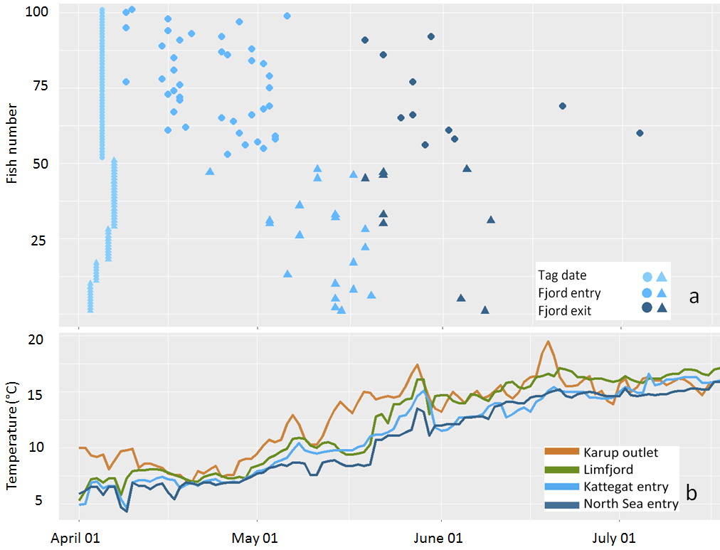
Figure 2a. Tag and registration dates of the post-smolts. Triangles are Simested-fish (lowest 51) and circles are Karup-fish (highest 50). RS3 is used as fjord entry for the Simested-fish on the figure although it is placed 11.2 km from the river outlet. The transmitters were guaranteed to last until July 23rd but expected to last until October 10th and there were no registrations in the system after July 4th. Figure 2b. Measured temperature in the river at the outlet and satellite measured surface (0-2 m) temperatures in the Limfjord and in 10x10 km areas at the eastern and western fjord-outlets to the Kattegat and North Sea. The river is generally warmer than the fjord, and the fjord is generally warmer than the sea. Temperatures are higher at the eastern sea outlet during May, but otherwise similar in the study period.

3.3 Marine phase
The distance from the river outlets to RS4 (used as the eastern fjord outlet) was 93 km for Karup-fish and 102 km for Simested-fish. RS3 was the first receiver site encountered by the Simested-fish due to the loss of the outlet-station in Simested, and the distance from RS3 to RS4 was 91 km. The distance from the river outlets to the actual eastern fjord outlet was 121 km and 132 km for Karup and Simested, respectively, while the distance to the western fjord outlet was 102 km and 113 km for Karup and Simested-fish, respectively.
Two fish from River Karup were registered at RS3 9.5 and 43.1 days after they had left the river. The first of these was not registered again thereafter, while the other was registered at RS3 again 1.9 days later and then at RS4 (eastern fjord outlet) 91 km away 5.2 days later. This fish therefore spent 45.0 days in the region close to the river outlets before migrating the 91 km from RS3 to RS4 with a velocity of 17.5 km d⁻¹.
Only one fish was detected in the western end of the fjord. This fish was from River Karup and was registered at RS2 on 3rd of May but was not registered again thereafter. No fish were registered at the western outlet of the fjord (RS1) or at RS5 which leads into a small compartment where several smaller rivers and streams run into the fjord.
A total of 20 smolts left the fjord to the east, of which nine were from River Simested and 11 were from River Karup. In total, 18 of these left between May 19th and June 9th. The remaining 2 individuals left the fjord later, on June 21st and July 4th. The registration at the eastern outlet on July 4th was the last registration of any post-smolt in the entire system in the study period that lasted until expected battery depletion in mid-October.
The mean velocity through the 93 km of fjord between the river mouth and the eastern fjord outlet at RS4 was 2.76 km d⁻¹ (SD = 0.75 km d⁻¹) or 0.20 bl s⁻¹ (SD = 0.05 bl s⁻¹) for the Karup-fish (Figure 3). The Simested-fish migrated the 91 km between RS3 and the fjord outlet at RS4 with 6.9 km d⁻¹ (SD = 4.9 km d⁻¹) or 0.44 bl s⁻¹ (SD = 0.28 bl s⁻¹). The mean residence times in the fjord for the fish that made it to the outlet was 19.5 days (SD = 10.0 days) for the Simested-fish and 38.8 days (SD = 13.5) for the Karup-fish. The values are, however, not comparable, as RS3 is located 11.3 km from the outlet of River Simested which means that the early marine phase is not included in the migration speed for the Simested-fish.
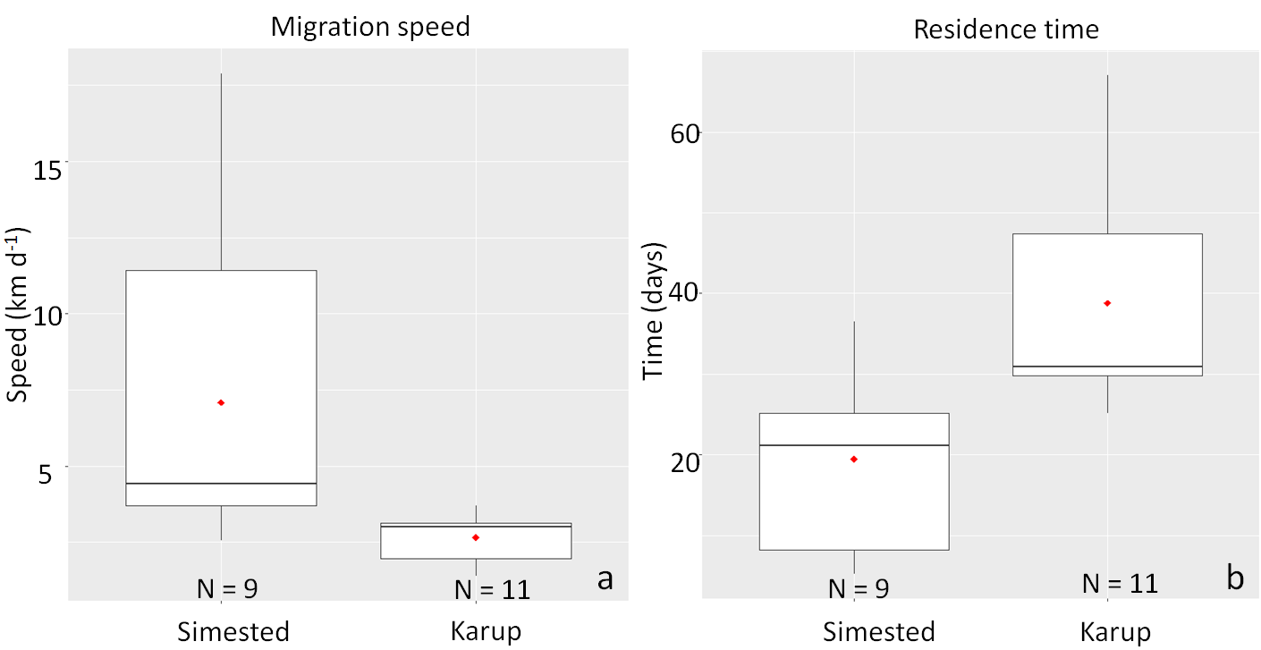
Figure 3. Migration speed (3a) and residence time (3b) in the area between river mouth and the eastern outlet at RS4 for the Karup-fish and between RS3 and RS4 for the Simested-fish. Horizontal black lines represent medians, boxes represent values between the first and the third quartiles of the data and red diamonds represent mean values. Only fish that made it out of the fjord are included. Note that the Simested-fish have already migrated 11.2 km in the fjord before reaching RS3, and the speeds and residence times are therefore not directly comparable.

The fish appeared to migrate mainly during the evening and night. In total, 80.2 % of all registrations on the hydrophones occurred between 16:00 and 4:00.
The wind data revealed generally easterly winds in the region in the beginning of May 2017 and westerly in the end of the month (Figure 4a) resulting in a mean vectorial east/west component of almost zero during the entire month (Figure 4b).
The satellite measured daily mean temperature of the fjord showed an increase in fjord temperature from 7.3º C as the first fish entered it on April 9th to 15.9º C as the last fish left it on July 4th. The mean fjord temperature during the period was 12.1º C. The mean temperature experienced by the fish at sea as they entered the Kattegat was 12.4º C with a range of 10.2º C to 15.1º C between individuals. If the fish had left the fjord in the western direction on the same dates, the mean temperature they would have experienced was 11.6º C with a range of 8.4º C to 14.9º C between individuals. Sea surface temperatures were generally lower in the North Sea than in the Kattegat during May, but similar during the rest of the study period (Figure 2b).
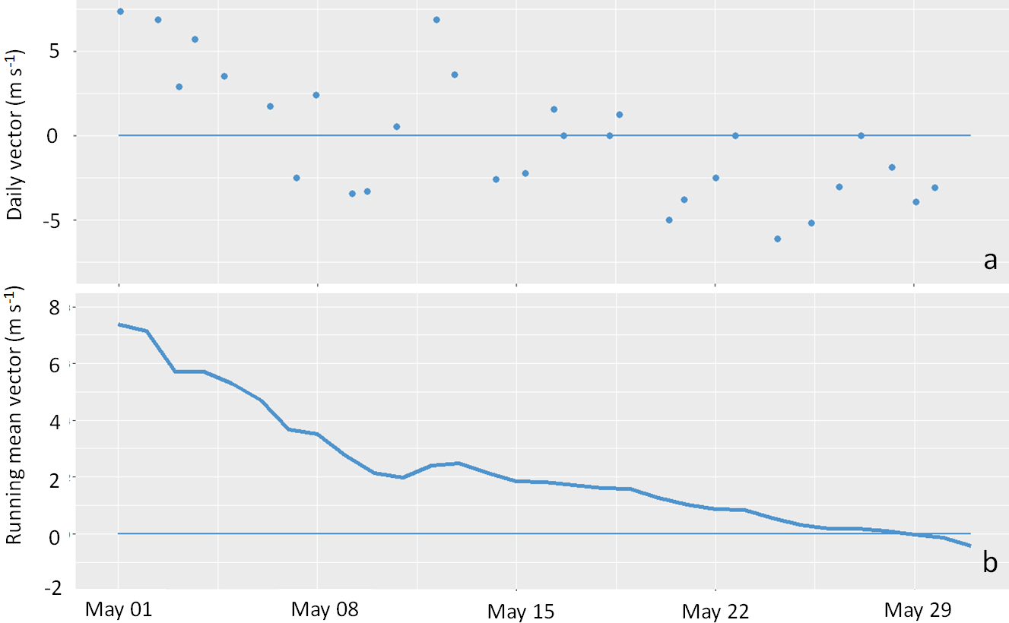
Figure 4a. Daily east/west wind vector (m s⁻¹) in the region during May 2017. Easterly winds are positive values while westerly winds are negative values. Figure 4b. The running mean east/westerly wind vector (m s⁻¹) in the same period. The winds were generally easterly in the beginning of the month and westerly in the end of the month, resulting in the mean wind movement ending close to zero in May 2017.

3.4 Survival
The combined minimum survival in river and fjord was 18 % for fish originating from River Simested and 22 % for River Karup when assuming that the remaining fish had died and had not expelled the tag or experienced tag malfunction. The survival in the fjord was 26.2 % (11/42) for the Karup-fish while the survival between RS3 and RS4 was 45.0 % (9/20) for the Simested-fish.
The mortality rate was 0.5 % km⁻¹ in the river and 0.8 % km⁻¹ in the fjord for the Karup-fish while the Simested-fish had a mortality rate of 0.6 % km⁻¹ in the fjord (between RS3 and RS4).
Length had a significant effect on the fate of fish in the fjord such that larger fish tended to leave the fjord more (logistic regression, P = 0.003; Figure 5), but condition (P = 0.56) and stream of origin (P = 0.68) had no significant effect.
The reason for mortality was not documented for the post-smolts, except for two Simested-fish where the tags were found at a random scan through cormorant nesting areas 19 and 36 km from the river outlet. Both of these post-smolts had disappeared between their tagging site 1.0 from the river outlet and RS3.
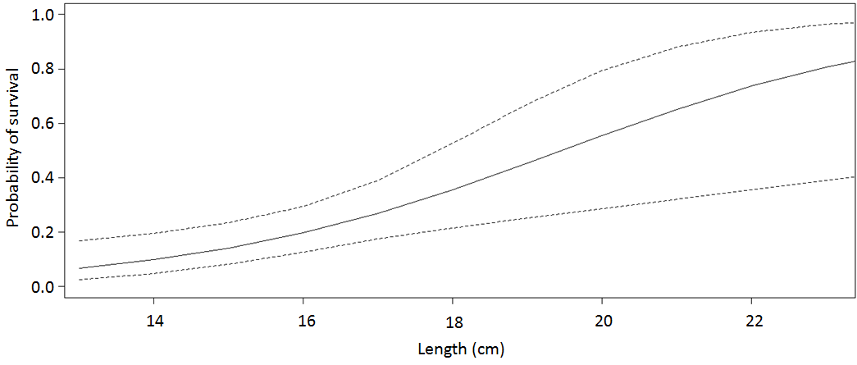
Figure 5. Modelled survival probability at different lengths with 95 % confidence intervals (dotted lines).

4. Discussion
We tracked wild brown trout post-smolts leaving the river systems and migrating through a large fjord system with two possible exit routes – one which has always existed (eastern) and another made in more recent years (western). We provide evidence that the smolts migrated out to sea through the eastern outlet of the Limfjord, and our results suggest that the smolts either appeared to leave the fjord or die in it.
4.1 Range of the receivers
The coverage generally appeared strong at the Karup river mouth and at RS3 and RS4, while post-smolts moving close to the bottom on shallow waters at RS2 could have avoided detection if they moved directly past the site. The range determined by the test at RS2 may differ in various environmental conditions or even on a daily basis (Paine et al. 2010; Thorstad et al. 2000). It is therefore possible that some fish may have migrated past RS2 and avoided detection. The fish would, however, have to move through areas with water deeper than 2 metres to get around the harbor and pier facilities present at the narrower RS1, and since no fish were detected at this site, we find it unlikely that our setup have failed to detect a westward movement in the population.

4.2 River and fjord behavior
The smolts left River Karup between April 9th and May 3rd (Figure 2a) in river temperatures ranging between 6.4º C and 11.8º C, which is within the normal period and temperatures for spring-migration in Danish smolts (Aarestrup et al. 2002, del Villar-Guerra et al. 2013).
It was expected that some of the post-smolts would residualize in the relatively large Limfjord, as previous studies have showed variable residency and migratory behavior for smolts in fjord systems. For example, no smolts stayed in the small Randers fjord (Aarestrup et al. 2014), few stayed in the larger and deeper Mariager Fjord (del Villar-Guerra et al. 2013) while all or a large proportion of post-smolts and adult fish stayed in the larger Norwegian fjords (Thorstad et al. 2007; Jensen et al. 2014; Eldøy et al. 2015, Flaten et al. 2016). It was thus expected that a proportion of post-smolts would stay in the Limfjord, but we found no evidence of any post-smolts residing in fjord after July 4th despite evidence for an abundance of food items there (Ebert 2004). In fact, only two post-smolt detections were made after June 9th, and both of these were from fish that appeared to be leaving. The lack of evidence for post-smolt residency in the fjord was surprising given that the Limfjord is comparable to the Norwegian fjords in terms of surface area, and the Danish Mariager Fjord in terms of depth. While it is not impossible for individuals to have residualized in the fjord without being detected, we find it unlikely that the fish would remain undetected by one of the receiver stations before the expected battery-lifetime ended in mid-October if a large proportion of the fish had stayed. Of the 20 post-smolts detected to leave the compartment between the Simested-outlet and RS3, 11 disappeared between RS3 and RS4 (the fjord outlet) and could have residualized permanently in the fjord. Mortality per km was already low between RS3 and RS4 for the Simested-fish, and we therefore find it unlikely that a large proportion of these 11 post-smolts settled as permanent fjord-residents, though we cannot make this conclusion for certain.
Temperatures in the fjord ranged between 7.3º C from the first entry of a tagged fish to 15.9º C as the last fish left it, and fjord temperatures were generally higher than temperatures at the sea outlets during the study period (Figure 2b). Brown trout growth is reported as optimal in temperatures ranging between 12-17º C (Elliott & Hurley 2000 a b, Larsson 2005) and individuals may seek areas with warmer temperatures when residing in cold waters (Jensen et al. 2014). However, with 18 of 20 fish leaving the fjord into colder sea water before fjord temperatures reached 14.0º C in the present study, we suggest temperatures are not the main driver in the decision to leave the Limfjord.
These results suggest that a shallow, highly productive and eutrophicated fjord environment may not provide a well- suited post-smolt growth habitat for the fish to stay in, even if the mortality associated with migrating through it may be high.
Studies with mark-recapture and genetic assignment techniques reveal a high abundance of Limfjord-trout in the Kattegat-Western Baltic region (data unpublished). Our findings support these observations: post-smolts appear to migrate eastward through the Limfjord into the Kattegat, where they presumably undergo their somatic growth and return to their native rivers through the Limfjord as sea trout.
Once beyond the river outlet, all but one fish headed in the eastern direction towards the Kattegat even though the distance to the western outlet is approximately 19 km shorter from both rivers. This clear preference for migrating east occurred despite the net current in the fjord being neutral during May 2017. We therefore hypothesize that the choice to go east may be rooted in historical reasons, as the fish may be evolutionarily adapted for going east as the western opening did not exist until 1825 (Meesenburg 1996).
Local adaptations are common in trout populations and may influence individual migratory behavior by conferring some advantages that may help the fish survive the dangers that the populations have been commonly exposed to (Quinn and Brannon, 1982; Fraser et al. 2011). Analysis of scale samples from the 1910s and 1950s have revealed that the gene pools of the Karup and Simested trout populations are almost unaltered (6 % for Karup and little or no change in Simested) by previous stockings with non-indigenous trout (unpublished). We therefore find it likely that the anadromous brown trout populations in those rivers are still genetically adapted for migrating east. Local adaptations of this type have previously been documented in sea trout in the Baltic region by Svärdson and Fagerström (1982) and Järvi et al. (1996), and the preference of the Simested- and Karup-fish for going east suggests that any advantage of taking the shorter western route to the sea has not been large enough to modify the inherited preference of the population, even though the opportunity to go west has existed since 1825.
It is possible that differences in osmoregulatory cost associated with migrating west towards the more saline North Sea (30-33 versus 20-25 in the Kattegat) has helped maintaining the eastward movement to the less saline Kattegat/Baltic seas. The advantage conferred by migrating into a salinity of 8-10 units lower may not counterweigh the costs associated with migrating an additional 19 km in the fjord perhaps because osmoregulatory costs and mechanisms are complex, and thus post-smolts may continue to choose the eastern outlet (Morgan and Iwama 1991; Morgan and Iwama 1999; Baeuf and Payan 2001). Other factors, such as differences in predation risk, may also be important drivers along the different routes, but their extent along each route remain unknown.

4.3 Migration speed
Simested-fish migrated with a velocity of 6.9 km d⁻¹ between RS3 and the eastern outlet at RS4, while the Karup-smolt migrated with a velocity of 2.8 km⁻¹ through the fjord (Figure 3). As a consequence, the residence time of the Simested-fish was shorter (19.5 days) than the Karup-fish (38.8 days). The 11 Karup-fish and nine Simested-fish that arrived at RS4 at the eastern outlet did, however, arrive at approximately the same time. The difference in migration speed between the two populations is likely to be a result of slow initial migration after leaving the river, as the speed of the Simested-fish in the first 11.2 km of the fjord is not included in their average fjord migration speed due to the loss of the receiver at the Simested river outlet. A similar slow initial migration has previously been documented by Middlemas et al. (2009). This is corroborated by the late arrival at RS3 for the Simested-fish, which on average arrived at the RS3-site 11.2 km from the river outlet 20 days later than the Karup-fish had arrived at the Karup-outlet in spite of 34/51 of the Simested-fish being released just 1.0 km from the river-outlet. Adding 20 days and 11.2 km to the movement data on the Simested-fish, results in them having a mean velocity of 2.8 km⁻¹, which is exactly the same as the Karup-fish.
We acknowledge the limitations of the comparisons we can make based on speed measurements given the loss of the Simested outlet receiver. Nonetheless, the migration speed for Karup-fish is comparable to those from previous studies with similar set ups. With a speed of 2.8 km d⁻¹, Karup-fish migrated slower than fish from the nearby Randers fjord (appr. 5 km d⁻¹ in the outer fjord; Aarestrup et al. 2014) where all smolts also left the fjord. This is likely due to the Limfjord having a more chaotic flow pattern than the Randers fjord, which is narrow and has a general outgoing current in the surface layers due to the high outflow of freshwater into the fjord.
4.4 Survival
We further demonstrate that the period following marine entry is associated with high mortality in anadromous brown trout in the Limfjord. Only 20 of 51 smolts from River Simested made it to RS3 (11.2 km from the river mouth), despite 34 of the smolts having been tagged 1.0 km from the river mouth. Furthermore, no post-smolts were detected as returning to the Simested-river after the missing receiver was replaced on 30th of May, although severe hypoxia developed in the area between the Simested-outlet and RS3 during July (Hansen et al. 2017). We suggest that early mortality was high, although the exact reason for disappearing has only been documented for two fish, where the tags have been found later in random searches through cormorant nesting areas located 19 and 36 km from the river outlet.
In general, the obtained values for survival in the fjord must, however, be considered minimum values, as tag malfunctioning, tag expulsion, lack of detection or residency outside receiver range may lead to under-estimation of survival. In addition, the tagging and handling process may have affected the fish by inducing some degree of stress, which may have had delayed consequences such as reduced growth and survival of tagged individuals compared to untagged conspecifics (Jepsen et al. 2008).
Minimum cumulative river and fjord survival was similar between fish originating from either rivers (19 % and 22 %), suggesting that fish from both populations sustain similar mortality rates in the rivers and fjord. Minimum survival was relatively low (20%) in comparison to those found in the adjacent Randers fjord by Aarestrup et al. (2014) (79 %) and Mariager Fjord by Villar-Guerra et al. (2013) (53 % left the fjord, 47 % stayed or died in the fjord). However, mortality per km was found to be similar with a range of 0.6- 0.9 % km⁻¹ in Randers fjord, and 0.8 % km⁻¹ and 0.6 % km⁻¹ for Karup- and Simested-fish respectively, when the post-smolts that disappeared in the fjord are assumed dead. This suggests that the distance which must be traveled within a fjord to reach the sea may be a key player in smolt marine survival and potentially also a factor that can lead to locally adapted populations that stay in the fjords like in the larger Norwegian fjords (Thorstad et al. 2007; Jensen et al. 2014; Eldøy et al. 2015, Flaten et al. 2016).
We found that larger individuals had a higher probability of surviving through the fjord than smaller individuals, perhaps due to predation as seen in other studies (e.g. Jepsen et al. 2006; Koed et al. 2006; Nathan et al. 2008). Being smaller in size may reduce swimming velocity (and thus a fish may be less likely to escape a predator), increase the number of potential predators (based on gape size of predators) but also increases the tag burden (mass of body to tag ratio). Together, these may have exposed fish to greater risks of predation, and thus lower survival. Similar size-dependent survival has previously been observed in studies investigating the migration of sea trout (e.g., Bohlin et al. 1993, Aarestrup et al. 2015) and other salmonids (e.g. Kallio-Nyberg et al. 2006), though there is also evidence for no size-dependent survival (e.g., del Villar-Guerra et al. 2013). The latter study also found a very high initial survival of 76 % after 30 days, which contradicts the classical description of high mortality during the early marine phase for post-smolts (Jepsen et al. 2006; Koed et al. 2006; Nathan et al. 2008; Middlemas et al. 2009; Thorstad et al. 2012). The same study (del Villar-Guerra et al. 2013) is also the only Danish study where a part of the tagged sea trout have been documented to stay in the fjords. This suggests that predation in Mariager Fjord is low compared to other Danish fjords, and that low predation rates are crucial for fjord residency to occur in shallow, highly productive and eutrophicated systems like the Danish fjords.
In conclusion, the present study identifies a crucial eastward route for outmigrating brown trout post-smolts through the Limfjord. Our findings suggest that post-smolts from rivers Simested and Karup do not residualize in the fjord for long periods of time despite large food abundance there, though some fish may have residualized without being detected. Because adult return rates are highly dependent on the survival of smolts and post-smolts, understanding the causes of low survival is an important step for improving population survival, productivity and sustainability. The preference for the eastward route calls for further investigation to understand the drivers for such preference. For example, the effect of salinity, predation pressure and evolutionary adaptations would be interesting avenues of future research to understand the underlying drivers behind the choice of migration route in post-smolts. The investigation of important migratory routes using telemetry provides a valuable approach to allocate conservation resources. Performing similar studies in rivers of varying sizes may also provide insight on population-specific routes, if any exist. The rivers Karup and Simested are large, and fish from smaller rivers and streams that enters the fjord may have other adaptations and behave differently. However, findings obtained from studies carried out in the Limfjord and other Danish fjords so far suggest that shallow and eutrophicated fjords may not be suited for post-smolt growth if other factors like predation pressures are unfavorable, even if the systems are large and have abundant food resources within them. This could be of potential management interest elsewhere in the world where fjords and estuaries are prone to eutrophication and predation.

5. Acknowledgments
Special thanks go to the Ocean Tracking Network for providing the receiver equipment used in this project. Additional support for the project was received from the EU Interreg project MarGen, the Limfjord-secretary and the Danish rod and net fishing license funds. Also thank you to Henry Hershey for creating the graphical abstract, Jørgen Skole Mikkelsen and Hans-Jørn Aggerholm Christensen for assisting us in the field and to DTU Aqua’s Shellfish Centre for providing bathymetry data for the fjord.

References
Aarestrup, K., Nielsen, C. and Koed, A. 2002. Net ground speed of downstream migrating radio-tagged Atlantic salmon (Salmo salar L.) and brown trout (Salmo trutta L.) smolts in relation to environmental factors. Aquatic Telemetry: 95-102
Aarestrup, K., Baktoft, H., Koed, A., del Villar-Guerro, D. and Thorstad, E. 2014. Comparison of the riverine and early marine migration behaviour and survival of wild and hatchery-reared sea trout Salmo trutta smolts. Marine Ecology Progress Series. 496: 197-206
Aarestrup, K., Baktoft, H., Thorstad, E., Svendsen, J., Höjesjö, J. and Koed, A. 2015. Survival and progression rates of anadromous brown trout kelts Salmo trutta during downstream migration in freshwater and at sea. Marine Ecology Progress Series. 535: 185-195
Andersen S.M., Teilmann J., Harders P.B., Hansen E.H., Hjøllund, D. 2007. Diet of harbour seals and great cormorants in Limfjord, Denmark: interspecific competition and interaction with fishery. ICES Journal of Marine Science 64: 1235–1245
Baeuf, G. and Payan, P. 2001. How should salinity influence fish growth? Comparative Biochemistry and Physiology Part C: Toxicology & Pharmacology 130:411–423
Bohlin, T., Dellefors, C., Faremo, U. 1993. Optimal time and size for smolt migration in wild sea trout (Salmo trutta). Can. j. Fish. Aquat. Sci. 50: 224-232.
Butler, J. R. A. and Walker, A. F. 2006. Perspectives on sea trout science and management. In Sea trout: Biology, Conservation and Management (Harries, G. and Milner, N., eds) Oxford: Blackwell Publishing
Crisp, D. T. 2000. Trout and Salmon Ecology, Conservation and Rehabilitation. Blackwell Science
Del Villar-Guerra, D., Aarestrup, K., Skov, C. and Koed, A. 2013. Fjord residency as a possible alternative in the continuum of migration to the open sea. Ecology of Freshwater Fish 2014: 23: 594-603.
Dormann, C. F., Elith, J., Bacher, S., Buchmann, C., Carl, G., Carré, G., Marquéz, J. R. G., Gruber, B., Lafourcade, B., Leitão, P. J., Münkemüller, T., McClean, C., Osborne, P. E., Reineking, B., Schröder, B.,
Drenner, S. M., Clark, T. D., Whitney, C. K., Martins, E. G., Cooke, S. J. and Hinch, S. G. 2012. A Synthesis of Tagging Studies Examining the Behaviour and Survival of Anadromous Salmonids in Marine Environments. Plos One 7 (3): e31311
Ebert, K. M. 2004. A comparative study of the diet of anadromous brown trout (Salmo trutta. L) in the Limfjord in two periods; 1958-63 and 1994-96. Master thesis report, University of Aarhus, unpublished.
Eldøy, S. H., Davidsen, J. G., Thorstad, E.B., Whoriskey, F., Aarestrup, K., Næsje, T.F., Rønning, L., Sjursen, A.D., Rikardsen, A.H. and Arnekleiv, J.V. 2015. Marine migration and habitat use of nadromous brown trout (Salmo trutta). Can. J. Fish. Aquat. Sci. 72: 1366–1378
Elliott, J. M. 1994. Quantitative Ecology and the Brown Trout. Transactions of the American Fisheries Society, Volume 123, Issue 6
Elliott, J. M. and Hurley, M. A. 2000 a. Daily energy intake and growth of piscivorous trout, Salmo trutta. Freshwater Biol. 44: 237–245
Elliott, J.M. and Hurley, M. A. 2000 b. Optimal energy intake and gross efficiency of energy conversion for brown trout, Salmo trutta, feeding on invertebrates or fish. Freshwater Biol. 44: 605–615
Flaten, A.C., Davidsen, J.G., Thorstad, E.B., Whoriskey, F., Rønning, L., Sjursen, A.D., Rikardsen, A.H., and Arnekleiv, J.V. 2016. The first months at sea: marine migration and habitat use of sea trout Salmo trutta post-smolts. Journal of Fish Biology 89:1624–1640
Fox, J. and Weisberg S. 2011. An {R} Companion to Applied Regression, Second Edition. Thousand Oaks CA: Sage. URL: http://socserv.socsci.mcmaster.ca/jfox/Books/Companion
Fraser D.J., Weir, L.K., Bernatchez L., Hansen M.M. and Taylor E.B. 2011. Extent and scale of local adaptation in salmonid fishes: review and meta-analysis. Heredity; 106(3): 404–420
Gargin, P., Poole, R. & Forde, G. 2006. Perspectives on sea trout science and management. In Sea trout: Biology, Conservation and Management (Harries, G. & Milner, N., eds), pp. 25–44. Oxford: Blackwell Publishing.
Hansen, J.W., Rytter, D., Balsby, T.J.S. 2017. Iltsvind i de danske farvande i juli-august 2017. Technical report from University of Aarhus (in Danish, with English abstract and figure texts), unpublished.
Healy S.J., Hinch S.G., Porter A.D., Rechisky E.L., Welch, D.W. Eliason, E.J., Lotto, A.G. and Furey, N.B. 2017. Route-specific movements and survival during early marine migration of hatchery steelhead Oncorhynchus mykiss smolts in coastal British Columbia. Mar Ecol Prog Ser 577:131-147.
Hofmeister R, Burchard G, Bolding K. 2009. A three-dimensional model study on processes of stratification and de-stratification in the Limfjord. Continental Shelf Research 29:1515-1524
Järvi, T., Holmgren, K., Rubin, J.F., Petersson, E., Lundberg, S., Glimsäter, C. 1996. Newly-emerged Salmo trutta Fry that Migrate to the Sea – An Alternative Choice of Feeding Habitat? Nordic J. Freshw. Res. 72 52-62
Jepsen, N., Mikkelsen, J.S., Koed, A. 2008. Effects of tag and suture type on survival and growth of brown trout with surgically implanted telemetry tags in the wild. Journal of Fish Biology 72:594-602
Jensen, J. L. A., Rikardsen, A. H., Thorstad, E. B., Suhr, A. H., Davidsen, J. G. and Primicerio, R. 2014. Water temperatures influence the marine area useof Salvelinus alpinus and Salmo trutta. Journal of Fish Biology 84: 1640–1653
Jepsen, N., Holthe, E., Økland, F. 2006. Observations of predation on salmon and trout smolts in a river mouth. Fish Man Ecol 13:341–343
Kallio-Nyberg, I., Jutila, E., Jokikokko, E., Saloniemi, I. 2006. Survival of reared Atlantic salmon and sea trout in relation to marine conditions of smolt year in the Baltic Sea. Fisheries Research 80: 295–304
Klemetsen, A., Amundsen, P.-A., Dempson, J.B., Jonsson, N., O’Connell, M.F. and Mortensen, E. 2003. Atlantic salmon Salmo salar L., brown trout Salmo trutta L. and Arctic charr Salvelinusalpinus (L.): a review of aspects of their life histories. Ecology of Freshwater Fish 12: 1–59
Koed A., Baktoft H., Bak B.D. 2006. Causes of mortality of Atlantic salmon (Salmo salar) and brown trout (Salmo trutta) smolts in a restored river and its estuary. River Res Appl 22:69–78
Larsson, S.2005. Thermal preference of Arctic charr, Salvelinus alpinus, and brown trout, Salmo trutta – implications for their niche segregation. Environmental Biology of Fishes 73: 89–96
Lucas, M., Baras, E. 2001. Migration of freshwater fishes. Blackwell Science, Oxford
Markager, S., Storm, L.M. & Stedmon, C.A. 2006: Limfjordens miljøtilstand 1985 til 2003. Sammenhæng mellem næringsstoftilførsler, klima og hydrografi belyst ved hjælp af empiriske modeller. Report from DMU, no. 577
Mathies, N.H., Ogburn, M.B., McFall, G., Fangman, S. 2014 Environmental interference factors affecting detection range in acoustic telemetry studies using fixed receiver arrays. Marine Ecology Progress Series 495:27-38
Melnychuk M.C., Welch, D.W., Walters, C.J. 2010. Spatio-Temporal Migration Patterns of Pacific Salmon Smolts in Rivers and Coastal Marine Waters. PLoS ONE 5(9): e12916.
Meesenburg, H. 1996. Man's role in changing the coastal landscapes in Denmark. GeoJournal 39.2:143-151
Middlemas, .S.J, Stewart, D.C., Mackay, S., Armstrong, J.D. 2009. Habitat use and dispersal of post-smolt sea trout Salmo trutta in a Scottish sea loch system. J. Fish Biol 74:639–651
Morgan, J.D. and Iwama, G. K. 1991. Effects of Salinity on Growth, Metabolism, and Ion Regulation in Juvenile Rainbow and Steelhead Trout (Oncorhynchus mykiss and Chinook Salmon Oncorhynchus tshawytscha. Can. I. Fish. Aquat. Sci. 46%: 2083-2094
Morgan, J.D. and Iwama, G. K. 1999. Energy cost of NaCl transport in isolated gills of cutthroat trout. American Journal of Physiology - Regulatory, Integrative and Comparative Physiology 277: R631-R639
Nathan, R., Getz, W.M., Revilla, E., Holyoak, M., Kadmon, R., Saltz, D., Smouse, P.E. 2008. A movement ecology paradigm for unifying organismal movement research. Proc Natl Acad Sci USA 105: 19052−19059
Olesen, B. 1996 Regulation of light attenuation and eelgrass Zostera marina depth distribution in a Danish embayment. Marine Ecology Progress Series 134:187-194
Payne, N.L., Gillanders, B.M., Webber, D.M., Semmens J.M. 2010. Interpreting diel activity patterns from acoustic telemetry: the need for controls. Marine Ecology Progress Series 419: 295–301
Quinn, T.P. and Brannon, E.L. 1982. The use of celestial and magnetic cues by orienting sockeye salmon smolts. Journal of comparative physiology 147:547-552
Sand-Jensen, K. and Møller, P. F. 2010. Naturen i Danmark - skovene. Gyldendal. Wind plots available at http://denstoredanske.dk/Naturen_i_Danmark/Skovene/Naturen,_mennesket_og_skovene/Skovenes_naturgivne_rammer/Klimaet (accessed 18-01-2018)
Svärdson, G., Fagerström, Å. 1982. Adaptive differences in the long distance migration of some trout (Salmo trutta) stocks. Institute of Freshwater Research, Drottningholm, 60: 51-80.
Thorstad, E.B., Økland, F., Rowsell, D. and McKinley, R.S. 2000. A system for automatic recording of fish tagged with coded acoustic transmitters. Fisheries Management and Ecology, 7: 281-294.
Thorstad, E. B., Økland, F., Finstad, B., Sivertsgård, R., Plantalech, N., Bjørn, P. A. and McKinley, R. S. 2007. Fjord migration and survival of wild and hatchery-reared Atlantic salmon and wild brown trout post-smolts. Hydrobiologia — 582:99-107
Thorstad, E. B., Whoriskey, F., Uglem, I., Moore, A., Rikardsen, A. H. and Finstad, B. 2012. A critical life stage of the Atlantic salmon Salmo salar: behaviour and survival during the smolt and initial post-smolt migration. Journal of Fish Biology 81:500–542
Thorstad, E. B., Todd, C. D., Uglem, I., Bjørn, P. A., Gargan, P. G., Vollset, K. W., Halttune, E., Kålås, S., Berg, M. and Finstad, B. 2016. Marine life of the sea trout. 163:47
Homepages:
http://www.danskehavnelods.dk/havneoplysninger.aspx?ID=474 (accessed 26-04-2018)
http://www.dmi.dk/vejr/ (accessed 12-11-2017)
http://www.marine.copernicus.eu (accessed 31-08-2017)

