Foraging response and acclimation of ambush feeding and feeding-current feeding copepods to toxic dinoflagellates
Jiayi Xu^{1, 2}, Lasse Tor Nielsen¹, Thomas Kiørboe¹
1. Centre for Ocean Life, National Institute of Aquatic Resources, Technical University of Denmark, Kemitorvet, 2800 Kgs. Lyngby, Denmark
2. Key and Open Laboratory of Marine and Estuary Fisheries, Ministry of Agriculture of China, East China Sea Fisheries Research Institute, Chinese Academy of Fisheries Sciences, 200090 Shanghai, China
Correspondence: sjxu@aqua.dtu.dk
Running head: Feeding behavior and toxin acclimation
Keywords: Feeding behavior; acclimation to toxic algae; Alexandrium tamarense; Temora longicornis; Acartia tonsa

Email address:
Jiayi Xu: sjxu@aqua.dtu.dk
Lasse Tor Nielsen: ltor@aqua.dtu.dk
Thomas Kiørboe: tk@aqua.dtu.dk

Abstract
Copepods exposed to toxic algae in ‘black box’ incubation experiments show highly varied responses, but the mechanisms cannot be revealed from such experiments and the implications to copepod and phytoplankton population dynamics consequently not evaluated. Here, we use direct video observations to examine the response and temporal acclimation (five days) of two copepods with different foraging behaviors to toxic dinoflagellates. Feeding-current feeding Temora longicornis and ambush feeding Acartia tonsa were offered three strains of toxic Alexandrium tamarense and a non-toxic control Protoceratium reticulatum . We hypothesize (i) that ambush feeders are less affected by toxic algae than feeding-current feeders, (ii) that copepods acclimate to the toxic algae, and (iii) that phytoplankton cells previously exposed to copepod cues elicit stronger responses. Both copepod species consumed the toxic algae at a reduced rate and there was no difference in their net-response, but the mechanisms differed. Temora longicornis responded in strain-specific ways by reducing its feeding activity, by rejecting captured algae, or by regurgitating consumed cells. Acartia tonsa reduced its consumption rate, jump frequency, and jump distance on all strains of the toxic dinoflagellate, and most so on copepod-cue induced cells. There was limited acclimation to algal toxins, although some behavioral responses relaxed or intensified during the first one to several days. Mortality rates were low and the various responses, thus, all allow the copepods to survive harmful algal blooms. However, the implications to algal population dynamics are species/strains specific, with only prey selection providing the toxic algae with a competitive advantage.
Introduction
It is well known that zooplankton may be affected negatively in various ways by harmful algae (HA), providing a potential mechanism for the formation of algal blooms with negative environmental implications (Turner and Tester 1997; Jonsson et al. 2009; Turner 2014). Effects on copepods, for example, range from practically no effect, to lethal or sub-lethal effects such as reduced grazing and fecundity and delayed development (Bagøein et al. 1996; Frangópulos et al. 2000; Colin and Dam 2002; Ianora et al. 2004; Selander et al. 2006). These different effects on the performance of grazers are typically demonstrated in ‘black box’ incubation experiments, where only the net effect is assessed. However, similar net effects, e.g., reduced grazing rate, may be the result of very different responses of grazer at the individual level, with radically different implications to the population dynamics of the toxin producing algae. Thus, Xu et al. (2017) demonstrated, for example, that reduced grazing rate of the copepods Temora longicornis on different strains of toxic dinoflagellate Alexandrium spp. could be the result of reduced generation of a feeding current due to reduced beating of the feeding appendages; or it could result from captured algae being consistently rejected. While the latter effect provides the toxin-producing algae with a clear competitive advantage, the former response does not, since grazing on competing algae are similarly reduced. Yet another strain of Alexandrium was readily consumed by the copepods, but most cells were subsequently fragmented and regurgitated – a big disadvantage to the copepods, but of no advantage to the – now dead - toxin-producing cell. Also, a consequent reduced population size of grazers may equally benefit other members of this phytoplankton species and its competitors. Thus, a mechanistic understanding of individual level effects of toxic algae on grazers is required to predict environmental implications.
Effects of a particular harmful algal species on a particular copepod species may vary widely between different algal strains (Teegarden 1999) and is often not related in any obvious way to differences in the measured toxin profiles (Liu and Wang 2002) suggesting that the toxins we measured may not necessarily be the components that are responsible for grazer effects (Tillmann and Hansen 2009; Xu et al. 2017). Effects of a harmful algal species may similarly vary between copepod species, and even between populations of the same copepod species due to evolutionary adaptation (Jiang et al. 2011). The genus Alexandrium, for example, one of the common dinoflagellates that have the ability to form harmful algal blooms and produce neurotoxins, such as Paralytic Shellfish Poisonings (PSP), offers an illustrative example. Despite the serious lethal or sublethal toxic effects of Alexandrium spp. on fish, marine mammals and human beings (Cembella 1998; Durbin et al. 2002; Turner 2014), the effects on copepods are highly species-specific (Teegarden 1999; Guisande et al. 2002; Ianora et al. 2004; Wohlrab et al. 2010). To further confuse the issue, the sensitivity of a grazer to a particular toxic algae may depend on its prior exposure to that algae (Colin and Dam 2002, 2007), and in some cases the production of grazer-inhibiting substances by the alga may be upregulated in response to exposure to grazers with a consequent stronger grazer impact of exposed than of unexposed cells (Selander et al. 2006, 2012, 2015).
In a previous study we examined the effects of various strains of Alexandrium spp. on the individual level feeding response of a copepod, T. longicornis (Xu et al., 2017, cf. above). We examined only the short term (four hours) response of copepods to algae that had not previously been exposed to grazers. Here, we examine the response of copepods to longer-term exposure (five days) and, in separate experiments, the effect of prior exposure of the algae to grazers. We use several different strains of Alexandrium tamarense, characterized by different toxicity profiles, and we examine the effects on two different species of copepods with contrasting feeding behaviors (feeding current feeder T. longicornis, and ambush feeder Acartia tonsa). The feeding-current feeder generates a feeding current and captures prey that arrives in the feeding current, while the ambush feeder remains motionless and captures motile prey that arrives within detection (Kiørboe 2011). Our hypotheses are (i) that copepods may acclimate to algal toxins over time, (ii) that exposed algae have a stronger negative impact on the copepods than non-exposed algae, and (iii) that the ambush feeder is less affected since it does not produce a feeding current.
Materials and methods
Experimental organisms
We used the alga Protoceratium reticulatum (CCMP 1889) as a non-toxic control prey; an inoculum was supplied by National Center for Marine Algae and Microbiota, USA (https://ncma.bigelow.org/). Three strains of Alexandrium tamarense (Alex2, Alex5, and AlexH5) with different toxin profiles were supplied by Alfred Wegener Institute. All the cultures were grown at 16 ˚C, 150 µmol photons m⁻²s⁻¹, 12 h light: 12 h dark cycle, and a salinity of 32. Algae were maintained in pasteurized, filtered sea water with B1 medium and used in late exponential growth phase. Before each experiment, the algae were diluted to the low desired concentration with filtered sea water with B1 medium.
The copepods, Temora longicornis, were collected in the Øresund region in Denmark and maintained in continuous cultures for ≈1/2 year in darkness at 15 ˚C, salinity 32, and on a mixed diet of Akashiwo sanguinea, Heterocapsa triquetra, Prorocentrum minimum, Thallasiosira weissflogii, and Rhodomonas salina. The copepod, Acartia tonsa, was taken from our long-term culture that was maintained at 17 ˚C, salinity 32, and on a diet of R. salina. Female adults were transferred to filtered sea water and starved overnight in the experiment room before each five-day experiment to remove or minimize any effects of the different feeding regimes of the animals in the cultures. Temora longicornis is a feeding current feeder that produces a continuous feeding current (van Someren Gréve et al. 2017), while A. tonsa can switch between feeding current and ambush feeding depending on the prey type. When offered large motile prey, like in the present experiments, A. tonsa is ambush feeding (Kiørboe et al. 1996).
Feeding rates estimated from black box incubation experiments
We measured feeding rates of both copepods species on all four algal strains/species in classical bottle incubation experiments (Frost 1972; Gonçalves et al. 2014). To examine the effect of exposure duration on the copepods, feeding rates were measured daily during five consecutive days using the same animals. Algae (200 cells ml⁻¹) and copepods were added to 630 ml bottles on day 0. We added 30 to 40 adult T. longicornis females or 50 to 60 adult A. tonsa females to each bottle. Bottles without copepods served as controls. For each treatment, we had three control bottles, and three bottles with animals. Bottles were placed on a plankton wheel rotated at 0.5 rpm and maintained in darkness at 16 ˚C during the entire experimental period (five days). Every 24 hours, 10 ml samples were collected for quantification of algal concentrations and the animals were sieved and then picked to new bottles with fresh algal suspensions (and/or to filming, see below). Dead animals were recorded and removed. Algae samples were fixed with Lugol’s solution and a minimum of 200 cells were counted in each sample under the inverted microscope. Ingestion rates were calculated from concentration measurements using Frost’s equations (Frost 1972).Animals for observation of feeding behavior (see below) were taken from the incubation bottles in association with the sampling above: All the A. tonsa were temporarily moved to a 67 ml Nunc culture bottle for filming and subsequently returned to the incubation bottles, and we collected three T. longicornis from each bottle every day for filming. The latter were not returned to the grazing bottles.
Behavioral observations
We described the feeding behavior of the copepods during the five-day incubation period by video-recording T. longicornis and A. tonsa following the procedures of Xu et al. (2017) and van Someren Gréve et al. (2017), respectively. We made video recording continuously during the first four hours after introducing the phytoplankton and then one hour every day during the subsequent five days. The data of T. longicornis for the first four hours were taken from Xu et al (2017).
For each day and treatment, nine individual T. longicornis (three from each incubation bottle) were tethered to a human hair glued to the dorsal surface of the copepods by a small drop of cyanoacrylate glue and placed in water with the same algal suspension. One successfully glued well-condition animal from each bottle was then separately suspended in a small filming chamber (size: 10×10×10 cm³) with 200 cells ml⁻¹ of the appropriate alga, at 16 ˚C and illuminated by infrared light (wave length: 940 nm). Cells were kept in suspension by a slowly rotating magnetic stirrer. A one-hour video (four times one hour in the initial) (720 × 576 pixels; frame rate: 25Hz) was then recorded for each animal using a Phantom v210 camera equipped with lenses to yield a field of view of about 2.6 mm x 1.6 mm. Filming was started at the same time every day. The three individuals were filmed one after another. Three 10-minute sequences (0-10 min, 25-35 min, and 50-60 min) of each of the one-hour videos were analyzed manually to quantify prey capture events, ingestion events, fraction of time the animal beats its appendages, and the fraction of cells rejected or regurgitated. We additionally and simultaneously recorded with the same camera a few (4-14) 2.5 seconds sequences at high resolution and frame rate (1280 × 800 pixels; frame rate: 2200Hz), evenly distributed within the one hour, to quantify beat frequencies and illustrate the various characteristic behaviors that we observed. Temora longicornis appears unaffected by tethering (Cowles and Strickler 1983; Yen and Strickler 1996): they can survive for many days, actively feeding and producing fecal pellets and eggs.
Acartia tonsa is an ambush feeder and thus tethering prevents it from capturing prey. It also does not survive tethering well, and so we filmed free swimming individuals during the five-day period. For each day and treatment, three 67 ml flasks with all the 50-60 individuals from each of the bottles from the incubation experiment were placed in front of the camera (field of view: 25.6 mm x 16.0 mm), one at the time, and filmed for four hours (at day 0) or one hour (at day 1-5) at the appropriate algal concentration of 200 cells ml⁻¹. We filmed at high resolution and moderate frame rate (1280 × 800 pixels; frame rate: 200Hz) and saved 16 (or 4) 27-second videos distributed evenly over the four hours (or one hour). Algal concentrations were checked and maintained at ≈ 200 cells ml⁻¹ after every hour in the initial four hours and flasks were gently rotated to re-suspend algal cells between each video recording. The animals were returned to the grazing bottles after filming
We analyzed 2-dimensional projections of copepod swimming tracks using Labtrack software (DiMedia), and subsequently ran the swimming tracks through a custom made R-script that classified the behavior of each individual over time (sinking, swimming, jumping) and quantified jump length, speeds, and event durations, all as described by van Someren Gréve et al. (2017). The density of A. tonsa in this filming experiment was high, up to 1 copepod ml⁻¹, which exceeds typical densities in nature although such high densities have been reported (Berasategui et al. 2016). Previous experiments have, however, demonstrated that behavior of A. tonsa is independent of concentration even at these densities (Dur et al. 2011; Kiørboe et al. 2017).
To examine the effect of grazer-exposed vs non-exposed algae (A. tamarense strain Alex5) on copepod behavior we recorded the behavior of A. tonsa offered exposed algal cells during a five-day exposure period. Exposed algal cells (referred to as Alex5+) were produced by submerging caged copepods at a concentration of 50 copepods L⁻¹ in the algal culture from day 0 onwards following Selander et al. (2012): A copepod cage was made from a 50 ml polypropylene tube; the bottom and part of the sides were closed with 8 µm plankton mesh that constrained algae and copepods to their original compartments but allowed copepod cues to move between cage and flask. Dead copepods in the cage were replaced by fresh individuals every day.
In all experiments, algal samples were collected every day for toxin measurements.
Toxin analyses
Ten to 20 ml of cell culture (≈ 2000 cells ml⁻¹) was centrifuged at 2150 g for 15 minutes. Most of the supernatant was then removed and the cells re-suspended and centrifuged a second time (3200 g, 15 min). All the supernatant was removed. The dry cell pellets were kept at -20 ˚C. The cell concentrations of both the original algal cultures and the supernatants were measured such that we could calculate the number of cells in the pellets. Paralytic shellfish poisonings (PSP) were analyzed at Alfred Wegener Institute, Germany, as described in Xu et al. (2017). Due to shortage of cells of strain Alex2 we were unable to measure their toxicity and therefore used the values reported earlier of cells grown under the same conditions (Xu et al. 2017).
Statistical analysis
On-way and two-way ANOVAs with Holm-Sidak post hoc test were used to test the differences of behaviors between and within treatments and times. In all comparisons, the number of bottles, not the number of copepods or swimming tracks, was considered the level of replication. We tested for normality, and in some cases log-transformation of data were necessary to meet the normality criterion of the statistical tests. In examining time effects, variation between bottles was considered independent of temporal variation. T-test was used to compare the mean values between the initial four hours and the subsequent five days. All analyses were done using SigmaPlot 13.0.
Results
Toxin content and composition
The Protoceratium reticulatum and the three Alexandrium tamarense prey cells were of similar sizes (Table 1). Saxitoxin (STX) and three other derivatives (C1/C2, GTX1/4, and NEO) of paralytic shellfish poisonings (PSP) were identified (Table 1). Strain Alex5 had high cell toxicity (expressed as saxitoxin equivalents, STXeq) and contained all derivatives. Strain AlexH5 also had high cell toxicity but lacked STX and contained consistently less NEO. The toxicity of the two strains varied significantly between the experiments with Temora longicornis and Acartia tonsa, particularly Alex5. Comparing PSP toxin profiles of strains Alex5 and Alex2 between studies (Tillmann et al. 2009; Wohlrab et al. 2017; Xu et al. 2017) demonstrates similar variability, independent of growth conditions. We obtained no toxin profile of strain Alex2 in the present experiments but based on Xu et al. (2017) we can assume that it contained all derivatives except GTX1/4 and – despite the above reported variability - that the toxin contents were substantially lower than those of strain Alex5 or AlexH5. The strain of P. reticulatum did not contain any PSP toxins and worked as a non-toxic control prey.
The cell toxicity of strain Alex5 exposed to copepod cues (strain Alex5+) varied by a factor of about 1.5 over time but not more so than unexposed cells, and exposed and unexposed cells thus had similar average toxin contents (Fig. 1).
Incubation experiments
The ingestion rate of T. longicornis differed significantly between the four different prey and between days (two-way ANOVA, p< 0.001 and p<0.05, respectively; Fig. 2a and 3a) with the temporal variation mainly due to the significant increase of P. reticulatum ingestion rate over the five-day period (one-way ANOVA, p<0.001; Fig. 3a). The ingestion rate of the non-toxic control alga, P. reticulatum, was the highest, but ingestion rate of A. tamarense strain Alex2 was nearly as high, while the ingestion rate of strains Alex5 and AlexH5 were substantially and significantly lower. The relative variation of ingestion rates of T. longicornis between the four prey was confirmed in the filming experiment (see below; Fig. 4a).
The ingestion rate of A. tonsa varied significantly both between prey and between days (two-way ANOVA, p<0.001). The consumption of the non-toxic P. reticulatum was the highest (Fig. 2b) and again increased over time (Fig. 3b). The consumption of strains Alex2 and Alex5 were about half of that, while AlexH5 was consumed at an intermediate rate, and the consumption ofAlex5+ was the lowest (Fig. 2b).
Mortality rates of copepods in the incubation experiments were low, particularly for A. tonsa (Fig. 2c, d). Still, mortality rates of T. longicornis differed between days and prey (two-way ANOVA, p<0.05 and p<0.001, respectively; Fig. 2c) but not in a way that was related to differences in consumption rates.
Temora longicornis feeding behavior
The five-day ingestion rates of T. longicornis recorded in the filming experiment largely mimicked the consumption rates measured in the incubation experiments, both with respect to magnitude and differences between prey cells (Fig. 4). Differences between prey were, however, even more pronounced than found in the incubation experiment, varying by a factor of five between prey. With one exception, AlexH5, average consumption rates during the initial four hours, as recorded in our earlier experiments (Xu et al. 2017), were similar to that recorded during the subsequent five days. In AlexH5, the time-effect on consumption rate only became evident after several days, and the consumption rate of Alex5 fluctuated over time (Fig. 5).
Reduced consumption of A. tamarense relative to consumption of the non-toxic P. reticulatum was accomplished by different mechanisms for the different strains. Thus, T. longicornis reduced the fraction of time beating its feeding appendages when offered strain Alex5; it normally beats its feeding appendages to produce a feeding current for most or all the time (Fig. 4b and 5). The long-term reduction of feeding on strain AlexH5, in contrast, was due to a larger fraction of captured cells being rejected in addition to a moderate reduction of appendages beating (Fig. 4b and c). These effects were most evident after one to several days of incubation with the strain. In two cases, Alex2 and Alex5, the long-term rejection rate of captured cells were significantly lower than recorded during the initial four hours suggesting some acclimation of the copepods (t-test, p<0.05).
Finally, some cells were regurgitated after being ingested, and this was particularly evident in strain Alex2 (Fig. 4d). Again in this case there appeared to be some acclimation of the copepod, since the fraction of regurgitated cells decreased significantly after the first four hours of incubation (t-test, p<0.05).
Acartia tonsa feeding behavior
Acartia tonsa was swimming for about 20 % of the time, both during the initial four hours and the subsequent five days, and independent of prey type (Fig. 6a), as is typical for ambush feeding behavior in this species (Kiørboe et al. 1996). When ambush feeding, prey encounter is rather related to its jumping behavior.
Jump distance varied between treatments (Fig. 6b). Typical jump distances were about 0.6 mm, but when offered strains AlexH5 and particularly Alex5 and Alex5+, average jump distances decreased significantly, particularly in the long-term treatment (two-way ANOVA, Holm-Sidak post hoc test, p<0.001, for each comparison). This is due to the occurrence of aberrant jumps in these treatments (Fig. 8, Appendix video 1 and 2). These jumps were of similar duration but at a lower velocity compared to the normal jumps and therefore the jump distance was reduced by about 45%. In a normal jump, the swimming legs beat sequentially backwards to produce a strong forward motion of the copepod (Fig. 8b and c, Appendix video 1). In the aberrant jump, by contrast, the swimming legs stop in the middle of the stroke, hence producing a much slower forward thrust (Fig. 8g and h, Appendix video 2). In the 72 videos (27 seconds per video) recorded during the five days for each treatment, these aberrant jumps never occurred in videos of non-toxic control P. reticulatum, but occurred in one video of A. tamarense strain Alex2 and AlexH5, in three videos of strain Alex5, and in 16 videos of strain Alex5+. The occurrence rate of aberrant jumps was significantly higher in strain Alex5+ (one-way ANOVA, Holm-Sidak post hoc test, p<0.001, for each comparison).
Jump frequency also varied significantly between treatments (Fig. 6c and 7). When the copepods were fed strain Alex2 the jump frequency was about twice as high as on other algae during the first four hours, while during the subsequent five days, copepods offered non-toxic P. reticulatum jumped increasingly frequently and on average twice as frequent as on the other prey (Fig. 7). The temporal change in jump frequency on a P. reticulatum diet, and the difference in average jump frequencies between treatments were similar to variations in cell ingestion rates, with P. reticulatum consumed at the highest and temporally increasing rate, and Alex5+ cells consumed at the lowest rate, with the other three strains in between (Fig. 2b and 3b).
Induced cells (Alex5+) were consumed at a lower rate than naive cells of the same strain (Alex5) (Fig. 2b), and caused significantly shorter jump distances, lower jump frequencies (Fig. 6 and 7), and higher fraction of short, aberrant jumps (t-test, p<0.05, for each comparison).
Discussion
Two copepod species with contrasting foraging behaviors, the feeding-current feeding Temora longicornis and the ambush feeding Acartia tonsa, consumed both non-toxic Protoceratium reticulatum and various strains of the similarly sized toxic dinoflagellate Alexandrium tamarense. Ingestion rates varied significantly between prey and the differences could largely be explained by differences in the feeding behavior of the copepods. Both copepod species consumed the non-toxic control alga at the highest rate. Temora longicornis responded to the toxic dinoflagellates in strain-specific ways by either reducing its feeding activity (Alex5), by rejecting captured algae (AlexH5), or by regurgitating consumed cells (Alex2). Acartia tonsa reduced its jump frequency and jump distances on diets of the toxic dinoflagellate (all strains) concurrent with reductions in feeding rate and in some cases also modified the execution of jumps. Repositioning jumps increase the encounter rate with prey as the jumps constantly bring the copepod to new unexploited parcels of water (Titelman and Kiørboe 2003), hence potentially explaining the rough correspondence between jump frequency and cell ingestion rate in this species (Figs 2b and 6c). Reduced jump distances to below the prey detection distance (~0.7 mm; Jonsson and Tiselius, 1990) will lead to overlap between the explored volumes, thus further reducing prey encounter rate. As observed in previous studies, there was no apparent relationship between toxin profiles of the various cell strains and the observed behavioral response of the copepods (Liu and Wang 2002; Teegarden et al. 2008; Tillmann and Hansen 2009; Xu et al. 2017). Below we first discuss the three hypotheses erected in the introduction, and then discuss the ecological implications of our findings.
Acclimation of the copepods to toxic algae
For both copepod species, the initial consumption rates of the various strains of toxic algae were mostly maintained during the subsequent five days, while the consumption of the non-toxic control alga increased (for unknown reasons). Thus, individual acclimation in the sense that the copepods become able over time to increase their utilization of the toxic strains did not happen at this time-scale. But the copepods may change their behavior over time thereby reducing their consumption of toxic cells, as described above. Behavioral changes may in T. longicornis occur within one or a few hours (Xu et al. 2017) or one or a few days after exposure to toxic cells, e.g., reduced feeding activity with Alex5 and AlexH5 after two-three days and increased rejection of strain AlexH5 cells after one day (Fig. 4). The reduced feeding activity of T. longicornis with strain Alex5 and AlexH5, as well as the induction of ‘aberrant’ jumps of A. tonsa with some strains are probably a consequence of cell-toxin consumption – such as neurotoxins – rather than an active adjustment to reduce cell consumption rate.
The various time-lags in the response of copepods to the effects of various strains may have implication for the conduction and interpretation of effect studies, and incubation studies conducted for shorter periods than the time-lag may erroneously conclude that a certain algae has no deleterious effects. For example, Xu el al. (2017) in four-hour filming experiments with T. longicornis concluded that strain AlexH5 had no negative effects on the grazer, while the present experiments demonstrate a significant reduction in feeding activity, but only after several days of exposure. The experimental durations in copepod effect studies vary widely in the literatures, for instance, 40 minutes (Hong et al. 2012), 24 hours (Teegarden 1999), three days (Selander et al. 2006), or six days (Frangópulos et al. 2000), thus often shorter than the time-lag reported here. Such variation can be one reason for different conclusions about the effects of toxic algae on copepods, even within the same species of copepod and phytoplankton.
While we found no acclimation to consume and thrive on toxic algae at the individual time scale, similar to results from Barreiro et al. (2006) and Colin and Dam (2003), there are several examples of trans-generational adaptations at the population time scale in copepods and other zooplankton. Thus, zooplankton may adapt to toxic algae in the course of several weeks (Gustafsson and Hansson, 2004) or a few years (Colin and Dam 2002), and adapted resistance may be lost again after just two generations of relaxed selection (Jiang et al. 2011). The latter also implies that our laboratory cultures of copepods may have lost resistance to the examined toxic species, thus resembling naïve population of Acartia previously unexposed to Alexandrium sp., and therefore vulnerable to Alexandrium sp. toxicity (Colin and Dam 2002).
Do copepod cues induce a stronger negative impact of the alga?
The dinoflagellate Alexandrium tamarense is demonstrated to have several grazer-induced responses to cues from copepods, including suppressed chain formation and increased contents of PSP toxins (Selander et al. 2006, 2011; Bergkvist et al. 2008). Thus, for example, Selander et al. (2012) found that the PSP toxin contents of A. tamarense increases two-fold after three days of exposure to waterborne cues from caged A. tonsa. Selander et al. (2006) found a reduced feeding rate in A. tonsa on induced vs. non-induced cells of a different Alexandrium species (A. minutum), but their experiments did not reveal the behavioral mechanism that caused the reduced grazing. We observed a significantly lower grazing rate on induced than on un-induced cells of A. tamarense strain Alex5 (Fig. 2). This reduction is presumably due to reduced jump distances and jump frequencies and a five-fold increase in the occurrence of aberrant jumps, possibly a direct effect of the consumption of toxic substances. However, the PSP toxicity of Alex5+ was not significantly increased compared to the toxicity of un-induced Alex5 cells (Fig. 1), similar to the findings of Wohlrab et al. (2017). Thus, the relationship between reduced consumption of induced cells and the cells’ contents of PSP toxins remain ambiguous.
This ambiguity in the relation between behavior and PSP toxicity applies also to the other predator-prey combinations tested here: There was no clear relation between PSP profiles of the prey cells and the feeding behavior of T. longicornis or A. tonsa. Thus, the PSP that we measure may not be the compounds that cause behavioral changes or toxic effects in the copepods. PSP can cause serious human illness (Hille 1968; Halstead et al. 1984) and paralytic shellfish poisoning and consequently Alexandrium spp. – the main PSP producers - have been widely studied, including their effects on zooplankton grazers (Turner and Tester 1997; Bricelj et al. 2005; Wiese et al. 2010; Turner 2014). However, in many cases, the interactions between Alexandrium spp. PSP profiles and zooplankton grazers are unclear and sometimes with contradictory results (Kamiyama and Suzuki, 2006 and as reviewed by Turner et al., 1998). There is increasing evidence that many extracellular metabolites of Alexandrium spp. have lytic activity and/or other allelochemical effects on their competitors (Tillmann and Hansen 2009) and grazers (Tillmann et al. 2008), although these compounds remain to be characterized chemically. The production of such substances may not closely parallel the production of PSP or other substances toxic to grazers but may be candidate chemical defense signal molecules – similar to classical aposematism - that may be induced by grazer cues.
Different toxic effects on copepods - ambush feeder is not less affected
We hypothesized that ambush feeders would be less affected by toxic algae than feeding-current feeders, because the former depend on the motility of the prey rather than on their own motility or feeding current to encounter prey. Based on the ingestion rates in incubation experiments, however, there was no evidence that ambush feeding A. tonsa was less affected by the toxins from A. tamarense than feeding current feeder T. longicornis (Fig 2a and b). The mechanisms by which feeding rates were reduced were, however, obviously different between the two foraging behaviors: reduced jump activity in the ambush feeders, and reduced appendage beating activity, increased prey rejection, and/or regurgitation of ingested cells in the feeding-current feeder. The latter two behaviors may also be found in the ambush feeder, but the lower magnification prevented us from resolving this in A. tonsa. Regurgitation of consumed toxic cells has been demonstrated in other copepods (Sykes and Huntley 1987). ‘Cryptic’ behaviors may account for some of the variation in feeding rate that cannot be explained by differences in jumping activity.
Ecological implications
In our study we did not see any acclimation to increased consumption of harmful algae (HA) by copepods over time. Rather, with varying time delays and different for the different strains, the consumption of toxic algae were reduced over time. At the individual level, during a harmful algal bloom (HAB), copepods may consume few toxic cells to survive and maintain the basic metabolism at the risk of passing accumulated toxin to the next generation or experience reduced fecundity (Frangópulos et al. 2000). Feeding and reproduction abilities may recover rapidly when the copepod is again exposed to a healthy diet (Guisande et al. 2002). Thus, reduced feeding may allow the copepod to survive a harmful algal bloom, irrespective of whether the reduction is due to regurgitation of consumed cells, reduced feeding activity, or rejection of captured cells. Algal bloom formation, however, may depend strongly on the mechanism by which the copepod reduces its feeding on the toxic algae. Only grazer deterrents that allow the copepod to reject the toxic cells while continue feeding on competing species will give the toxic algae a competitive advantage and facilitate bloom formation. In contrast, substances that induce reduced feeding activity, regurgitation of ingested cells, or reduced survival of the copepod may benefit ‘cheaters’ and competing algal species equally or more. Thus, the actual mechanism of behavioral adaptation to toxic algae has important implication to the population dynamics of the algae.
At the population level, there is plenty of evidence that copepods may evolve tolerance to harmful algae over just a few generations (Colin and Dam 2003, 2004; Kozlowsky-Suzuki et al. 2003; Jiang et al. 2011). Rapid co-evolution may be one reason for the high diversity of potentially toxic substances produced by some dinoflagellates as well as for the diversification of chemical profiles between different strains of the same species.

References:
Bagøein, E., A. Miranda, B. Reguera, and J. M. Franco. 1996. Effects of two paralytic shellfish toxin producing dinoflagellates on the pelagic harpacticoid copepod Euterpina acutifrons. Mar. Biol. 126: 361–369. doi:10.1007/BF00354618
Barreiro, A., C. Guisande, M. Frangópulos, and others. 2006. Feeding strategies of the copepod Acartia clausi on single and mixed diets of toxic and non-toxic strains of the dinoflagellate Alexandrium minutum. Mar. Ecol. Prog. Ser. 316: 115–125. doi:10.3354/meps316115
Berasategui, A. A., M. D. Fernandez-Severini, M. C. Menendez, and others. 2016. Reproductive trade-off of the copepod Acartia tonsa in a hypersaline estuary of the Southwestern Atlantic. Temporal variations in the morphology of eggs. Mar. Biol. Res. 12: 817–829. doi:10.1080/17451000.2016.1203950
Bergkvist, J., E. Selander, and H. Pavia. 2008. Induction of toxin production in dinoflagellates: the grazer makes a difference. Oecologia 156: 147–154. doi:10.1007/s00442-008-0981-6
Bricelj, V. M., L. Connell, K. Konoki, S. P. MacQuarrie, T. Scheuer, W. A. Catterall, and V. L. Trainer. 2005. Sodium channel mutation leading to saxitoxin resistance in clams increases risk of PSP. Nature 434: 763–767. doi:10.1038/nature03415
Cembella, A. D. 1998. Ecophysiology and metabolism of paralytic shellfish toxins in marine microalgae, p. 381–403. In Physiological Ecology of Harmful Algal Blooms, Springer-Verlag, Heidelberg, Anderson, DM, AD Cembella, GM Hallegraeff (Eds.), NATO-Advanced Study Institute Series, 41.
Colin, S. P., and H. G. Dam. 2002. Latitudinal differentiation in the effects of the toxic dinoflagellate Alexandrium spp. on the feeding and reproduction of populations of the copepod Acartia hudsonica. Harmful Algae 1: 113–125. doi:10.1016/S1568-9883(02)00007-0
Colin, S. P., and H. G. Dam. 2003. Effects of the toxic dinoflagellate Alexandrium fundyense on the copepod Acartia hudsonica: A test of the mechanisms that reduce ingestion rates. Mar. Ecol. Prog. Ser. 248: 55–65. doi:10.3354/meps248055
Colin, S. P., and H. G. Dam. 2004. Testing for resistance of pelagic marine copepods to a toxic dinoflagellate. Evol. Ecol. 18: 355–377. doi:10.1007/s10682-004-2369-3
Colin, S. P., and H. G. Dam. 2007. Comparison of the functional and numerical responses of resistant versus non-resistant populations of the copepod Acartia hudsonica fed the toxic dinoflagellate Alexandrium tamarense. Harmful Algae 6: 875–882. doi:10.1016/j.hal.2007.05.003
Cowles, T. J., and J. R. Strickler. 1983. Characterization of feeding activity patterns in the planktonic copepod Centropages typicus Kroyer under various food conditions. Limnol. Oceanogr. 28: 106–115. doi:10.4319/lo.1983.28.1.0106
Dur, G., S. Souissi, F. Schmitt, F. G. Michalec, M. S. Mahjoub, and J. S. Hwang. 2011. Effects of animal density, volume, and the use of 2D/3D recording on behavioral studies of copepods. Hydrobiologia 666: 197–214. doi:10.1007/s10750-010-0586-z
Durbin, E., G. Teegarden, R. Campbell, A. Cembella, M. F. Baumgartner, and B. R. Mate. 2002. North Atlantic right whales, Eubalaena glacialis, exposed to paralytic shellfish poisoning (PSP) toxins via a zooplankton vector, Calanus finmarchicus. Harmful Algae 1: 243–251. doi:10.1016/S1568-9883(02)00046-X
Frangópulos, M., C. Guisande, I. Maneiro, I. Riveiro, and J. Franco. 2000. Short-term and long-term effects of the toxic dinoflagellate Alexandrium minutum on the copepod Acartia clausi. Mar. Ecol. Prog. Ser. 203: 161–169. doi:10.3354/meps203161
Frost, B. W. 1972. Effects of size and concentration of food particles on the feeding behavior of the marine planktonic copepod Calanus pacificus. Limnol. Oceanogr. 17: 805–815. doi:10.4319/lo.1972.17.6.0805
Gonçalves, R. J., H. Van Someren Gréve, D. Couespel, and T. Kiørboe. 2014. Mechanisms of prey size selection in a suspension-feeding copepod, Temora longicornis. Mar. Ecol. Prog. Ser. 517: 61–74. doi:10.3354/meps11039
Guisande, C., M. Frangópulos, Y. Carotenuto, I. Maneiro, I. Riveiro, and A. Ruth Vergara. 2002. Fate of paralytic shellfish poisoning toxins ingested by the copepod Acartia clausi. Mar. Ecol. Prog. Ser. 240: 105–115. doi:10.3354/meps240105
Gustafsson, S., and L.-A. Hansson. 2004. Development of tolerance against toxic cyanobacteria in Daphnia. Aquat. Ecol. 38: 37–44. doi:10.1023/B:AECO.0000020985.47348.5e
Halstead, B. W., E. J. Schantz, and World Health Organization. 1984. Paralytic shellfish poisoning.
Hille, B. 1968. Pharmacological Modifications of the Sodium Channels of Frog Nerve. J. Gen. Physiol. 51: 199–219. doi:10.1085/jgp.51.2.199
Hong, J., S. Talapatra, J. Katz, P. A. Tester, R. J. Waggett, and A. R. Place. 2012. Algal toxins alter copepod feeding behavior. PLoS One 7: e36845. doi:10.1371/journal.pone.0036845
Howard, M. D. A., G. J. Smith, and R. M. Kudela. 2009. Phylogenetic relationships of yessotoxin-producing dinoflagellates, based on the large subunit and internal transcribed spacer ribosomal DNA domains. Appl. Environ. Microbiol. 75: 54–63. doi:10.1128/AEM.00818-08
Ianora, A., J. T. Turner, F. Esposito, and others. 2004. Copepod egg production and hatching success is reduced by maternal diets of a non-neurotoxic strain of the dinoflagellate Alexandrium tamarense. Mar. Ecol. Prog. Ser. 280: 199–210. doi:10.3354/meps280199
Jiang, X., D. J. Lonsdale, and C. J. Gobler. 2011. Rapid gain and loss of evolutionary resistance to the harmful dinoflagellate Cochlodinium polykrikoides in the copepod Acartia tonsa. 56: 947–954. doi:10.4319/lo.2011.56.3.0947
Jonsson, P. P., and P. Tiselius. 1990. Feeding behaviour, prey detection and capture efficiency of the copepod Acartia tonsa feeding on planktonic ciliates. Mar. Ecol. Prog. Ser. 60: 35–44. doi:10.3354/meps060035
Jonsson, P. R., H. Pavia, and G. Toth. 2009. Formation of harmful algal blooms cannot be explained by allelopathic interactions. Proc. Natl. Acad. Sci. 106: 11177–11182. doi:10.1073/pnas.0900964106
Kamiyama, T., and T. Suzuki. 2006. Lack of accumulation of paralytic shellfish poisoning (PSP) toxins in the tintinnid ciliate Favella taraikaensis feeding on the toxic dinoflagellate Alexandrium tamarense. Mar. Ecol. Prog. Ser. 317: 57–65. doi:10.3354/meps317057
Kiørboe, T. 2011. How zooplankton feed: mechanisms, traits and trade-offs. Biol. Rev. 86: 311–339. doi:10.1111/j.1469-185X.2010.00148.x
Kiørboe, T., E. Saiz, P. Tiselius, and K. H. Andersen. 2017. Adaptive feeding behavior and functional responses in zooplankton. Limnol. Oceanogr. doi:10.1002/lno.10632
Kiørboe, T., E. Saiz, and M. Viitasalo. 1996. Prey switching behaviour in the planktonic copepod Acartia tonsa. Mar. Ecol. Prog. Ser. 143: 65–75. doi:10.3354/meps143065
Kozlowsky-Suzuki, B., M. Karjalainen, M. Lehtiniemi, J. Engström-Öst, M. Koski, and P. Carlsson. 2003. Feeding, reproduction and toxin accumulation by the copepods Acartia bifilosa and Eurytemora affinis in the presence of the toxic cyanobacterium Nodularia spumigena. Mar. Ecol. Prog. Ser. 249: 237–249. doi:10.3354/meps249237
Krock, B., C. M. Borel, F. Barrera, and others. 2015. Analysis of the hydrographic conditions and cyst beds in the San Jorge Gulf, Argentina, that favor dinoflagellate population development including toxigenic species and their toxins. J. Mar. Syst. 148: 86–100. doi:10.1016/j.jmarsys.2015.01.006
Liu, S., and W. X. Wang. 2002. Feeding and reproductive responses of marine copepods in South China Sea to toxic and nontoxic phytoplankton. Mar. Biol. 140: 595–603. doi:DOI 10.1007/s00227-001-0714-4
Selander, E., T. Fagerberg, S. Wohlrab, and H. Pavia. 2012. Fight and flight in Dinoflagellates? Kinetics of simultaneous grazer-induced responses in Alexandrium tamarense. Limnol. Oceanogr. 57: 58–64. doi:10.4319/lo.2012.57.1.0058
Selander, E., H. H. Jakobsen, F. Lombard, and T. Kiørboe. 2011. Grazer cues induce stealth behavior in marine dinoflagellates. Proc. Natl. Acad. Sci. 108: 4030–4034. doi:10.1073/pnas.1011870108
Selander, E., J. Kubanek, M. Hamberg, M. X. Andersson, G. Cervin, and H. Pavia. 2015. Predator lipids induce paralytic shellfish toxins in bloom-forming algae. Proc. Natl. Acad. Sci. 112: 6395–6400. doi:10.1073/pnas.1420154112
Selander, E., P. Thor, G. Toth, and H. Pavia. 2006. Copepods induce paralytic shellfish toxin production in marine dinoflagellates. Proc. R. Soc. B 273: 1673–1680. doi:10.1098/rspb.2006.3502
van Someren Gréve, H., R. Almeda, and T. Kiørboe. 2017. Motile behavior and predation risk in planktonic copepods. Limnol. Oceanogr. 62: 1810–1824. doi:10.1002/lno.10535
Sykes, P. F., and M. E. Huntley. 1987. Acute physiological reactions of Calanus pacificus to selected dinoflagellates: Direct observations. Mar. Biol. 94: 19–24. doi:10.1007/BF00392895
Teegarden, G. J. 1999. Copepod grazing selection and particle discrimination on the basis of PSP toxin content. Mar. Ecol. Prog. Ser. 181: 163–176. doi:10.3354/meps181163
Teegarden, G. J., R. G. Campbell, D. T. Anson, A. Ouellett, B. A. Westman, and E. G. Durbin. 2008. Copepod feeding response to varying Alexandrium spp. cellular toxicity and cell concentration among natural plankton samples. Harmful Algae 7: 33–44. doi:10.1016/j.hal.2007.05.010
Tillmann, U., and P. J. Hansen. 2009. Allelopathic effects of Alexandrium tamarense on other algae: evidence from mixed growth experiments. Aquat. Microb. Ecol. 57: 101–112. doi:10.3354/ame01329
Tillmann, U., T. Alpermann, U. John, and A. Cembella. 2008. Allelochemical interactions and short-term effects of the dinoflagellate Alexandrium on selected photoautotrophic and heterotrophic protists. Harmful Algae 7: 52–64. doi:10.1016/j.hal.2007.05.009
Tillmann, U., T. L. Alpermann, R. C. da Purificação, B. Krock, and A. Cembella. 2009. Intra-population clonal variability in allelochemical potency of the toxigenic dinoflagellate Alexandrium tamarense. Harmful Algae 8: 759–769. doi:10.1016/j.hal.2009.03.005
Titelman, J., and T. Kiørboe. 2003. Motility of copepod nauplii and implications for food encounter. Mar. Ecol. Prog. Ser. 247: 123–135. doi:10.3354/meps247123
Turner, J. T. 2014. Planktonic marine copepods and harmful algae. Harmful Algae 32: 81–93. doi:10.1016/j.hal.2013.12.001
Turner, J. T., and P. A. Tester. 1997. Toxic marine phytoplankton, zooplankton grazers, and pelagic food webs. Limnol. Oceanogr. 42: 1203–1214. doi:10.4319/lo.1997.42.5_part_2.1203
Turner, J. T., P. A. Tester, and P. J. Hansen. 1998. Interactions between toxic marine phytoplankton and metazoan and protistan grazers, p. 453–474. In Physiological Ecology of Harmful Algal Blooms, Springer-Verlag, Heidelberg, Anderson, DM, AD Cembella, GM Hallegraeff (Eds.), NATO-Advanced Study Institute Series, 41.
Wiese, M., P. M. D’Agostino, T. K. Mihali, M. C. Moffitt, and B. A. Neilan. 2010. Neurotoxic alkaloids: Saxitoxin and its analogs. Mar. Drugs 8: 2185–2211. doi:10.3390/md8072185
Wohlrab, S., M. H. Iversen, and U. John. 2010. A Molecular and Co-Evolutionary Context for Grazer Induced Toxin Production in Alexandrium tamarense. PLoS One 5: e15039. doi:10.1371/journal.pone.0015039
Wohlrab, S., E. Selander, and U. John. 2017. Predator cues reduce intraspecific trait variability in a marine dinoflagellate. BMC Ecol. 17: 8. doi:10.1186/s12898-017-0119-y
Xu, J., P. J. Hansen, L. T. Nielsen, B. Krock, U. Tillmann, and T. Kiørboe. 2017. Distinctly different behavioral responses of a copepod, Temora longicornis, to different strains of toxic dinoflagellates, Alexandrium spp. Harmful Algae 62: 1–9. doi:10.1016/j.hal.2016.11.020
Yen, J., and J. R. Strickler. 1996. Advertisement and concealment in the plankton: what makes a copepod hydrodynamically conspicuous. Invertebr. Biol. 115: 191–205. doi:10.2307/3226930

Acknowledgments
We are grateful to Bernd Krock and the staff at Alfred Wegener Institut Helmholtz- Zentrum für Polar-und Meeresforschung for toxin analysis of algal samples. We would also like to thank Urban Tillmann and Per Juel Hansen for providing algal cultures, Jack Melbye for maintaining algal and copepod cultures, and Philipp Brun for writing the R-code for swimming track analysis. Jiayi Xu is supported by a PhD fellowship from China Scholarship Council. The Centre for Ocean Life is supported by the Villum Foundation.

Figure legends
Fig. 1. Comparison of the PSP contents (fmol cell⁻¹) in Alexandrium tamarense exposed or not exposed to copepods as a function of the duration of the exposure. Alex5 (dots) are cells never exposed to copepod cues; and Alex5+ (diamonds) are cells exposed continuously to Acartia tonsa cues since the initiation of the experiment. There was only one data point for each day. Error bars show standard errors (n=4 for un-induced cells, n=6 for induced cells).
Fig. 2. Average ingestion rate and mortality rate of Temora longicornis and Acartia tonsa in five-day incubation experiments. (a) Average ingestion rate (cells copepod⁻¹ h⁻¹) of non-toxic Protoceratium reticulatum (Pr) and toxic Alexandrium tamarense (strain Alex2, AlexH5, and Alex5) by T. longicornis. (b) Average ingestion rate (cells copepod⁻¹ h⁻¹) of non-toxic P. reticulatum (Pr), A. tamarense (strain Alex2, AlexH5, and Alex5) and copepod-induced A. tamarense Alex5 (Alex5+) by A. tonsa. (c) Average mortality rate (day⁻¹) of T. longicornis fed with P. reticulatum (Pr) and A. tamarense (strain Alex2, AlexH5, and Alex5). (d) Average mortality rate (day⁻¹) of A. tonsa fed with P. reticulatum (Pr) and A. tamarense (strain Alex2, AlexH5, Alex5, and Alex5+). Error bars show standard errors (n=12 for T. longicornis fed with Alex5, n=15 for all other cases).
Fig. 3. Temporal variation in ingestion rate (cells copepod⁻¹ h⁻¹) estimated from bottle incubations of (a) Temora longicornis and (b) Acartia tonsa fed on Protoceratium reticulatum (Pr, dots), Alexandrium tamarense strain Alex2 (triangles), AlexH5 (squares), Alex5 (diamonds) and Alex5 exposed in copepods’ cues (Alex5+, stars). Error bars show standard errors (n=3 in all cases).
Fig. 4. Feeding behavior of Temora longicornis fed with Protoceratium reticulatum (Pr) and Alexandrium tamarense (strain Alex2, AlexH5, and Alex5) recorded by video observations. Data from the first four hours (dark bars) and the subsequent five days (white bars) were averaged separately. (a) Average ingestion rate (cells copepod⁻¹ h⁻¹) during filming experiments. Differences between species were significant (one-way ANOVAs, p<0.05 for initial four hours and p<0.001 for subsequent five days,) whereas differences between the initial four hours and the subsequent five days were significant only in the case of AlexH5 (t-test, p<0.001). (b) Average fraction of time that copepods beat their appendages during filming experiments. Differences between the initial four hours and the subsequent five days were insignificant whereas Alex5 differed significantly from the other species (Two-way ANOVA, p=0.846; Holm-Sidak post hoc test, p<0.001) (c) Average percentage of cells rejected after being captured by copepods during filming experiments. Differences between prey species were insignificant during the initial four hours (one-way ANOVA, p=0.919), but differed significantly during the subsequent five days (one way ANOVA, p<0.001) Differences between the initial four hours and the subsequent five days were significant for Alex 2 and Alex5 (t-tests; p=0.006 and 0.032, respectively) (d) Average fraction of cells regurgitated after being eaten by copepods during filming experiments. Differences between prey species were significant during both the initial four hours and the subsequent five days (one-way AVONAs, p<0.001). Difference between initial four hours and subsequent five days were significant for Alex 2 (t-test; p<0.05) Error bars show standard errors (n=12 for initial four hours, n=15 for subsequent five days).Data for four-hour experiments from Xu et al. (2017).
Fig. 5. Fraction of time that Temora longicornis is beating its feeding appendages as a function of time when offered the non-toxic control Protoceratium reticulatum (Pr, dots), or toxic Alexandrium tamarense strain Alex2 (triangles), AlexH5 (squares), and Alex5 (diamonds) during the first four hours and the subsequent five days. Differences are statistically significant between prey species and there is also a significant time effect during the subsequent five days (Two-way ANOVAs, p<0.05, for each comparison). Error bars show standard errors (n=3 in all cases). Data for four-hour experiments from Xu et al. (2017).
Fig. 6. Observed feeding behaviors of Acartia tonsa fed on Protoceratium reticulatum (Pr) and Alexandrium tamarense (strain Alex2, AlexH5, Alex5, and Alex5+). Data from the initial four hours (dark bars) and the subsequent five days (white bars) were averaged separately. (a) Average fraction of time copepods swim during filming experiments. (b) Average length (mm) of each jump during filming experiments. During the initial four hours Alex5 differed significantly from the other treatments (One-way ANOVA, Holm-Sidak post hoc test, p<0.05, for each comparison). During the subsequent five days AlexH5, and Alex5 differed significantly from the other treatments (One-way ANOVA, Holm-Sidak post hoc test, p<0.05 in each comparison). Also, Alex5+ was significantly less than Alex5 (t-test, p<0.05) (c) Average numbers of jumps per second during filming experiments. During the initial four hours, Alex2 differed significantly from the other treatments (One-way ANOVA, Holm-Sidak post hoc test, p<0.001 in each comparison), and during the subsequent five days, Pr differed significantly from the other treatments (One-way ANOVA, Holm-Sidak post hoc test, p<0.05 in each comparison). Also, Alex5+ was significantly less than Alex5 (t-test, p<0.05). Differences between the initial four hours and the subsequent five days were significant for Pr and Alex2 (t-tests, p<0.05, in each comparison) Error bars show standard errors. (n=12 for initial four hours, n=15 for subsequent five days).
Fig. 7. Temporal variation in jump frequency (s⁻¹) of Acartia tonsa when fed non-toxic control Protoceratium reticulatum (Pr, dots), Alexandrium tamarense strain Alex2 (triangles), AlexH5 (squares), Alex5 (diamonds), and Alex5+ (stars) varying in the initial four hours and the subsequent five days. Error bars show standard errors. (n=3 in all cases).
Fig. 8. The jump behavior of Acartia tonsa illustrated by sequential still images (from video). (a-d) A normal jump of A. tonsa fed on Protoceratium reticulatum at 0ms, 15ms, 25ms, and 50ms (resolution: 124×178 pixles). (e-h) An aberrant jump of A. tonsa fed on Alexandrium tamarense strain Alex5 at times 0ms, 15ms, 25ms, and 50ms (resolution: 130×152 pixels). Arrows show the direction and length of jumps.
Appendix video 1. Acartia tonsa normal jump. Video was recorded within the first hour after A. tonsa started feeding on Protoceratium reticulatum after starving overnight. Video is 100 times slower than real speed.
Appendix video 2. An aberrant jump of Acartia tonsa. Video was recorded after five days’ feeding of un-induced Alexandrium tamarense strain Alex5. Video sequence slowed down 100 times.
Table 1. List of phytoplankton used as prey for Temora longicornis and Acartia tonsa in video observations with their toxin profiles and contents (means ± SD). ESD is equivalent spherical diameter; PSP are paralytic shellfish poisonings; STXeq means saxitoxin equivalents; ‘-’ indicates toxin levels below the limit of detection.
Algae | Strain | ESD (µm) | Copepods | PSP (fmol cell⁻¹) |  |  |  |  | Cell Toxicity  (pg STXeq cell⁻¹)
 |  |  |  | C1/C2 | GTX1/4 | NEO | STX | total
Protoceratium reticulatum | CCMP1889¹ | 32.0±2.3 | T. longicornis | - | - | - | - | - | -
 |  |  | A. tonsa | - | - | - | - | - | -
Alexandrium tamarense | Alex5² | 33.8±0.5 | T. longicornis | 27.9±5.6 | 10.6±2.7 | 22.2±4.0 | 1.5±0.2 | 62.2±11.7 | 12.5±2.3
 |  |  | A. tonsa | 55.9±10.6 | 23.9±1.2 | 34.2±6.4 | 8.6±2.1 | 122.6±20.2 | 24.3±3.6
 |  |  | A. tonsa⁴ | 57.4±9.4 | 13.6±4.1 | 42.2±7.6 | 4.5±0.8 | 117.8±21.3 | 22.1±4.4
 | AlexH5³ | 31.6±0.7 | T. longicornis | 64.6±12.1 | 15.9±3.6 | 4.6±1.6 | - | 85.2±15.9 | 10.1±1.9
 |  |  | A. tonsa | 70.2±13.1 | 12.7±3.3 | 4.9±1.7 | - | 87.8±17.5 | 9.3±2.2
 | Alex2² | 31.3±2.5 | T. longicornis | 4.7⁵ | 0.0 | 4.2 | 2.1 | 11.4 | 2.3
 |  |  | A. tonsa | 4.7 | 0.0 | 4.2 | 2.1 | 11.4 | 2.3
1. Strain was originally isolated from Friday Harbor, USA (Howard et al. 2009);
2. Strain was originally isolated from North Sea off Scotland (Tillmann and Hansen 2009; Tillmann et al. 2009);
3. Strain was originally isolated from Gulf of San Jorge, Argentina (Krock et al. 2015);
4. Algae were collected from experimental culture with A. tonsa cues,
5. Data were from Xu et al. (2017).
Fig 1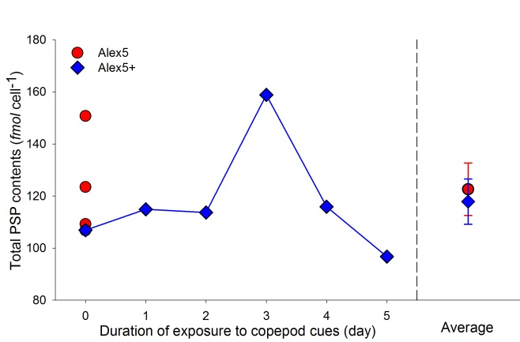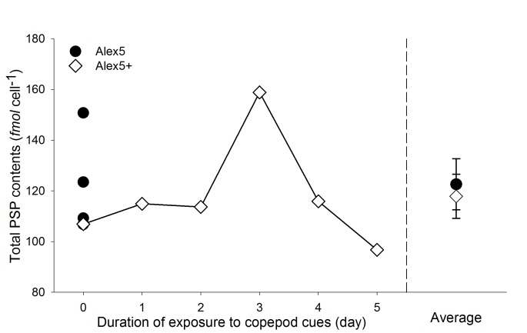
Fig 2 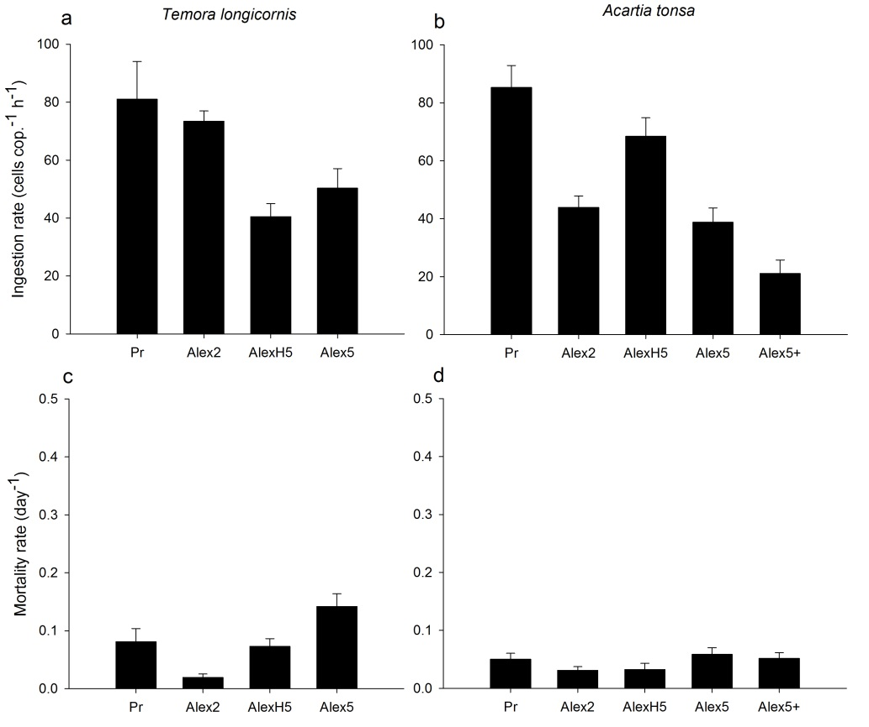
Fig 3 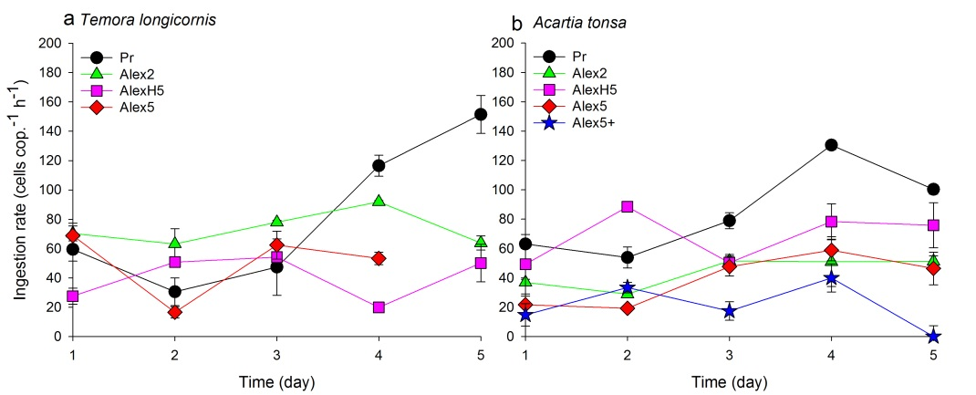
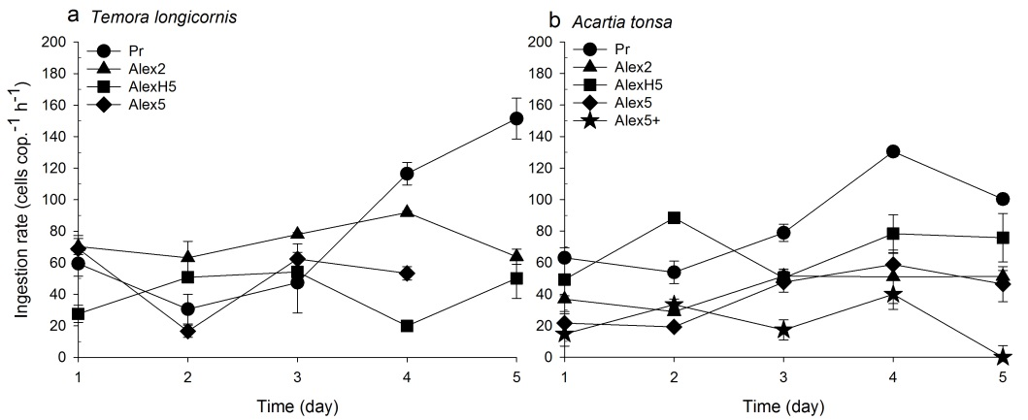
Fig 4 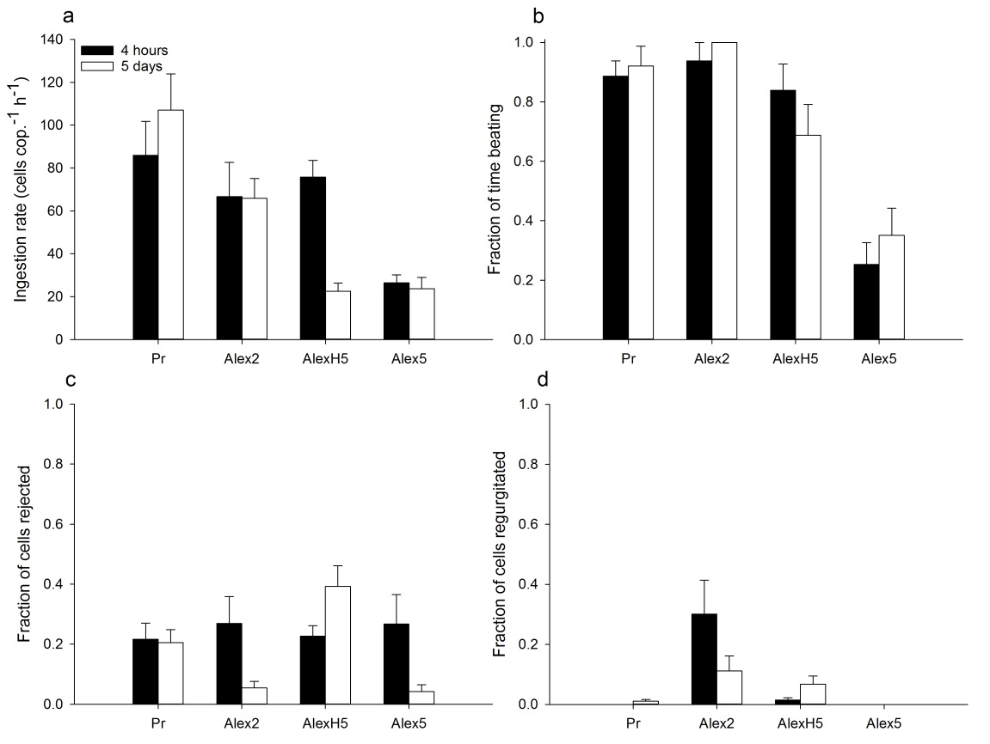
Fig 5 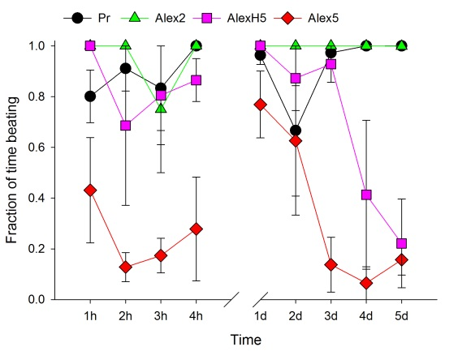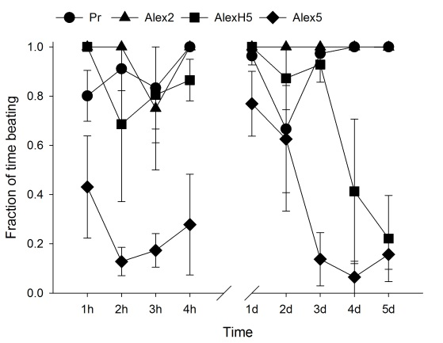
Fig 6 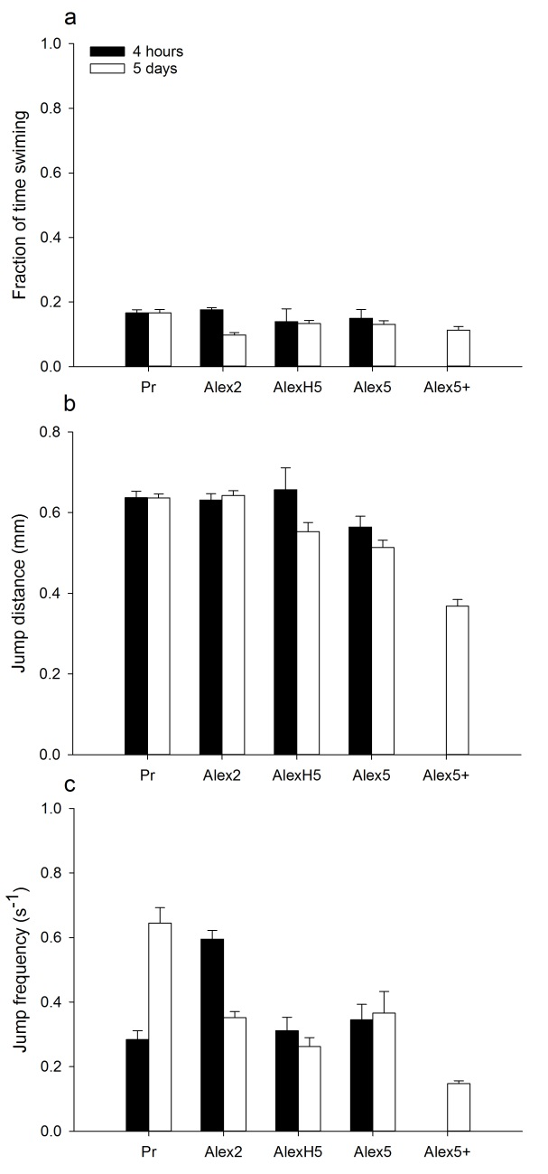
Fig 7 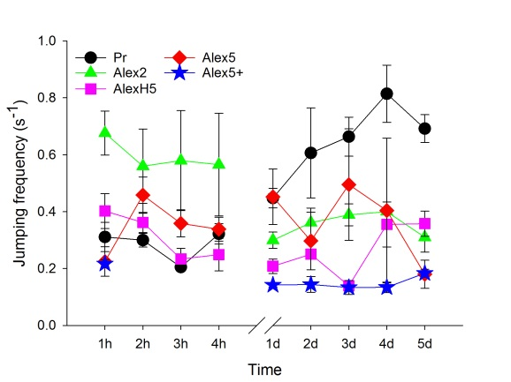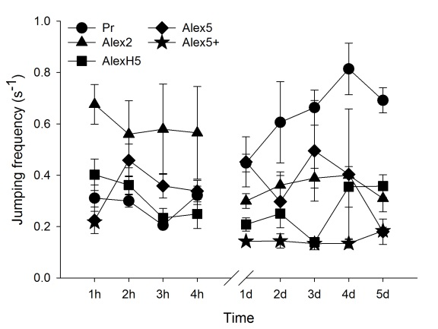
Fig 8 