Chapter 11. Clean district heating for the green energy transition in China: lessons from Sino-Danish collaboration

Zhuolun Chen^{1,3}, Niels Frederik Malskær², Stefan Petrovic³, Jianjun Xia⁴, Michele Rosa²
^{1.} Copenhagen Centre on Energy Efficiency, UNEP-DTU Partnership, Denmark
^{2.} Danish Energy Agency, Denmark
^{3.} Department of Technology, Management and Economics, Denmark Technical University, Denmark
^{4.} Building Energy Reservation Centre, Qinghua University, China

Introduction
Cities are important role models for achieving sustainable green urban development. More than half the world’s population now lives in cities, which are responsible for over 70% of global energy use. Energy use in the urban areas of municipal corporations accounts for 40 to 50% of GHG emissions worldwide, compared to rural areas outside cities (Gielen 2019). In 2013, the United Nations Environment Program (UNEP) initiated research on and surveyed low-carbon cities worldwide to identify the key factors underlying their success in scaling up energy efficiency and renewable energy, as well as in attaining targets for low or zero greenhouse gas (GHG) emissions (UNEP 2015).
District energy provision, including centralized heating and/or cooling at the regional level, is a proven energy solution; indeed, in many locations with the appropriate circumstances, it has been deployed for many years in a growing number of cities worldwide (Dhar 2013) District energy systems have three main components: energy production as suppliers, distribution systems as thermal networks, and end-users as consumers(see Figure 1). They represent a diversity of technologies to develop synergies between the production and supply of heat, cooling, domestic hot water and electricity. However, there is no fixed term for 'district energy system' (DES) in use worldwide. For district heating (DH) or district cooling (DC), such systems are defined as distributing thermal energy in the form of steam, hot water or chilled liquids from a central production source through a thermal network to multiple buildings or sites for space or process heating or cooling (EU 2010).
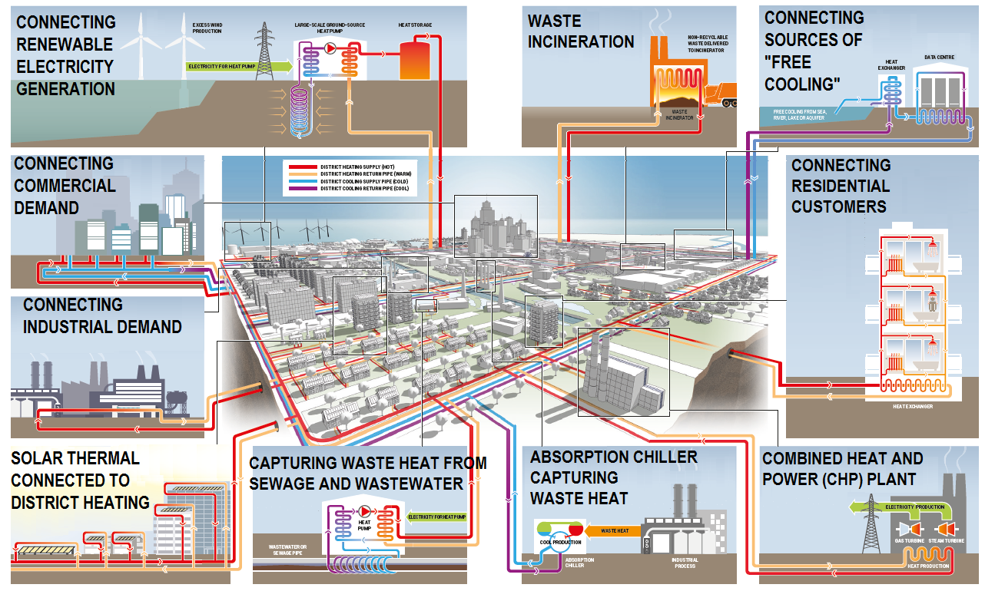
Figure 1. Illustration of a typical district energy system (UNEP, 2015)
Cities with sustainable development goals are adopting district energy systems to achieve what they regard as important benefits. DES can contribute to affordable energy provision; higher overall system efficiency, with reduced reliance on energy imports and fossil fuels; community economic development and community control of energy supply; local improvements to air quality; CO₂ emission reductions; and an increased share of renewables in the energy mix. All these elements, which are seen as attributes of ‘clean’ or ‘green’ district energy systems, can be regarded as making major contributions to the UN's Sustainable Development Goals (SDGs), including SDG-7 (Affordable and clean energy), 9 (Industry, innovation and infrastructure), 11 (Sustainable cities and communities) and 13 (Climate change).
Given the motivations driven by the ambitions just mentioned, cities around the world are taking real actions to impose ambitious sustainability targets on projects on the ground. The city of Copenhagen has gone one step further by using the SDGs as an opportunity to raise the bar and expand both new and existing sustainability initiatives beyond the thermal field to include the spatial planning of buildings and vegetation, and transportation. These efforts, including the climate plan’s goal of a CO₂-neutral Copenhagen by 2025, are made in dialogue with citizens, companies and civil-society organizations through activities at the city level (Department of Finance 2018). In another example, the city of Bristol, UK, has mapped SDG targets on to its One City Plan objectives, to be achieved by 2030 (University of Bristol 2019). Many other cities in the world with similar ambitions for sustainability are learning about successful experiences and best practice from both cities through city networks or partnerships like C40 (C40 Cities 2020) and Eurocities (Eurocities 2020). The aim of such partnerships is to find ways to make the world’s metropolises more sustainable.
In line with the experience of Denmark, achieving the goal of having 100% renewable energy by 2050 requires not only a long-term national policy to set the general direction and policy framework – it also requires active and creative cooperation at the regional and local levels by cities and citizens to implement the policy. Last but not least, it will involve developing and testing concrete new green solutions to create better and more liveable urban environments (State of Green, 2019).
Based on the experience and observations of Sino-Danish and international collaboration projects in the DH sector, this chapter aims to summarize the lessons learnt and provide recommendations for a green transition so that Chinese cities can prepare their clean DH action plans and integrate them into the upcoming national 14th five-year plan.

1.1 China's national clean district-heating strategy
Due to China's rapid urbanization, the total building area in the country will exceed 60,000 km² in 2020 (National Bureau of Statistics of China 2012). This urban development is generating high levels of energy consumption for building operations (including space-heating), which has reached 963 million tons of standard coal equivalent (or about 27 PJ). This type of use accounts for 21% of China's total final energy consumption (Building Energy Conservation Research Center 2019). Due to the lower availability of natural gas, Chinese DH systems are still dominated by coal, with coal boilers and large coal-fired electricity-generating plants often operating in CHP mode supplying 32% and 45% respectively of the DH heating area in northern China. Approximately half China’s annual consumption of heating coal takes place at low efficiencies of 10%-15%, as with small district boilers and household coal stoves (Zhang, et al. 2020).
To alleviate environmental problems and reduce the pollution from heating, the Chinese government has drawn up a “Clean Heating Plan in the Northern Region (2017-2021)”, officially making clean heating a national strategy. The target is to reduce the overall use of coal boilers in rural and urban areas to less than 30% of total installations as heat sources in the Northern Region and to reduce the primary energy consumption for DH to 8 kg_{ce}/m² (234 MJ/m²). To reach this target, cleaner heating processes with higher efficiencies, lower primary energy consumption and lower emissions of pollution were promoted by the Chinese government to replace low-efficiency coal boilers (Clean heating plan in Northern region 2017). The road map of clean DH development in North China from 2016 to 2018 is shown in Figure 2.
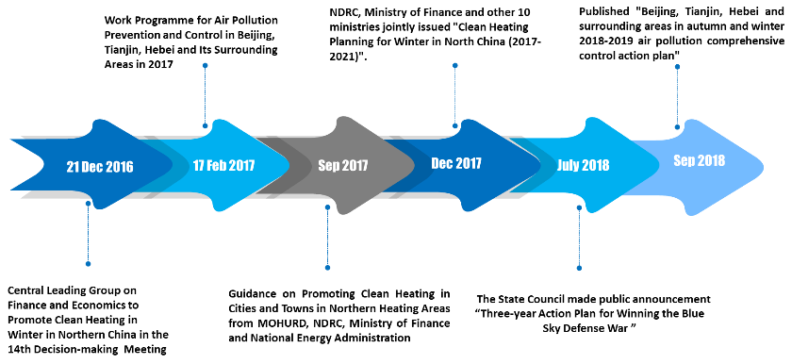
Figure 2. Clean DH developing in China from 2016 to 2018

1.2 Denmark's target for becoming carbon neutral by 2050
Denmark has a long tradition of setting ambitious national energy targets. In 2030, renewables should cover at least half the country’s total final energy consumption. By 2050, Denmark aims to be a low-carbon society independent of fossil fuels. The country is moving convincingly to meeting these world-leading targets (IEA 2017). Denmark has successfully decoupled its economic growth from its greenhouse gas emissions, thanks to a combination of improvements in energy efficiency and fuel-switching to renewables. The Danish Energy Model has shown that it is possible to sustain significant economic growth, a high standard of living and a high level of security of energy supply while reducing fossil-fuel dependency and mitigating its climate change footprint. This situation can be achieved by means of a persistent, active and cost-effective energy policy with ambitious renewable energy goals, enhanced energy efficiency and support for technical innovation and industrial development (DEA 2016).
Electricity generation in Denmark has changed fundamentally over the past two decades. Coal generation has deliberately been vastly reduced, and the bulk of power generation now comes from wind and bioenergy (DEA 2018). Supported by a flexible domestic power system and a high level of interconnection with neighbouring countries, Denmark is now widely recognized as a global leader in integrating variable renewable energy while at the same time maintaining a highly reliable and secure electrical power grid (DEA 2016).
The heating sector is also critical for Denmark’s low-carbon ambitions. Denmark’s large-scale use of combined heat and power plants with heat storage capacity and its increasing deployment of wind power, which connects electricity from renewable energy to the thermal energy of heating, offers great potential for the efficient integration of heat and electricity systems. In 2015, total DH supply in Denmark amounted to 128 PJ, and 67.4% of all DH was produced in cogeneration with electricity (CHP). Heat and power generated using CHP reflects the significantly greater efficiency of overall energy systems than heat and power generated separately. Typically in Denmark, a heat-only boiler has an efficiency of around 90-95%, while a condensing power plant generating electricity alone has an efficiency of only 40-50%. A CHP plant may have an overall energy-system efficiency of 85-93% (here for convenience simply defined as the sum of thermal and electrical efficiencies), resulting in an overall fuel saving of approximately 30% compared to the separate production of heating and electricity compared to the typical systems (DEA 2017).

Demonstration projects in the DH sector as part of Sino-Danish and international collaboration
For quite some time, there has been considerable collaboration in providing technical support to assist the green energy transition in China. Significant attention has been given to building local capacity in China in order to spread knowledge about energy planning by teaching local decision-makers and technical staff in relevant government agencies and local communities. In recent years, the demonstration projects in Tongchuan and another five pilot cities are examples of this kind of collaboration. Danish experience has played an important role in these projects.

2.1 DH planning project in Tongchuan
Sino-Danish collaboration to demonstrate Danish heat planning in China was recently concluded in the city of Tongchua in Shaanxi province and its surrounding area. The area has a population of around a million people and is located just north of Xi’an. Danish heat planning was used to analyse the situation in the area, with the invaluable help of the local government.
Danish heat planning is about finding the best space-heating solutions for a selected area, taking into account the heat-technical aspects, as represented by heat demand densities, sources of low-cost waste heat, and the economic and environmental impacts. This methodology often results in local district-heating solutions being introduced in urban areas, along with a more efficient and flexible energy system, compared to individual heating choices being made by consumers.
The Tongchua DH planning project showed that DH can be beneficial in large urban areas with available excess heat from power plants and/or industry. The same is true in smaller towns where residual resources are available cost-effectively, as well as in small rural villages with high building densities, when small-scale biomass boilers, heat pumps or renewable sources are available and the price of electric power is sufficiently low.
Danish experience shows that DH and DC can be the key to creating an energy-efficient society. DH systems in particular contribute substantially to the development of low-emission urban societies. However, this must be carefully planned and designed to secure low or reasonable heat prices.
The Tongchuan analysis revealed that the inherent heat-storage benefits of a DH system assist in avoiding emissions and expensive peak-load heat-production capacity investments. Additionally, heat storage and solar collectors were shown to be a possible solution for the transition of small rural villages from coal to clean heating. However, this transition would need to be financially supported in a demonstration period until supplier competition has emerged and technology prices are reduced.
In order to take full advantage of these synergies when doing heat planning, it may be advantageous to include the electricity sector in the planning process, thus opening the door to more efficient and flexible systems. However, some information about the electricity situation is required. Normally, data on the electricity system are not available for heat supply areas, which are typically different from electricity planning areas. In China, some electricity planning is carried out in the provinces, meaning that the required data on electricity systems may be aggregated data from the provincial level.

2.2 Demonstration projects in five pilot cities under GEF-6
Under the auspices and with the support of the Global Environment Facility (GEF-6), the National Development and Reform Committee (NDRC) and local municipalities in China, since 2016 UNEP has been conducting demonstration projects to implement modern DES in five pilot cities (Jinan, Xi'an Chanba, Baotou, Yinchuan and Qianxi). The objectives of this project are to:
- increase knowledge of the multiple benefits of DH
- provide technical assistance to identify potential pilot projects, undertake pre-feasibility studies, design business models, support the tendering process and develop local long-term DH strategies
- scale-up locally, through the establishment of local multi-stakeholder coordination units, and nationally, through a National Delivery Unit and the development of a regulatory framework
- unlock investments by means of suitable financial mechanisms to address financial barriers and support the initial projects in new markets.
Using rapid assessment methods, the potential of different DH technologies, policies and environmental benefits in these pilot cities were evaluated. The region of Chanba in Xi'an was selected for an extended, deep-dive assessment, including a city-level GIS-based energy mapping and planning exercise, pre-feasibility studies of two potential clean DH projects with initial design of business models, a financial support mechanism and preparation for public tendering. At the same time, applicable methodologies and tools for technical, environmental and cost-effective DH evaluations are being developed.
The Chanba deep-dive analysis reveals that the municipality has a strong interest in capacity-building to develop a clean DH action plan and a suitable business model. This requires a degree of coordination among different authorities inside the municipality to implement the energy planning results and to incentivize policies and the involvement of relevant stakeholders. The region has great potential to develop multiple clean heating sources, but it cannot combine them into a single DH network due to complications over ownership. The metering strategies need to be re-evaluated and integrated with digital technologies to optimize the control and operation of both the heating sources and the DH network.

Recommendations for the 14th five-year plan for clean DH in cities based on Sino-Danish collaboration
Denmark has gone and is going through a path from energy savings in buildings and the low-carbon development of cities and regions towards making the whole country carbon-neutral by 2050. Even though the size of the population and the economic and energy requirements are totally different in Denmark and China, Chinese cities can still learn from Denmark and its cities. Indeed, much can be learnt by treating the road map as an overall experiment with policies, technologies and business models with a view to addressing the kinds of roles cities can play in achieving a green transition. The medium- to long-term targets of carbon neutralization at different administrative levels in Denmark, such as cities, regions and communities, and their climate-change action plans have provided China with good examples in launching on the path towards clean DH development. According to the national 14th five-year plan, at present under consultation, cities and municipalities can and should adapt the national plan and develop their own action plans for the coming five years in respect of GHG emissions reductions, air pollution mitigation and energy savings. The cities and municipalities are recommended to break down their medium- and long-term targets in these actions plans so as to determine how to implement clean DH and to what level the clean DH can contribute.
Based on the experiences and observations in this Sino-Danish collaboration, several recommendations can be made for Chinese cities to consider in developing their own action plans for clean DH and thus fulfilling the national 14th five-year plan.

3.1 The role of municipalities in coordinating stakeholders
Municipalities should play a key role as planners and regulators, facilitators, providers, consumers, coordinators and advocators (UNEP 2015) in introducing clean DH. Although the national government can still impose high-level requirements and set targets in the 14th five-year national plan, Chinese cities should try and adapt these targets on the basis of the current development level. In order to achieve this, they should not only publish local incentivizing energy policies and carry out energy mapping and planning, but also facilitate the market for clean DH and regulate municipal utilities’ interconnections with resources and networks.
The implementation of clean DH requires huge amounts of cross-sectional coordination. Municipalities are recommended to set up a DH authority or appoint a focal point to coordinate with different authorities inside the government, including construction, energy provision, urban planning, environment protection and financing, to implement clean DH action plans. Energy mapping and planning should be integrated into the master plan within the same document. The energy planning should not only cover DH, but also achieving energy efficiencies, introducing green-building certification requirements and stimulating renewable energy so as to take into account the overall contributions to reducing energy consumption from different sectors in the region.
The municipalities should also take the lead in publishing guidelines for the design, implementation, operation and pricing structure of clean DH so that different stakeholders can also work out their roles or ways of participating in or benefiting from the transition to clean DH.
Finally, attention should be paid to avoiding counterproductive administrative procedures or mechanisms and instruments that discourage potential participants and investors. The future DH market in China can only be successful if smooth and consistent system-friendly regulations and market designs are put in place.

3.2 Cutting-edge technologies from planning to implementation of clean DH
As just noted, energy mapping and planning should be integrated into urban planning as one of the documents in the overall master plan, but they should be updated or revised whenever necessary. Advanced technologies, including digitalization in energy systems, a Geographic Information System (GIS), big-data analysis of predictions of end-user energy demand and the Internet of things (loT) or 'Internet+' for optimization in DH and DC operation should be used in the process and considered not only in planning, designing and implementing, but also in operating and optimizing. Chapter 13 of this report has detailed descriptions of these digitization technologies and their impacts and contributions to overall energy efficiency.
Meanwhile, some criteria which differ from those frequently used at the building level to evaluate energy efficiency, including primary energy efficiency and peak electric power load shifting etc., should be used to measure the energy efficiency of cities and even regions.
In Denmark’s experience, one of the most promising advanced technologies for achieving clean DH is the 4th generation of district energy systems (4GDH) (Henrik Lund 2014). This system is operated at low temperatures and includes the integration of excess waste heat, renewable energy, booster heat pumps, advanced control or metering strategies and the energy efficiency of buildings. 4GDH are district heating systems running at low temperatures that match the lower energy requirements of more efficient buildings. Lowering supply temperatures reduces losses in heat distribution and enables suppliers to use the additional heat sources available at those temperatures, notably excess industrial heat, and solar and geothermal energy. Developing 4GDH requires new infrastructure in heat production, distribution and consumption. Some applications of 4GDH in Denmark have also enabled buildings such as data centres, supermarkets and industries to sell excess heat to the DH network, which in turn increases the region’s primary energy efficiency.
Another often used concept in Denmark is sector coupling between heat and electricity systems, especially because of the large share of wind energy (and the large peaks of instantaneous power generation). Well-integrated DH systems with co-generation of electricity and heat, power-to-heat production in large-scale heat pumps or thermal energy storage can help to balance the grid by producing or consuming more electricity in a specific period of time, representing effectively some sort of virtual electricity storage (DBDH 2019). Even though some types of co-generation systems have been applied to some of China’s DH systems in recent years, the greatest share of electricity still comes from coal-fired or other types of fossil fuel-driven power plants, thus reducing the sustainability of energy systems overall.

3.3 Business models for clean DH
A new type of business model in the DH sector in China is heating as a service. The roles of DH suppliers should change from regular energy suppliers to whole-chain service providers. Decarbonizing heat, is difficult, as the energy sector needs to combine building renovations with network upgrades in different ways to deliver high-quality low-carbon heating services. Other sectors have already discovered how to marshal complex supply chains to deliver heating services that consumers want to pay for. They have done this by developing processes to reveal what consumers are willing to pay and how well their offers perform.
Best practice regarding successful business models for engaging energy service companies (ESCOs) and private sectors as partners in public-private partnerships should be shared. Clean DH projects in China should move from depending mainly on financial support from governments to self-sufficient commercialized ones. More activities to build local capacity are needed in order to make good use of energy planning as a tool for long-term DH business planning.
Developing and applying suitable and maybe innovative business models in clean DH has the potential to unlock investments from the private sector. As a result, the transition to green energy in the DH sector can be accelerated.

3.4 Ownership of DH suppliers
One of the key drivers of efficient and green district-heating systems is the prevalence of consumer-owned district-heating companies. In broad terms, these fall into three types:
- Directly owned systems where consumers finance, build and operate their own district heating system
- Consumer-owned systems held through housing cooperatives
- Municipally owned systems, where the company is run on behalf of the consumers
In all three types, though more directly in the first two, consumers hold the power in the company through an executive board. This structure ensures that long-term operational and investment decisions are geared towards lowering consumer costs, as each consumer pays based on his or her consumption, and economically viable non-profit legislation keeps extra revenue in the company.
The majority of district-heating companies in Denmark have favourable consumer prices compared to alternative heat supplies from natural gas, oil, electric heating etc. They also have well-functioning boards, which continuously invest in new cost-effective and energy-efficient and/or green solutions.
A clear recommendation for China’s 14th five-year plan, based on Danish experience, would therefore be to close the revenue loop around district-heating companies and give consumers a direct stake in the system. This would ensure that revenue resulting from efficiency gains would directly benefit the district-heating system, and that consumers are incentivised to manage their consumption better. This combination, when paired with consumption-based heat bills, would undoubtedly improve efficiency and open the door to cleaner heating initiatives.
In order to ensure that the district-heating companies are as efficient as possible, the regulator should compare the costs and tariffs of all companies and publish the results. This helps to correct the information imbalance that would otherwise exist and makes it possible for the consumers to demand better management if their company has high costs.
In conclusion, while the publicly owned heating companies in China provide a good service to its citizens, their incentives to make efficiency improvements are weak. A change to ownership rules that closes the revenue loop and hands more power to consumers would ensure strong long-term incentives to achieve efficiency gains.

Conclusion
This chapter has focused on the lessons learnt from Sino-Danish collaboration to develop modern district-heating systems (DH). It has summarized the recommendations for Chinese cities to implement clean DH as part of their green transition and to develop relevant action plans based on the requirements of the upcoming 14th five-year national plan. In general, there are recommendations in four key fields for cities to take into account in integrating clean DH into local energy systems for a green energy transition: enhancing stakeholder coordination, employing cutting-edge technologies in planning, developing suitable business models, and improving definitions of DH supplier ownerships.

Acknowledgements
The work on district energy at the Copenhagen Centre on Energy Efficiency is financially supported by funding from the ‘'Bitten and Mads Clausen Foundation’'. Support from the UNEP-led GEF-6 project ‘'Increasing Investments in District Energy Systems in Cities: A SE4All Energy Efficiency Accelerator’' is also acknowledged. This chapter is partly a result of the strategic collaboration between the Copenhagen Centre on Energy Efficiency under UNEP DTU Partnership and the Danish Energy Agency.

References
Building Energy Conservation Research Center, 2019. 2019 Annual report on China building energy efficiency. s.l.: China Architecture / Building Press.
C40 Cities, 2020. C40 cities. [Online]
Available at: https://www.c40.org/
[Accessed 1 8 2020].
Clean heating plan in Northern region, 2017. Clean heating plan in Northern region. [Online]
Available at: http://www.gov.cn/xinwen/2017-12/20/content_5248855.htm
[Accessed 24 12 2017].
DBDH, 2019. District heating: heat-as-a-service and sector coupling. [Online]
Available at: https://dbdh.dk/2019/07/01/district-heating-heat-as-a-service-and-sector-coupling/
DEA, 2016. Security of electricity supply in Denmark, s.l.: s.n.
DEA, 2016. The Danish energy model: Innovative, efficient and sustainable, s.l.: DEA.
DEA, 2017. Regulation and planning of district heating in Denmark, s.l.: s.n.
DEA, 2018. Long term planning for a greener future, s.l.: DEA.
Department of Finance, t. c. o. C., 2018. The capital of sustainable development: The city of Copenhagen's action plan for sustainable development goals, s.l.: s.n.
Dhar, S. P. M. &. S. P. R., 2013. Low carbon city: A guidebook for city planners and practitioners, s.l.: s.n.
EU, 2010. DIRECTIVE 2010/31/EU OF THE EUROPEAN PARLIAMENT AND OF THE COUNCIL of 19 May 2010 on the energy performance of buildings. Official Journal of the European Union, pp. 13-35.
Eurocities, 2020. Eurocities. [Online]
Available at: https://eurocities.eu/
[Accessed 1 10 2020].
Gielen, D., 2019. The role of renewable energy in the global energy transformation. Energy Strategy Reviews, Volume 24, pp. 38-50.
Henrik Lund, S. W. R. W. S. S. J. E. T. F. H. B. V. M., 2014. 4th Generation District Heating (4GDH): Integrating smart thermal grids into future sustainable energy systems. Energy, Volume 68, pp. 1-11.
IEA, 2017. Energy Policies of IEA Countries: Denmark 2017 Review, s.l.: International Energy Agency.
National Bureau of Statistics of China, 2012. National Bureau of Statistics of China. [Online]
Available at: http://www.stats.gov.cn/
[Accessed 10 10 2020].
State of Green, 2019. Three Danish cities at the forefront of implementing sustainable urbanisation. [Online]
Available at: https://stateofgreen.com/en/partners/danish-energy-agency/solutions/green-urban-denmark/
UNEP, 2015. District Energy in Cities, s.l.: s.n.
University of Bristol, B. c. c. e. a., 2019. One City Plan and the Sustainable Development Goals, s.l.: s.n.
Zhang, W., Zhang, Y., Xia, J. & Jiang, Y., 2020. Cleaner heating in Northern China: potentials and regional balances. Resources, Conservation & Recycling, Volume 160.

